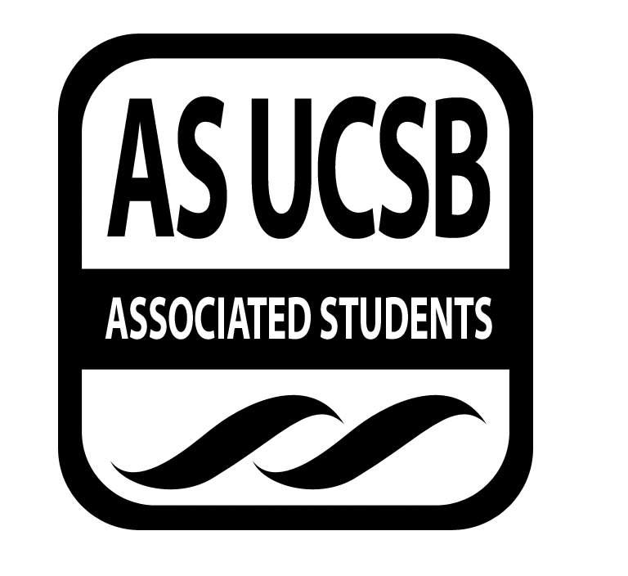
WOMYN’S COMMISSION MINUTES

Associated Students
April 29, 2014, 7pm
Asian Resource Center Minutes/Actions recorded by: Kristina

CALL TO ORDER 7pm, Delyla Mayers

A. MEETING BUSINESS
- Roll Call

Name | Note:  absent (excused/not excused)  arrived late (time)  departed early (time)  proxy (full name) | Name | Note:  absent (excused/not excused)  arrived late (time)  departed early (time)  proxy (full name)
Marilyn Dukes |  | Rosina Saeed
Delyla Mayers |  | Danielle Maldonado
Cassie Rubio |  | Kristina Didero

B. PUBLIC FORUM
  - Ice Breaker: What's an ability you’d like to wake up with tomorrow?
  - Announcements
    - Areli Ariana
    - Janet Mock 7:30 tonight
    - WOCC
    - Girl Rising, May 20th
    - Pride starts May 5th, rally 12:30
    - WISE - going to have discussion about breaking down gender stereotypes in male-dominated fields
    - Cassie needs help on Herstory
        - Staphany can help
  - Funding Requests
    - Girl Up
        - Leadership Summit Conference
        - 3 days
        - Washington D.C.
        - June 16-18
- DISCUSSION ITEMS
G-1. Womyn of Color Conference Planning
Kristina wants people to volunteer to email graduate students from different departments:
Email list passed around for volunteers
Meeting this weekend

ADJOURNMENT

