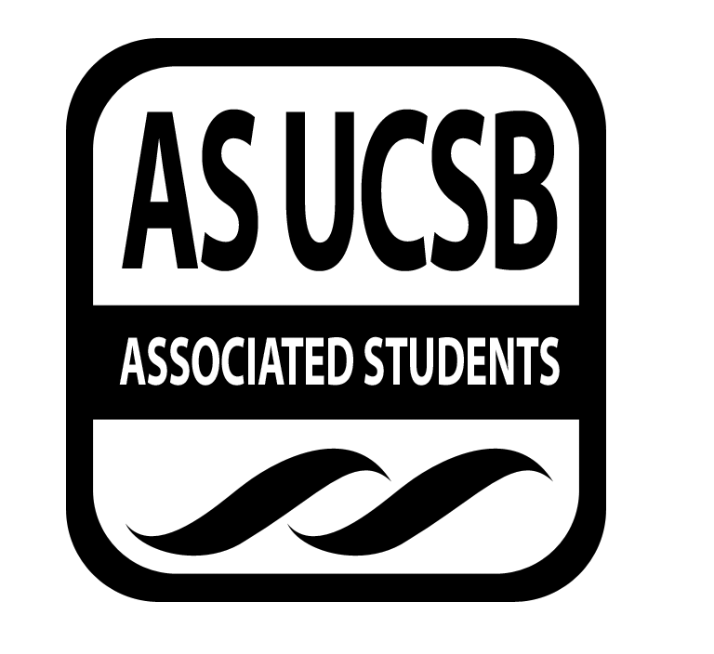
Womyn’s Commission Minutes/Action Summary

Associated Students
2/3/15, 7 P.M. El Centro Conference Room
Minutes/Actions recorded by: Kate Kesner

CALL TO ORDER 7:10, Danielle Maldonado

A. MEETING BUSINESS
- Roll Call

Name | Note:  absent (excused/not excused)  arrived late (time)  departed early (time)  proxy (full name) | Name | Note:  absent (excused/not excused)  arrived late (time)  departed early (time)  proxy (full name)
Danielle Maldonado | Present | Cassie Rubios | Present
Roxanne McNally | Present | Kate Kesner | Present
Ximena Garcia | Present | Pre-entered Name | Present

B. PUBLIC FORUM
  - Ice Breaker: What ice cream flavor would you be and why?
  - Announcements: WETT’s V-day Event on Feb. 12th; RCSGD Fashion Show on Feb. 26th
  - Discussion: I am Beautiful Planning, Human Rights Workshop, Women in Social Sciences Mixer and WOCC preliminary planning

F-2 New Business

- RCSGD, Annual Fashion Show — Monetary Request
Proposed by La Familia de Colores
$300 to cover fashion accessories for RCSGD Fashion Show on Feb. 26th

MOTION/SECOND: Ximena Garcia/Roxanne McNally
I motion to fund La Famila de Colores $300 for fashion accessories.
ACTION: Vote: 5-0 to APPROVE
Additional approval required: YES, Senate

- DISCUSSION ITEMS
G-1. I Am Beautiful Runway Show
- 5 PM setup, 7-9 event at Corwin Pavillion
- providing water, lemonade, cookies & fruit
- runway show, securing more models
- acapella groups & spoken word artists (two reserved now)
- t-shirt making: have t shirts & paint
- Taylor creating playlist for runway
- G-2. Human Rights Week Workshop :
- workshop on expanded reproductive rights (especially for women of color)
  - Daisy contacting in Planned Parenthood Rep
- Civil Brand: possible movie choice on incarcerated women of color in MCC, with discussion afterwards drawing on actual statistics
- MCC, Week 8
- finalized by Thursday
- 4-5 for workshops
- G-3. Women in Social Sciences Mixer :
- Non profit career focus
- end of February (hopefully in the MPR)
- G-4. Womyn of Color Conference:
- in Spring, plan conference for next year
- specifically for UCSB this year
- culmination on the weekend
- in model of Humyn Right’s Week — get other organizations to collaborate
- pick up workshops that got dropped last year due to Isla Vista shooting
- potential theme: reclaiming spaces after acts of violence
- workshops in the SRB, lecture hall in Theater & Dance for main speakers
- need outside keynote speakers, student leaders, UCSB professors
- tickets from AS program board (do we want it to be free for other UC students?)
- main order of business: reserving a space

ADJOURNMENT

MOTION/SECOND to ADJOURN: Kate Kesner/Roxanne McNally
ACTION: Vote: 5-0 to APPROVE
Vote Taken: 8:35 P.M.

