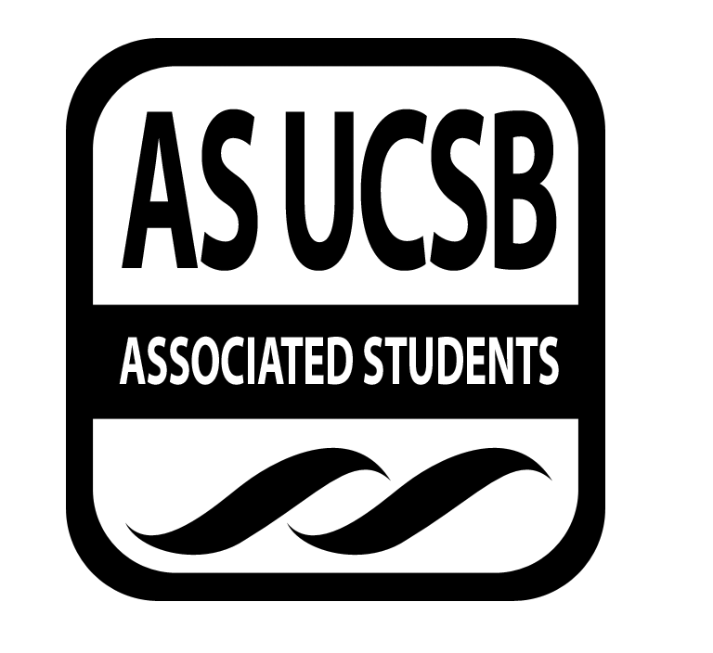
Womyn’s Commission Minutes

Associated Students
January 22, 2014, @ 5pm
MIDDLE EASTERN RESOURCE CENTER
Minutes/Actions recorded by: Kristina Didero

CALL TO ORDER 5:00 by Olivia Jaffe-Pachuilo, Chair

A. MEETING BUSINESS
- Roll Call

Name | Note:  absent (excused/not excused)  arrived late (time)  departed early (time)  proxy (full name) | Name | Note:  absent (excused/not excused)  arrived late (time)  departed early (time)  proxy (full name)
Marilyn Dukes |  | Danielle Maldonado
Olivia Jaffe-Pachuilo |  | Pre-entered Name
Kristina Didero |  | Pre-entered Name

B. PUBLIC FORUM
  - Announcements/Information/Introductions
    - [OLIVIA] Ice Breaker: What’s the first song you ever knew the words to?
    - [DANIELLE] Applications are closed and the position will be filled by the end of the week
  - Other Org Announcements
    - March 4th, RCGSD Fantasy Fashion Show
    - PISA Social Jan 23rd 7-9pm Flying A Room UCen
    - Feb. 26th Scale Smashing Event Lot 22 + Discussion in MPR
    - SCORE Facing Race Conference Feb 22nd
    - MCC Pushing Forward Conference

- REPORTS

- Group Project/Member Report(s)
  - [KRISTINA] – “I am Beautiful” & Womyn Unite Update
      - Ideas for performers?
        - Intervals
      - Speakers for Womyn Unite?
      - Other things people want to see or have happen?
        - Mirrors as party favors for I am Beautiful
        - Decals that say “I am Beautiful”
        - To be notes
        - Collaborating with Friends of Rachel
  - [DANIELLE] – re-announce WOCC committee

- DISCUSSION ITEMS
- [OLIVIA] Privilege
  - White feminism graphic

ADJOURNMENT

