BCU Agenda

Associated Students
03/09/2019,
Transfer Student Center Conference room

CALL TO ORDER by Mackenzie Calderon at 6:35 pm

A. MEETING BUSINESS
- Roll Call (Pre-entered Names)

Name | Note:  absent (excused/not excused)  arrived late (time)  departed early (time)  proxy (full name) | Name | Note:  absent (excused/not excused)  arrived late (time)  departed early (time)  proxy (full name)
Mackenzie Calderon | Present | Clara Lemus | Excused
Juan Ornelas | Present | Leah Churchill | Excused
Neyra Patricio | Present | Katherin Jordan | late- excused
Sophia Weimer | Present | Nathan Canales | Late-excused
Thomas Thrush | Present | Rebekah Burke | Not Excused
Anthony Hernandez | Present | Nima Bencohen | Excused

- Acceptance of Excused Absences
MOTION/SECOND: Weimer/ Patricio
Motion language Acceptance of excused absences
ACTION: Vote: X-X to APPROVE/DENY.
- Acceptance of Proxies
MOTION/SECOND: Last Name/Last Name
Motion language
ACTION: Vote: X-X to APPROVE/DENY.

B. PUBLIC FORUM
  - Announcements/Information/Introductions
Welcome back!! With role, do a high and low of spring break and/or first week
  - Testimony for items on today’s agenda (out of order)
  - Appreciations/Concerns
THANK YOU GRAD COMMITTEE!! Special thanks to sophie’s hard work on itinerary, it looks so professional
d. Add specific goals to each TSC position to make sure we reach goals
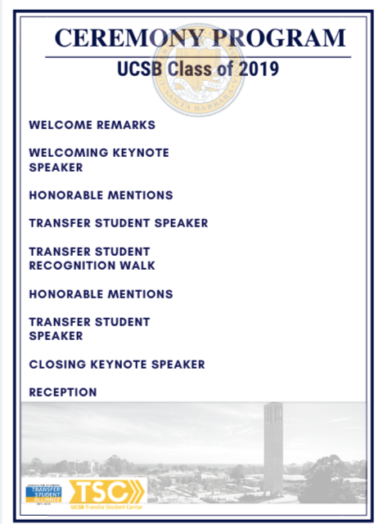
Grad speakers?

Update on website?

updates on the gauchospace and orientation
Have the transfer inter application and drop by the TSC to learn about TSA
Coffee cart update: Needs to be reusable pods; photos of events on the coffee cart

  - Request to have item added to today’s agenda
Optional: The BCU will not take action today on issues raised in the Public Forum except requests for financing which BCU members agree to add to the agenda for consideration under Action Items.

Senator Anthony request to add a new funding for 705 dollars for event.

- REPORTS
Brief reports on matters relevant to the BCU and matters of general interest to the public in attendance.
- Advisor’s Report
- Executive Officer’s Report(s)
Spring Quarter goals:
More people involved in the events and help with troubleshooting
Don’t wait to be asked, just jump in and see what you can do
NEED TO PUSH FOR RSVPs and Applications
If duties are not fulfilled, honoraria will be affected
Orientation is coming up, obligated to go to ⅔ Fridays - will be a sign up sheet
- Application ends Friday (will be extended)
Spring Insight this weekend from 8:30am-3:30pm (don’t need to be there that long)
- Treasure/tommy - make sure to turn in forms early. Think calmly under stressful situations.
- Senator/ Anthony- make sure check up on our forms because it’s your events. Absences only 2 per year or else you get honorian cut.

3. Media/ Sophie - show up to more events
4. Chair/Mac - spread the board applications
    - Ask Professor Lobach to email the board application.
    - Spring insight on Saturday,
5. Katherin - website ready, waiting for approval by A.S

- Group Project/Member Report(s)
  - Transfer Student Spotlight
  - Project with TSC, ONDAS, Don Lubach
  - Sign up and share!

- ACCEPTANCE of AGENDA/CHANGES to AGENDA
The Chair may, with members’ consent, add items to the agenda for consideration at the current meeting if they meet one of the following criteria:
a) Emergency Situation -- the issue falls within ten days from this meeting.
b) Deadline -- if the issue arose after the agenda deadline and must be acted on before the next scheduled meeting.
MOTION/SECOND: Last Name/Last Name
Motion language
ACTION: Vote: X-X to APPROVE/DENY.

- ACCEPTANCE of ACTION SUMMARY/MINUTES

- Approval of our Action Summary/Minutes from
MOTION/SECOND: Last Name/Last Name
Motion to accept the agenda
ACTION: Vote: X-X to APPROVE/DENY.

- ACTION ITEMS
These are generally financial approvals. Detailed information and staff recommendations/reports are provided in attachments. Approvals of allocations of funds require Senate approval. Travel requests and exceptions to policy require Finance and Business Committee approval.

F-1. Old Business: Items that were continued from some previous meeting date to this date for further discussion, usually after new research/information which was not available at the previous meeting.

Approval/Consideration of
Last Name/Last Name:

ACTION: Vote: X-X to APPROVE.
Advisor/Staff recommendation/instruction/request: Advisor will provide
Responsible for Follow-through: NAME of PERSON/GROUP/N/A
Additional approval required?

F-2 New Business

- Approval/Consideration of $500 for Gaucho Transfer Friday Lunches, split between the three Fridays
Thrush/Canales -

ACTION: Vote: 10-0 to APPROVE.
Advisor/Staff recommendation/instruction/request: Advisor will provide
Responsible for Follow-through: NAME of PERSON/GROUP/N/A
Additional approval required?
- Approval/Consideration for Alumni Weekend Event in the Transfer Student Center for $250, through UCen Catering purchase order (probably need to make a direct payment versus a cash advance)
Ornelas/Canales: -

ACTION: Vote: 10-0 to APPROVE.
Advisor/Staff recommendation/instruction/request: Advisor will provide
Responsible for Follow-through: NAME of PERSON/GROUP/N/A
Additional approval required?

c. Approval/Consideration of for $705 for TSA pin merch for 300 pins
Thrush/Canales: advice

ACTION: Vote: 10-0 to APPROVE.

d. Approval/Consideration of relocating from $1500 of TSA retreat, for a new transfer food insecure for TSA retreat open to all
Thrush/Weimer:

ACTION: Vote: 10-0 to APPROVE.

- DISCUSSION ITEMS Approval/Consideration of brief description & dates item continued from for
Items on which we may make a decision in the future. Public testimony is welcome. We will not make decision motions but may instruct members/staff to do research and/or place item on future agenda.

- TSA Bill Update
- Transfer Grad Committee Meeting Times
  - Tuesday’s - 3:30 at TSC
- Food Security Town Hall
  - Next Tuesday at the GSA in the MCC at 5 pm
- REMARKS

- Erica - transfer mental health peers, will be updated
- Spring insight; is a go.
  - 8:30 am to 3:30 but we’re going “10:40 am” to unknown
  - Sophie, Anthony, Neyra, Nathan,

ADJOURNMENT
MOTION/SECOND: Weimer/Ornelas

ACTION: Vote: 10-0 to APPROVE

