Take Back the NIGHT AGENDA

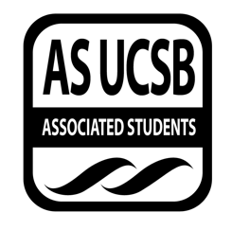
Associated Students
1/31/18, 7:00
Women’s Center Conference Room

CALL TO ORDER at 7:10

A. MEETING BUSINESS
- Roll Call

Name | Note:  absent (excused/not excused)  arrived late (time)  departed early (time)  proxy (full name) | Name | Note:  absent (excused/not excused)  arrived late (time)  departed early (time)  proxy (full name)
Midory Ibanez | Present | Mikayla Knight | Present
Jane Diep | Present | Lynnee Morrow-Lampton | Present
Anna Jevtic | Present | Emily Umana | Absent (excused)
Nicole Lott | Absent

B. PUBLIC FORUM
  - Announcements
- Vagina Monologues 9th and 10th
- COC event this weekend on Sunday
- WOCC this Saturday
- REPORTS
- Advisor’s Report
- None
- Executive Officer’s Report(s)
- None
- Group Project/Member Report(s)
- None

- ACTION ITEMS
- None

F-1. Old Business:
- None

DISCUSSION ITEMS
- Applicant for Ourstorian will be interviewed on Friday
- We will be tabling at WOCC on Saturday
- Possible locations for Rally
  - The Pub
  - The SRB
  - Storke Tower
- Open up the opportunity to provide us with a shirt graphic to the Art Students
- Janes Survivors Circle:
  - March 1st
  - Art work and stories can be dropped off ahead of time outside the office in a box
  - Will take place in womens center conference room
  - First 30 min-food,arts,
  - 45-1 hour: start with ice breaker activities
  - Food Tbd

ADJOURNMENT
Meeting adjourned at 7:50 by Midory Ibanez.

