Take Back the NIGHT AGENDA

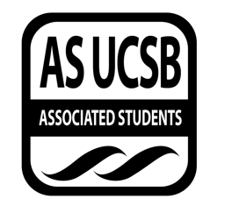
Associated Students
10/24/17, 7:00
Women’s Center Conference Room

CALL TO ORDER at 7:00

A. MEETING BUSINESS
- Roll Call

Name | Note:  absent (excused/not excused)  arrived late (time)  departed early (time)  proxy (full name) | Name | Note:  absent (excused/not excused)  arrived late (time)  departed early (time)  proxy (full name)
Midory Ibanez | Present | Anna Jevtic | Absent (excused)
Sofia Mejias | Absent (excused) | Makayla Knight | Present
Nicole Lott | Present | Lynnee Morrow-Lampton | Present
Emily Umana | Present | Jane Diep | Present

B. PUBLIC FORUM
  - Announcements
- Safe Space happening this weekend
- Invite friends to the event page om Facebook
- Kristen- UCPD will have their established help station this Halloween weekend
- Jason Katz will be coming November 1
- Sigma Alpha Zeta- domestic awareness week have events every day; everyone is welcome to come
- Channing Tater Tottum/study jam next weekend
  - Scantrons, food, Channing Tatum movie
- REPORTS
- Advisor’s Report
- None
- Executive Officer’s Report(s)
- Mikayla: Speak About It event description
- Group Project/Member Report(s)
- None

- ACTION ITEMS

- None
F-1. Discussion:
- Chai and Chat talk: Current events
  - Harvey Weinstein
  - #MeToo Campaign

ADJOURNMENT
Meeting adjourned at 9:00 by Midory Ibanez.

