Take Back the NIGHT AGENDA

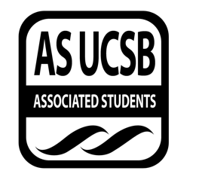
Associated Students
11/14/17, 7:05
Women’s Center Conference Room

CALL TO ORDER at 7:05

A. MEETING BUSINESS
- Roll Call

Name | Note:  absent (excused/not excused)  arrived late (time)  departed early (time)  proxy (full name) | Name | Note:  absent (excused/not excused)  arrived late (time)  departed early (time)  proxy (full name)
Midory Ibanez | Present | Anna Jevtic | Absent (excused)
Nicole Lott | Present | Mikayla Knight | Present
Emily Umana | Present | Lynnee Morrow-Lampton | Present
Jane Diep | Present

B. PUBLIC FORUM
  - Announcements
- Delta Dogs- Tri Delta is selling hot dogs and dog therapy that goes to fundraise for St. Jude’s Hospital.
- Meeting next week is cancelled
- REPORTS
- Advisor’s Report
- None
- Executive Officer’s Report(s)
- Lynnee-Meeting in two weeks meeting is self affirmation self care jars/envelops
- Group Project/Member Report(s)
- None

- ACTION ITEMS
Midory motioned to allocate 50 dollars for supplies for Self Affirmation meeting.
MOTION/SECOND: Ibanez,Midory/ Knight, Mikayla
Motion language: Midory motioned to allocate 50 dollars to the Self Affirmation event. Mikayla seconded motion. Motion put to a vote. 11 in favor, none opposed, none obtained.
ACTION: Vote: 11-0 to APPROVE
Additional approval required: YES (Senate)

F-1. Discussion:
- CARE presented on how to be a good Ally for friends in abusive relationships.

ADJOURNMENT
Meeting adjourned at 8:50 by Midory Ibanez.

