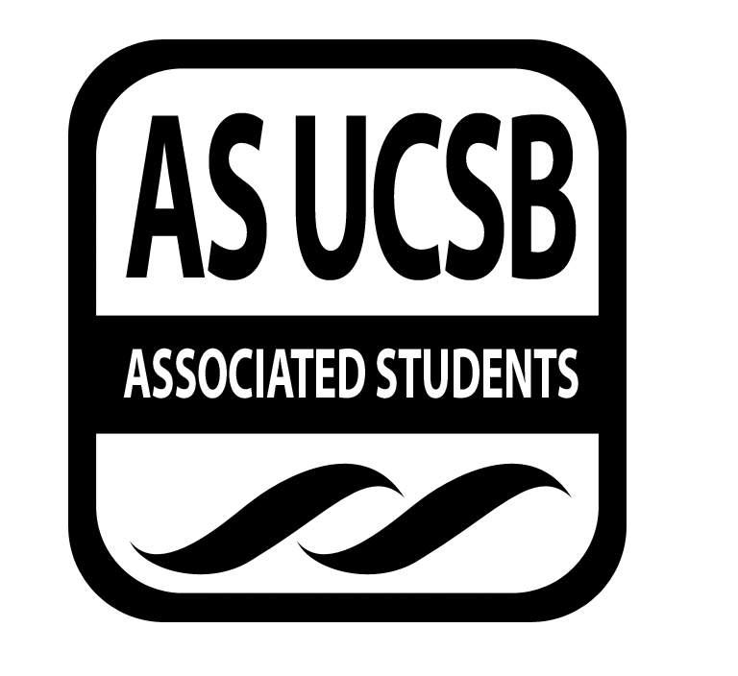
A.S. SIRRC Minutes

Associated Students
May 4, 2017 @ 6:00 pm
AS Annex Minutes Recorded By: James Fonseca

CALL TO ORDER at 6:04 by Lorena Alvarez

A. MEETING BUSINESS
- Roll Call

Name | Note:  absent (excused/not excused)  arrived late (time)  departed early (time)  proxy (full name) | Name | Note:  absent (excused/not excused)  arrived late (time)  departed early (time)  proxy (full name)
Lorena Alvarez | Present | Bryan Garcia | Present
Josh Hudson | Present | Salvador Hernandez | Present
Michelle Martinez | Present | James Fonseca | Present
Ernesto Jimenez | Present | Renata Rodriguez | Present
Julia Hsueh | Present | Tiffany | Present
Joseph Rico | Present | Lesly Silva | Excused
Brenda Cruz | Present | Jonathan Lopez | Excused
Carmen Garcia | Present

A-2. Acceptance of Excused Absences
Motion to make
Additional approval required: YES Senate
B. PUBLIC FORUM
  - Announcements/Information/Introductions/ Ice Breaker
  - Testimony for items on today’s agenda (out of order)
    - Ice Breaker- “Blanket Game”
    - Break-out Groups
    - Announcements
    - Voting
  - Appreciations/Concerns
  - Request to have item added to today’s agenda
- REPORT ITEMS
D-1. Retention-
-Went through the workshops planned for GSO.
D-2. Recruitment-
-Are awaiting the final approval for the college trip next Wednesday.

-Action Items

Presentations
BSU- Will put on a Black culture week from May 22nd to May 27th. They are requesting $350 to help pay for one of the artists they are planning to recruit.

- New Business
Funding Requests
BSU of $450 for covering costs of entertainment. Sal/Andrea. Tiffany calls to question. Betty calls consent. No objections to consent; motion passes.

Reimbursement to Brenda of $19.48 for buying snacks for bookbank tabling.Lorena/Michelle.Sal calls to question. Tiffany calls consent.

Cash Advance for $180 for GSO and GTSO. Lorena/Sal. Jhan calls to question. Joseph calls consent. No objections to consent; motion passes.

Cash Advance for the college trip $1500.Lorena/Carmen.Carmen calls to question. Tiffany calls consent. No objections to consent; motion passes.

Additional approval required: YES Senate

- REMARKS
-Undocumonalogues will be happening Tuesday May 16th 6-8pm at the MCC Lounge.
-Next Wednesday Book bank will table from
-Cinco De Mayo event at Hardee Elementary School will happen tomorrow from 2-7
-Banda Night will be tomorrow night!
-Saturday is Kaichella for the people living in the Kai-five area of UCSB at San Miguel Hall
-Sunday is Facing Race event 8:30-5pm
-Hermanas is hosting Carne Asada Con La Raza from 6-9pm
-CAPS Internship program application is open until May 15th.
-ADJOURNMENT
MOTION/SECOND to ADJORN: James/Mara
ACTION: Vote: 13-0 to APPROVE
Vote Taken: 8:05 pm

