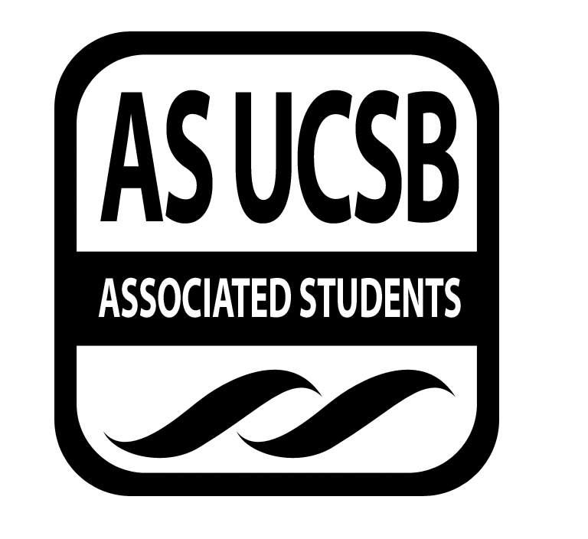
A.S. SIRRC Minutes

Associated Students
May 25, 2017 @ 6:00 pm
AS Annex Minutes Recorded By: James Fonseca

CALL TO ORDER at 6:05 by Lorena Alvarez

A. MEETING BUSINESS
- Roll Call

Name | Note:  absent (excused/not excused)  arrived late (time)  departed early (time)  proxy (full name) | Name | Note:  absent (excused/not excused)  arrived late (time)  departed early (time)  proxy (full name)
Lorena Alvarez | Present | Bryan Garcia | Excused
Josh Hudson | Present | Salvador Hernandez | Present
Michelle Martinez | Present | James Fonseca | Present
Ernesto Jimenez | Present | Renata Rodriguez | Present
Julia Hsueh | Present | Tiffany | Present
Joseph Rico | Excused | Lesly Silva | Excused
Brenda Cruz | Present | Jonathan Lopez | Excused
Carmen Garcia | Present

A-2. Acceptance of Excused Absences
Motion to make
Additional approval required: YES Senate
B. PUBLIC FORUM
  - Announcements/Information/Introductions/ Ice Breaker
  - Testimony for items on today’s agenda (out of order)
    - Ice Breaker- “Blanket Game”
    - Break-out Groups
    - Announcements
    - Voting
  - Appreciations/Concerns
  - Request to have item added to today’s agenda
- REPORT ITEMS
D-1. Retention-
-Will talk about GSO and GTSO planning
-Began establishing team leaders and coordinators for GSO and GTSO
-Began recruiting orgs fro the org fair for both programs
D-2. Recruitment-
-Will go over the itinerary for the college trip tomorrow
-Went over the itinerary for the college trip

-Action Items

- New Business

Cash Advances
Josh of $1000 for the end of the year Banquet. Carmen/Sal. Brenda calls to question. Michelle calls consent. No objections to consent; motion passes.
Mara of $4800 for GSO and GTSO expenses. Carmen/Raquel. Tiffany calls to question. Ernesto calls consent. No objections to consent; motion passes
Brenda of $1000 to buy books for next year. Carmen/Sal. Jhan calls to question. Bryant calls consent. No objections to consent; motion passes
Additional approval required: YES Senate

- REMARKS
-Lamda Theta Phi fundraiser at PMH
-MAC event tomorrow 2-5pm at the San Nicholas lawn
-Sustainibility Internship application is open!
-Our last study Jam is net Thursday from 9-12 at the SRB MPR
-Our End of the year banquet is Sunday June 4th at the GSA lounge
-
-ADJOURNMENT
MOTION/SECOND to ADJORN: Sal/Eddie
ACTION: Vote: 13-0 to APPROVE
Vote Taken: 7:06 pm

