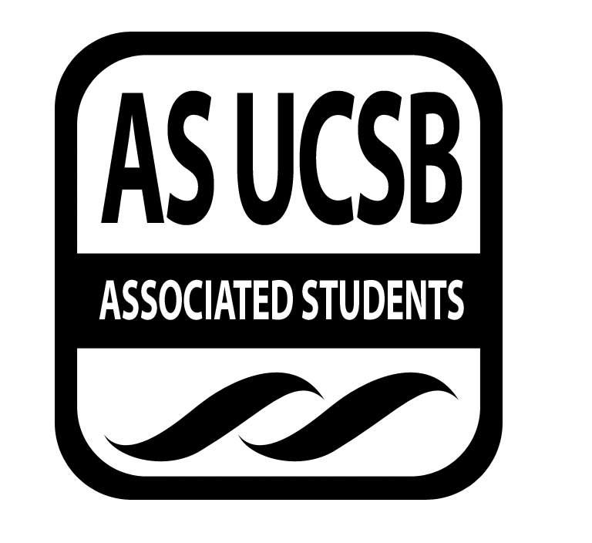
A.S. SIRRC Minutes

Associated Students
March 2, 2017 @ 6:00 pm
AS Annex Minutes Recorded By: James Fonseca

CALL TO ORDER at 6:02 by Lorena Alvarez

A. MEETING BUSINESS
- Roll Call

Name | Note:  absent (excused/not excused)  arrived late (time)  departed early (time)  proxy (full name) | Name | Note:  absent (excused/not excused)  arrived late (time)  departed early (time)  proxy (full name)
Lorena Alvarez | Proxy | Bryan Garcia | Present
Josh Hudson | Present | Mara Tinajero | Proxy
Michelle Martinez | Excused | James Fonseca | Proxy
Ernesto Jimenez | Present | Renata Rodriguez | Present
Julia Hsueh | Proxy
Joseph Rico | Present | Lesly Silva | Excused
 |  | Jonathan Lopez | Excused
Carmen Garcia | Present

A-2. Acceptance of Excused Absences
Motion to make Betty Proxy for James.
Additional approval required: YES Senate
B. PUBLIC FORUM
  - Announcements/Information/Introductions/ Ice Breaker
  - Testimony for items on today’s agenda (out of order)
    - Ice Breaker- “Zig Zag”
    - Break-out Groups
    - Announcements
    - Voting
  - Appreciations/Concerns
  - Request to have item added to today’s agenda
- REPORT ITEMS
D-1. Retention-
Julia: Finish application for GSO, social coming up so let us know if you’re going to we can accommodate you.
Mara: Org sync app, finalizing the details. Orientation and GSO. Questions on the app were changed a little. We talked about the social at the ice skating rink, 7 pm, we’ll be bussing there
D-2. Recruitment-

Carmen: Locke High is coming on Tuesday from 10 – 1. We’ll be giving tours. If you want to volunteer come out. CAMP also needs volunteers

Michelle: I can add anyone that is interested to the group chat.

-Action Items

Presentations

- New Business

Funding Requests

Reimbursement for Carmen 25 for fingerprints for GTSO
MOTION to Reimburse Carmen: Mara/Xally
Jhan calls to questions
Parry calls consent

Cash Advances

Additional approval required: YES Senate

- REMARKS
- Just Dance Social will be this upcoming Friday March 3rd at the Annex from 7-9PM!
- Next week we are having a themed meeting, baseball gear. Just get creative, it’s encouraged.
- After the meeting we have our study jam, 9-12. Food coffee, us, scantrons, etc.
- Friday week 9 we are having a Loteria Night social.
- Next Wednesday the elotero is coming to the SRB, he’ll be there from 10-3.
- FAFSA is due today, submit it ASAP
- This weekend, Early Academic Program is holding a conference. If anyone is interested in tabling it is this Saturday from 12-1
- MESA is having an outreach event this Saturday, Los Ingenieros is hosting it contact them if you want to help.
- El Congreso’s 25th Raza College Day, March 5th is the deadline to apply for hosting a workshop.

ADJOURNMENT
MOTION/SECOND to ADJORN: Mara/Joseph
ACTION: Vote: 13-0 to APPROVE
Vote Taken: 7:30 pm

