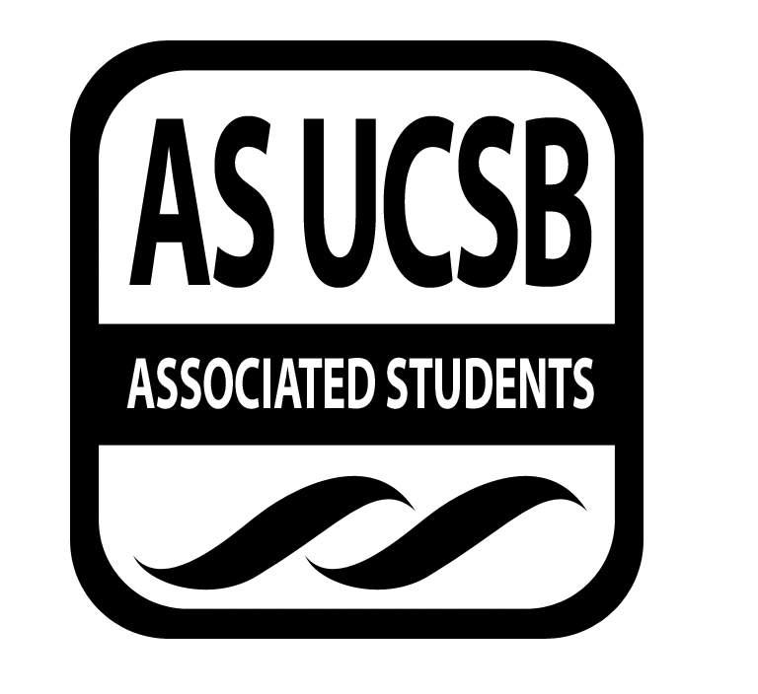
A.S. SIRRC Minutes

Associated Students
February 9, 2017 @ 6:00 pm
AS Annex Minutes Recorded By: James Fonseca

CALL TO ORDER at 6:04 by Lorena Alvarez

A. MEETING BUSINESS
- Roll Call

Name | Note:  absent (excused/not excused)  arrived late (time)  departed early (time)  proxy (full name) | Name | Note:  absent (excused/not excused)  arrived late (time)  departed early (time)  proxy (full name)
Lorena Alvarez | Present | Bryan Garcia | Present
Josh Hudson | Present | Mara Tinajero | Present
Michelle Martinez | Proxy | James Fonseca | Present
Ernesto Jimenez | Present | Renata Rodriguez | Present
Julia Hsueh | Present
Joseph Rico | Present | Lesly Silva | Excused
 |  | Jonathan Lopez | Present
Carmen Garcia | Present

A-2. Acceptance of Excused Absences
Motion to make Sal a proxy for Michelle. Carmen/Joseph. Lorena calls to question. Renata calls consent. No objections to consent; motion passes.
Additional approval required: YES Senate
B. PUBLIC FORUM
  - Announcements/Information/Introductions/ Ice Breaker
  - Testimony for items on today’s agenda (out of order)
    - Ice Breaker- “Extreme Rock-Paper-Scissors”
    - Break-out Groups
    - Announcements
    - Voting
  - Appreciations/Concerns
  - Request to have item added to today’s agenda
- REPORT ITEMS
D-1. Retention-
-Talked about how Page Plus went
-Discussed possible ideas for future socials
D-2. Recruitment-
-Discussed details for CAMP
- Date for event is March 7th
Talked about FAFSA workshop at San Marcos
- New Business
Additional approval required: YES Senate
Reimbursements
Motion for Anthony for$27.54 for buying pizzas for the first meeting. Lorena/Carmen. Sal calls to question. Jerry calls consent. No objections to consent; motion passes.

Motion for jerry for$26.88 for gas spent driving to and from the Winter Retreat. Mara/Sal. Carmen calls to question. Jose calls consent. No objections to consent; motion passes.

- REMARKS
- Study Jam is tonight at 9 at the SRB
- Just Dance social will be postponed to a later date
- Social Justice Jeopardy at San Miguel at 7pm
- Latinx in the Workforce event tomorrow at the MCC at 6pm
- Vagina Monologues have a show tomorrow and Saturday
- Free Valentines Day photos at the lobby at the Ucen The 13th and the 14th from 12-4
- Women of Color Conference
- Pre-screening of Get Out
- Hermanas Unidas Sharkeez Fundraiser. Tickets are $5 and you can buy them from Hermanas members
- John Legend is coming to Santa Barbara Feb. 27th
ADJOURNMENT
MOTION/SECOND to ADJORN: James/Sal
ACTION: Vote: 13-0 to APPROVE
Vote Taken: 7:00 pm

