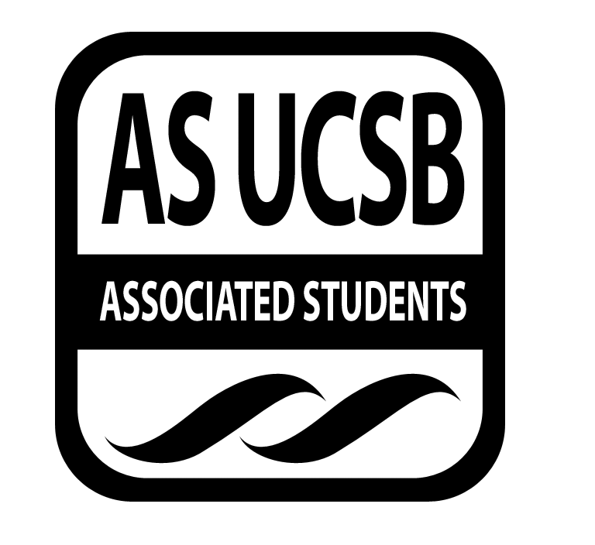AS SIRRC Agenda

Associated Students
February 5, 2015 6:00 pm
AS Annex Minutes recorded by: Eric Rubio
CALL TO ORDER

A. MEETING BUSINESS
- Roll Call

Name | Note:  absent (excused/not excused)  arrived late (time)  departed early (time)  proxy (full name) | Name | Note:  absent (excused/not excused)  arrived late (time)  departed early (time)  proxy (full name)
Mariana Cruz-Garcia | Present | Cairo Briceño | Present
Oscar Gutierrez | Present | Josh Hudson | Present
Carmen Mares | Present | Ariana Munoz | Arrived Late (6:15)
Joselyne Matamoros | Present | Janette Ruano | Present
José Javier Mendoza Magana | Absent (excused) | Eric Rubio | Present
José Javier Mendoza Magana | Absent (excused) | Nelson Monge | Present

B. PUBLIC FORUM
  - Announcements/Information/Introductions/ Ice Breaker
  - Testimony for items on today’s agenda (out of order)
    - Ice Breaker
    - Break-out Groups
    - Announcements
    - Voting
  - Elections for new Community Builder
  - Budget Requests

- REPORTS
- Recruitment Report
  - Mentee College Trip- The college trip will be going to UC
Berkeley, SFSU, and Stanford University on May 8th Saturday and May 9th Sunday
  - FAFSA Workshop will be next Thursday February 12th
- Retention Report
  - GSO- signed contract for Anacapa July 21-25th. This is during
Week 5 of Session A in the Summer Quarter.
  - Discussed how to obtain more members for next quarter.

- ACTION ITEMS

D-1. New Business:
- Sigma Chi Omega: Multicultural Show “Around the World”
17th annual Multicultural Show. Need money to bring the acts. Venue was covered by AS funding. The show will take place on February 21st, 2015. Open to general public, free admission.
MOTION/SECOND: Josh/Cynthia
Mariana motions to fund the Sigma Chi Omega $150 for their Multicultural Show
Jocelyn calls to question. Carmen calls consent.
There is no objection to consent. Motion passes.
Additional approval required: YES Senate

- NASPA Undergraduate Fellows Program
Starting an open delegation to go the national conference in New Orleans. They are now taking applications for people who would like to go and learn and develop a network and then use that knowledge to give back to the UCSB community.
MOTION/SECOND: Oscar/Janette
Mariana motions to fund NASPA $150 for their National conference
Josh calls to question. Carmen calls consent.
There is no objection to consent. Motion passes.
Additional approval required: YES Senate
- Zero Waste Committee
The Zero Waste Committee needs to get paid $31.15 for supplies provided.
MOTION/SECOND: Cynthia/Josh
Mariana motions to pay $31.15 to the Zero Waste Committee
Carmen calls to question. Jocelyn calls consent.
There is no objection to consent. Motion passes.
Additional approval required: YES Senate
- Cash advance for Josh Hudson
Josh Hudson is requesting a cash advance of $115 to reserve a spot on the beach for the BBQ.
MOTION/SECOND: Oscar/Ernesto
Mariana motions to grant a cash advance of $115 to Josh Hudson.
Carmen calls to question. Ariana calls consent.
There is no objection to consent. Motion passes.
Additional approval required: YES Senate

- Reimbursement for Mariana Cruz-Garcia
Mariana is requesting to get reimbursed $48.60 for the pizza bought for the Study Jam.
MOTION/SECOND: Carmen/Ricardo
Cairo motions to reimburse Mariana the $48.60 she spent on the pizza.
Josh calls to question. Ernesto calls consent.
There is no objection to consent. Motion passes.
Additional approval required: YES Senate

- Reimbursement for Eric Rubio
Eric Rubio is requesting to get reimbursed for the scantrons and bluebooks bought for the study jam.
MOTION/SECOND: Ernesto/Kimberly
Mariana motions to reimburse Eric Rubio the $38.08 spent on the scantrons and blue books.
Josh calls to question. Carmen calls consent.
There is no objection to consent. Motion passes.
Additional approval required: YES Senate
- Reimbursement for Cairo Briceno
Cairo Briceno is requesting to be reimbursed $115.00 for the food provided at our Winter Retreat.
MOTION/SECOND: Nelson/Carmen
Mariana motions for Cairo to get reimbursed $115.00 for the food provided.
Arianna calls to question. Ricardo calls consent.
There is no objection to consent. Motion passes.
Additional approval required: YES Senate

- DISCUSSION ITEMS
- AS Olympics- February 8th from 1:00 to 4:00
- Valentines themed gift exchange. $10 limit for the gift.
- Community Builder Election The two candidates for the community builder election are Ricardo Leon and Leyda Alvarado. Ricardo won the election for the Community Builder position. Training will start immediately.
- Relay for Life- Overnight community event to walk for cancer awareness. If interested in joining the SIRRC team please contact Carmen.
- CLOP Fundraiser- Next Wednesday, February 11th, there will be a fundraiser for CLOP all day at Sushiya.
- Lambda Theta Phi Interests- selling raffle tickets for a $40 dollar gift card to the UCSB Bookstore.
- SIRRC Study Jam -today at the SRB multipurpose room. All officers must attend this event

ADJOURNMENT

MOTION/SECOND to ADJOURN: Janette/Josh
ACTION: Vote: Consent
Vote Taken: 7:21

