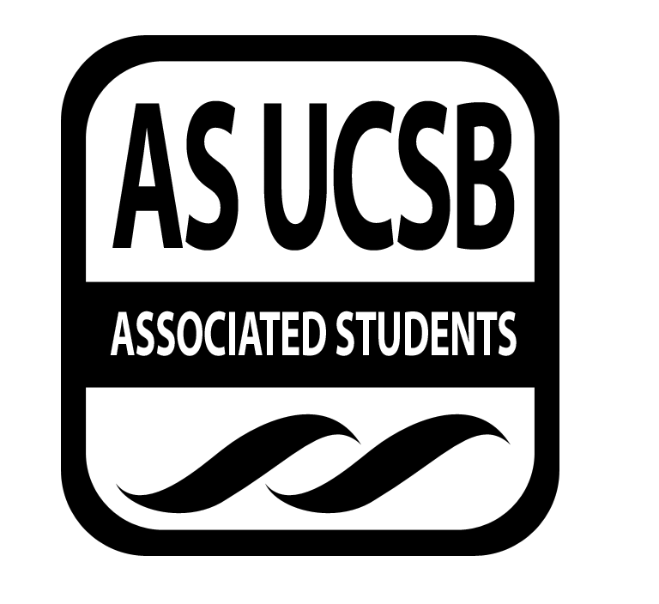
SIRRC Officer Meeting Minutes

Associated Students

October 15, 5:00 PM
A.S. ANNEX Minutes/Actions recorded by Ximena, secretary

CALL TO ORDER 5:05 PM, Mariana

A. MEETING BUSINESS
- Roll Call

Name | Note:  absent (excused/not excused)  arrived late (time)  departed early (time)  proxy (full name) | Name | Note:  absent (excused/not excused)  arrived late (time)  departed early (time)  proxy (full name)
Mariana Cruz-Garcia | Present | Josh Hudson | Present
Cairo Briceño | Present | Carmen Mares | Present
Oscar Gutierrez | Present | Janette Ruano | Present
Joselyne Matamoros | Present | Nelson Monge | Present
Ximena Garcia | present | Jennifer Argueta | Unexcused absence

B. PUBLIC FORUM
  - Announcements/Information/Introductions
    - Co-chair, Mariana Cruz-Garcia: Officers, please email your office hours to the Secretary as soon as possible.
    - Senate liaison Hiro Bower’s office hours are in A.S. Main on Tuesday 2-4 pm and in the Pardall Center on Wednesday 2-4 pm.
    - Above Bagel Café, there is a voter registration and volunteer office if anyone is interested in helping the IV community register to vote.
    - Do not forget to vote on November 4th.
    - IDEAS will be selling smoothies and nachos in front of the SRB tomorrow.
    - Applications for the Student of Color Conference is Oct 21st. The conference is November 7-9.
    - Senate liaison Paola de la Cruz’s Wednesday 1-3 in A.S. Main, Wednesday 3-4 in Pardall Center
  - Testimony for items on today’s agenda (out of order)
  - Appreciations/Concerns
  - Request to have item added to today’s agenda

- REPORTS

Retention—This past Sunday, only 4 or 5 pairs of mentors and mentees got to meet each other. Upcoming (tentatively dated) mentor-mentee activities are hiking on Wednesday Nov 1st and bowling on Sunday November 5th. These two dates are likely to change. Kimberly, Julie, and Cynthia are interested in being Book Bank Coordinators.

Recruitment—I am trying to get a college counselor or admissions counselor to speak at La Caza de la Raza on Wednesday at 5:30 pm. Since this location is off-campus, there are extra issues. Volunteers from SIRRC should take their laptops to help the high school students with their online college applications. Wednesday Nov 5th 6-8 pm is the College Fair. All juniors and seniors in the area were mailed an invitation to go to the College Fair at Earl Warren Showgrounds. I am still waiting for the Assistant Principal from Goleta Valley Jr High School to get back to me concerning their interest in setting up a mentorship program. On October 25th, SIRRC will have a booth at Children’s Park for Safe Halloween. I had the idea of a game called “Pin the Pumpkin,” similar to “Pin the Tail on the Donkey.” Concerning the open position ‘Recruitment co-chair’ only one person discussed candidacy with me.
Mariana: There were 5 people that signed up as candidates.
Some good questions to ask candidates: 1. Do you have a car? 2. Do you have any experience working with high schoolers? 3. What would you do if a GUIDES high schooler is not cooperating?

Publicity—Please let me (Joselyne) know if anyone wants the language or information about Recruitment and/or Outreach on the website changed. Also, tell both publicity co-chairs your office hours and if you want a different or preferred email address on the SIRRC website. Cairo: Judy Ann can answer questions about the website, particularly concerning WordPress.

Treasurer—All I had to was talk to Cindy about switching financial accounts.

Senate Liaison, Hiro Bower—The A.S. wide code of conduct is currently being drafted. After this meeting, there will be an open forum. Senators will be posting a sign of everyone’s office hours in The Hub. The founder of the LIFT foundation gives $10,000 scholarship to a college student every year for four years and combines that with mentorship. The founder was interested in talking to SIRRC and collaborating and contributing financially since their missions are similar. Paola and I need to update the SIRRC legal code and SIRRC can have as much of an input and influence as they like. Cairo: I am not sure if we can accept funds from outside sources since SIRRC is a Unit. We will have to check the by-laws.

Mariana: Hiro, would you please keep SIRRC updated on the goings-on of Senate meetings.
Cairo:I was contacted by Jocelyne Garcia from USSA because USSA is focusing on recruiting and retaining college students, particularly student of color. She wants SIRRC to run the UCSB campaign on recruitment and retention. The SIOP committee and the Chancellor’s Committee on Outreach wants Mariana and I to sit on those committees so she and I are waiting to see which meetings work best with our schedule. Mariana and I spoke with the A.S. Food Bank Chair on how our two organizations can better collaborate and concluded that SIRRC should have an A.S. Food Bank liaison. That position will be open to the SIRRC general body. I told them that SIRRC members would help them with their events. A.S. Food Bank also wants to throw events for I.V. families. Outreach and Recruitment could tutor UCSB students while the Food Bank gives a talk or has a workshop on food justice and healthy eating.
Mariana: The Food Bank will allow SIRRC to publicize its events at their location.

Cairo: Twinn and Mahader were instrumental in helping SIRRC set up the book bank and food bank. With Mahader absent, Twinn has stepped up to help SIRRC set up S.P.E.C.

F-2 New Business

Impeaching the current Community Builder for lack of involvement
MOTION/SECOND: Nelson/Josh
I motion to impeach our current Community Builder, Jennifer Argueta.
Oscar: If she stopped communicating with SIRRC completely then she might not fulfill her position duties either.
Carmen calls to question.
Oscar consents.
CONSENT-YES

ADJOURNMENT

MOTION/SECOND to ADJOURN: Cairo/Oscar
Carmen consents.
CONSENT-Yes
Vote Taken: 5:48

