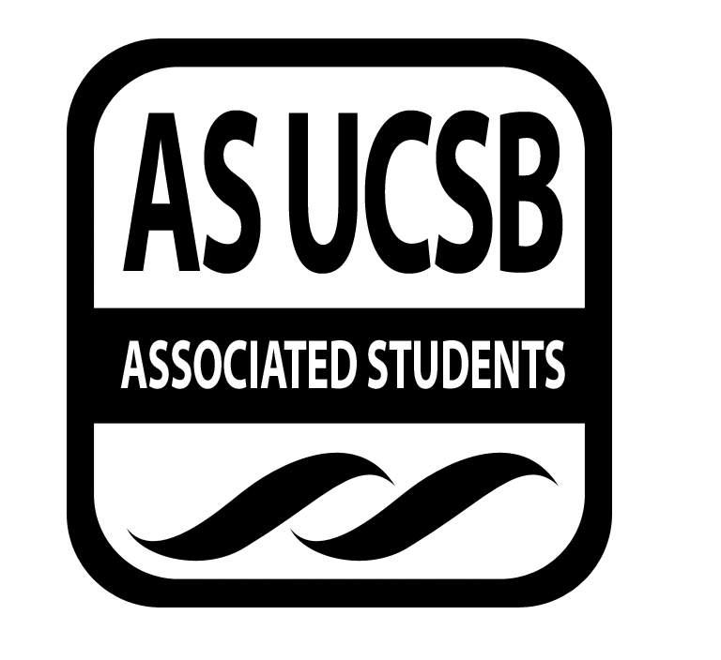
A.S. SIRRC Minutes

Associated Students
January 26, 2017 @ 6:00 pm
AS Annex Minutes Recorded By: James Fonseca

CALL TO ORDER at 6:03 by Lorena Alvarez

A. MEETING BUSINESS
- Roll Call

Name | Note:  absent (excused/not excused)  arrived late (time)  departed early (time)  proxy (full name) | Name | Note:  absent (excused/not excused)  arrived late (time)  departed early (time)  proxy (full name)
Lorena Alvarez | Present | Bryan Garcia | Present
Josh Hudson | Present | Mara Tinajero | Present
Michelle Martinez | Present | James Fonseca | Present
Ernesto Jimenez | Present | Renata Rodriguez | Present
Julia Hsueh | Present | Stella Au | Present
Joseph Rico | Present | Lesly Silva | Excused
Anthony Lai | Proxy | Jonathan Lopez | Present
Carmen Garcia | Present

A-2. Acceptance of Excused Absences
Motion to make Ulises proxy for Anthony. Lorena/Joseph. Jose calls to question. Sal calls consent. No objections to Consent; motion passes.
Additional approval required: YES Senate
B. PUBLIC FORUM
  - Announcements/Information/Introductions/ Ice Breaker
  - Testimony for items on today’s agenda (out of order)
    - Ice Breaker- “Baby I Love You”
    - Break-out Groups
    - Announcements
    - Voting
  - Appreciations/Concerns
  - Request to have item added to today’s agenda
- REPORT ITEMS
D-1. Retention-
Page Plus Updates
- Everything is progressing as planned.
-Event Page is made. Spread the Word!
- Volunteers will be fed if they help with either set up or clean up.
D-2. Recruitment-
Updates
-February: Will hold a financial Aid workshop
-Discussed about CAMP and where they will take the high school students.

Action Items
Funding Requests
Southeast Asian Union- April 15th-16th will hold a youth conference with the purpose of providing low-income high school students the opportunities to give them the opportunities to experience life at a University setting. They are asking for $178 to cover supplies for the workshops.

American Indian Student Association will hold a program called STANDS, which helps provides an opportunity to reach out to Native American middle schools and high school students from different tribes to give them an opportunity to experience life at a higher education environment and help educate about the value that education has to help protect their sovereignty and their communities.

- New Business
Funding Requests

Motion to give Southeast Asian Union $200 for workshop materials. Jhan/Daniel. Betty calls to question. Carmen calls consent. No objections to consent; motion passes.

American Indian Student Association: Motion to give them $500 for T-shirt order for STANDS. Lorena/Renata. Sal calls to question. Xally calls consent. No objections to consent; motion passes.

Cash Advance for $400 to Julia for Winter Social. Xally/Michelle. Jhan calls to question. Jose calls consent. No objections to consent; motion passes.

Cash Advance for $500 for Renata for ordering textbooks for the bookbank. Xally/Lorena. Sal calls to question. Betty calls consent. No objections to consent; motion passes.
Reimbursements
$25 to Christina Mitine for fingerprinting and scanning for GSO. Betty/Joselyne. Sal calls to question. Jose calls consent. No objections to consent; motion passes.

$25 for Jenson Wang for fingerprinting for GSO. Joselyne/Ernesto/Nat. Sal?.Mara calls consent.

$25 to Joselyne for fingerprinting and scanning. James/Jhan. Stella calls to question. Renata calls consent. No objections to consent; motion passes.

$21.65 for pizza for San Marcos Mentorship program. Lorena/Sal. Eric calls to question. Julia calls consent. No objections to consent; motion passes.

$54.27 for bookbank supplies. Betty/Sal. Michelle calls to question. Daniel calls consent. No objections to consent; motion passes.
Additional approval required: YES Senate

- REMARKS
-Study Jam is Next Week
CSO Bike Sale tomorrow from 12:30-4:00pm in front of the SRB. Will need a 50$ fee
-CLG: Packages are starting $100 Until Wednesday Feb 5th
-EOP Application open until Feb 1st
O-Staff application open until Jan. 30th
McNair Application open until Feb 2nd
-Tuesday Feb 7th on campus job and internship fair 4-5:30pm at the SRB multipurpose room
-LEAD fundraiser at Hana Kitchen from 9-10pm
Dia De La Red Social- Next Monday from 5-7pm at the SRB MPR
-La Escuelita fundraiser Monday Jan 30th
-LOTP job information meeting Feb 1st at Embarcadero hall 7-10pm
ADJOURNMENT
MOTION/SECOND to ADJORN: Sal/Carmen
ACTION: Vote: 13-0 to APPROVE
Vote Taken: 7:11 pm

