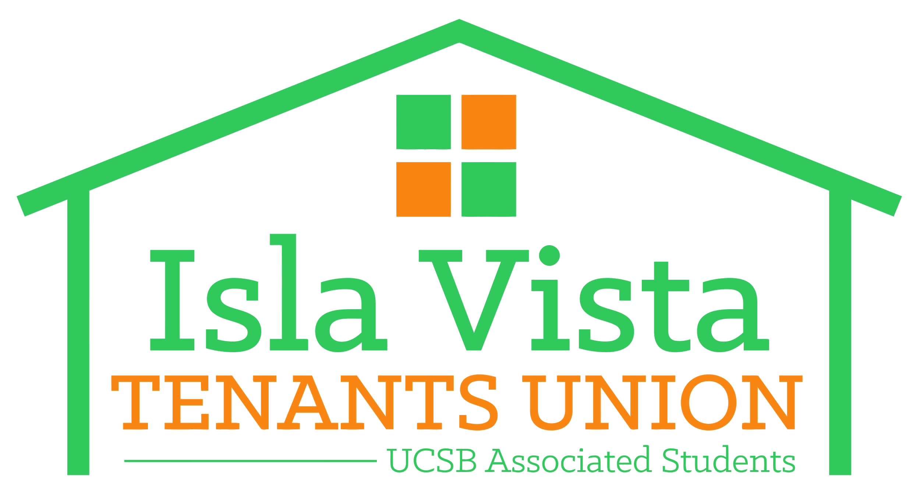
IVTU Position on Landlord Abuse
The Associated Students (AS) of the University of California, Santa Barbara, is a non-profit organization and department of the UCSB campus, funded by undergraduate student fees. A.S.’s Isla Vista Tenants Union states in its Mission that it “is an organization serving the interests of Isla Vista tenants. We recognize the diversity of our community, and we strive to meet the different needs of our members while uniting our common interests as tenants...” The Isla Vista Tenants Union has provided much needed housing-related services to students and all members of our community through education, advocacy and grassroots organizing.
Isla Vista is a small unincorporated town in the Santa Barbara County adjacent to the world-renown University of California at Santa Barbara and near the Santa Barbara City College among other private universities and colleges. Isla Vista has experienced an influx of very young and college-going millennials from all-walks of life who live in very expensive, yet substandard housing units. Also, immigrant families, international, and houseless people call Isla Vista their home. However, housing is controlled by a few large corporations and multimillionaire landlords who have overstepped their legal boundaries.
The Isla Vista Tenants Union has assisted many students and members of the community who deal with pervasive housing injustices from a handful of landlords, or poorly-trained “onsite managers,” in our community. When tenants assert their legal rights, they are often treated as “trouble-makers.” All tenants, and co-tenants, have legal rights and protections under the law. The Isla Vista Tenants Union unequivocally opposes all landlords or agents of landlords who harass or intimidate their tenants. For example, landlords cannot retaliate against tenants by making excessive deductions to security deposits.
The videotaped remarks made by James Gelb, the owner of Del Playa properties, one of the largest property owners in Isla Vista, to Ethan Bertrand, a community leader and tenant of Isla Vista, cannot go without comment and condemnation. The homophobic verbal abuse that was displayed on the video stands against the most basic principles of our community.

While Mr. Bertrand is not a tenant of Mr. Gelb’s, the recorded exchange appears to be representative of numerous interactions between Gelb and his tenants, in fact numerous videos and texts depicting altercations between Gelb and Isla Vista tenants have been published online. The Isla Vista Tenants Union strongly believes that no person should endure abuses in any form or shape regardless of race, class, sexual orientation or other protected status. This apparent pattern of abusive behavior is unacceptable and we believe more must be done to protect the rights of tenants in Isla Vista and all our communities.

We stand with Ethan and all other members of our community who have been subjected to these patterns of behavior. We condemn all disrespectful and disparaging communications between landlords and tenants. In addition, we support tenants rights to speak and organize against unjust housing conditions.

Signed by
The Board Members of the Isla Vista Tenants Union

[1] For an excellent detailed discussion on housing in Isla Vista see Burns, Melinda. “Isla Vista: Investor’s Paradise, High Rents, “Captive Demand” Make for Upscale Market in Rundown Community.” The Santa Barbara Independent, June 15, 2015. http://www.independent.com/news/2015/jun/11/isla-vista-investors-paradise/ Accessed November 15, 2017.

