Queer Commission Minutes

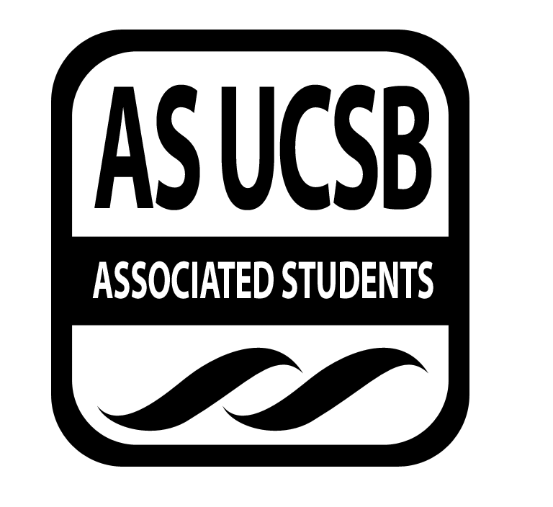
Associated Students
February 24, 2014 7:00 PM; Pardall Center in IV
Minutes recorded by: Ryan Orihood, Queerstorian

CALL TO ORDER: 7:00 by Andrew, Co-Chair

A. MEETING BUSINESS
- Roll Call (Pre-entered Names)

Name | Note:  (note if non-voting) | Name | Note:
Chris Buck |  | Shane Stringfellow
Andrew Farkash |  | Derek Wakefield
Melba Martinez |  | Danielle Patterson
James Neally
Ryan Orihood
Christian Perez
Ariana Rodriguez
Cristina Roman

B. PUBLIC FORUM
  - Ice Breaker: Name, Year, Major, Something about your weekend
  - Announcements
    - QSU Meeting: Tomorrow, 7 PM @ State St Room in UCen
    - May 5: Professional Drag Show
    - Meningitis vaccines at the Multi-Activity Court (MAC)
    - De Colores open meeting: Wednesday, 8 PM @ RCSGD
    - Adelina Anthony: Thursday, 7:30 PM @ IV Theater

- ACTION ITEMS/FUNDING REQUESTS

F-1. Old Business: N/A

F-2 New Business: N/A

- OFFICER UPDATES
Andrew
- Lock in cancelled – one week left and only 1000 signatures
- Going to Senate to get on ballot
- Would need 60% of vote – campaign!!
- Please feel free to pursue any projects you wish (Pride and campaign are always welcome!)
- Attended Nehirim in Boston
  - UCSB comprised large number of conference!
  - Diverse identities of attendees
Shane
- Registration for Transgender Leadership Summit (April 11-13)
Melba
- QPOC: May 2-3 @ SD State
- Free registration, interest meeting before end of quarter
Ryan
- Soc 145 peeps: design a flyer/board for campaign
- Attended Nehirim in Boston
Derek
- Restructure coming up, check Senate agenda
- “A Resolution to Mandate Warnings” - trigger warnings mandatory for classes
Cristina
- Attended Facing Race
Chris
- Planning several Pride events!
- Reconstructing the Rainbow conference at UOP
  - Half the attendance advertised
  - Disappointed in lack of qpoc and trans spaces/workshops
James
- Gaymer con in July
- Campaign for QComm and Pride!

ADJOURNMENT: 7:44 by James, Co-Chair

