Queer Commission Minutes

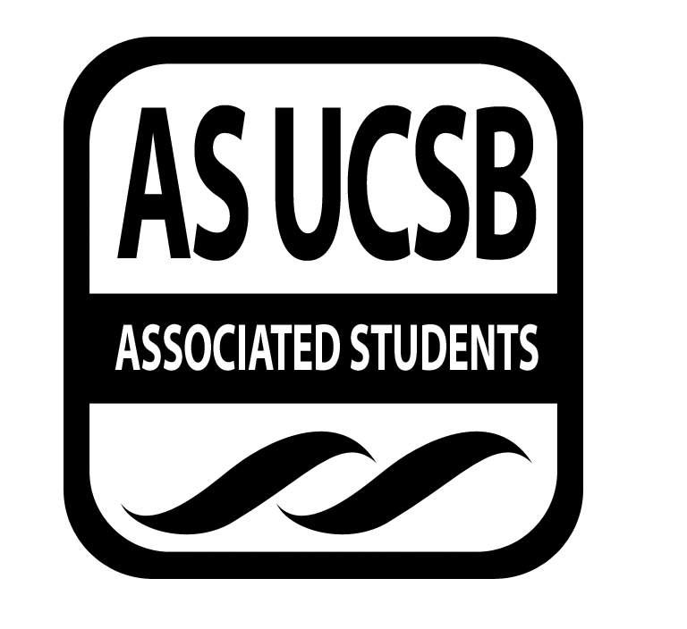
Associated Students
April 21, 2014 7:00 PM; Pardall Center
Minutes recorded by: Ryan Orihood, Queerstorian

CALL TO ORDER: 7:06 PM by James, Co-Chair

A. MEETING BUSINESS
- Roll Call (Pre-entered Names)

Name | Note:  (note if non-voting) | Name | Note:
Chris Buck |  | Shane Stringfellow
Andrew Farkash |  | Derek Wakefield
Olivia Miller
James Neally
Ryan Orihood
Christian Perez
Maira Nuyen | Non-voting
Cristina Roman

B. PUBLIC FORUM
  - Ice Breaker: Name, Year, Major, What’s your Patronus/Spirit Animal
  - Announcements
    - TBTN Rally: Tuesday, 5 PM @ Anisq’Oyo Park
    - QSU meeting: Tuesday, 7 PM @ State Street room
    - FUQIT S’mores: Thursday, 8 PM @ RCSGD
    - Pride is in 2 weeks!

- ACTION ITEMS/FUNDING REQUESTS

F-1. Old Business: N/A

F-2 New Business:

Motion to fund $104.05 to End Fake Clinics Pride Workshop
MOTION/SECOND: Neally/Orihood
Andrew calls to question
Cristina consents
ACTION: Consent, APPROVE, motion passes to fund Pride
Additional approval required: YES, senate
Motion to fund $117.75 to QComm Elections Board and Paint
MOTION/SECOND: Buck/Farkash
Cristina calls to question
Ryan consents
ACTION: Consent, APPROVE, motion passes to fund QComm
Additional approval required: YES, senate

Motion to fund $60.24 to QComm Operations: Flag and Flyers
MOTION/SECOND: Neally/Orihood
Ryan calls to question
Chris consents
ACTION: Consent, APPROVE, motion passes to fund QComm
Additional approval required: YES, senate

Motion to fund $2965 to Pride Shirts
MOTION/SECOND: Neally/Farkash
Chris calls to question
ACTION: Vote, 6-0-1 APPROVE, motion passes to fund Pride
Additional approval required: YES, senate

ADJOURNMENT: 8:42 PM by James, Co-Chair

