Queer Commission Minutes

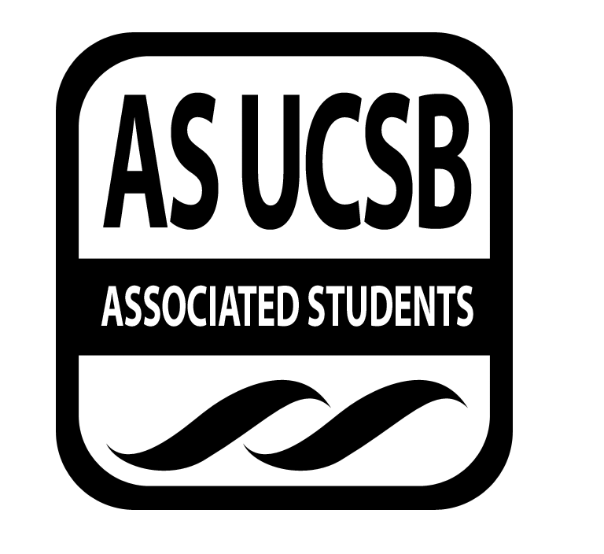
Associated Students
November 18, 2013 6:00 PM; 2nd floor of MCC
Minutes recorded by: Ryan Orihood, Queerstorian

CALL TO ORDER: 6:07 by James, Co-Chair

A. MEETING BUSINESS
- Roll Call (Pre-entered Names)

Name | Note:  (note if non-voting) | Name | Note:
Chris Buck
Derek Wakefield
Jeremy Ginsberg
James Neally
Ryan Orihood
Christian Perez
Ariana Rodriguez
Cristina Roman

B. PUBLIC FORUM
  - Ice Breaker: Name, Year, PGPs, Best/Worst/Strangest gift you’ve ever received
  - Announcements
    - QAPI Catch Phrase: Tonight 7 PM @ RCSGD
    - MANversations: Tonight 8 PM @ Santa Rosa Formal Lounge, San Raf Tower Lounge, San Cat Fiesta Room, Santa Ynez Gibralter Community Center

- ACTION ITEMS/FUNDING REQUESTS

F-1. Old Business: N/A

F-2 New Business:

Motion to fund $500 for hotel and meet-and-greet for Mary Lambert @ The Hub
MOTION/SECOND: Neally/Wakefield
Ryan calls to question
ACTION: 7-0-1, APPROVE, motion passes to fund PAVE
Additional approval required: YES, senate

Motion to fund $2571.37 to Keshet for Nehirim Conference
MOTION/SECOND: Buck/Wakefield
Ryan calls to question
Ryan consents
ACTION: Consent, APPROVE, motion passes to fund Keshet
Additional approval required: YES, senate

- OFFICER UPDATES
Andrew
- Lock in fee intent form sent in - $2 that would give $75K budget. Reaffirmed every 2 years, Senate can’t slash it. This is a great opportunity to get the word out about QComm
- Sexuality/Gender GE: master list of classes
- TABLA Conference registration due December 6th
- Against Equality US Tour – something QComm wants to do?
Shane
- Safe Zone-ing cab on Wednesday
- Evaluations for Safe Zone presentation
- Delegation for T Camp: January 3rd – 5th
- Workshop on Heterosexism and Cissexism – suggestions for blog articles welcome!
- Creating Change: 5 day conference end of Jan/beginning of Feb in Houston. Costly!
Cristina
- Ask a Queer – postponed until winter quarter
- Draft for staff letter for Gender/Sexuality GE
- Students assigned for professors to get support for gender/sexuality GE
Ariana
- QLC happening this week! Date TBA
Derek
- Gender/Sexuality GE: once professors support, draft resolution for Senate.
Ryan
- Gender/Sexuality GE letter
- Yoga Conference: UC Berkeley, April 25th
- Affirmation, Gay and Lesbian Mormons: Spring
Chris
- Reconstructing the Rainbow conference, UOP: February 21st
- Winter Wonder Drag: January 16th. Requested event staff, ticket sales as soon as winter quarter starts
James
- Eucalyptus: 3 professors, directors of RCSGD, PPF. Talked about gender neutral restroom policy (all new building projects at least one gender neutral restroom), update about QComm/lock in fee

ADJOURNMENT: 7:01 by James, Co-Chair

