Program Board Agenda

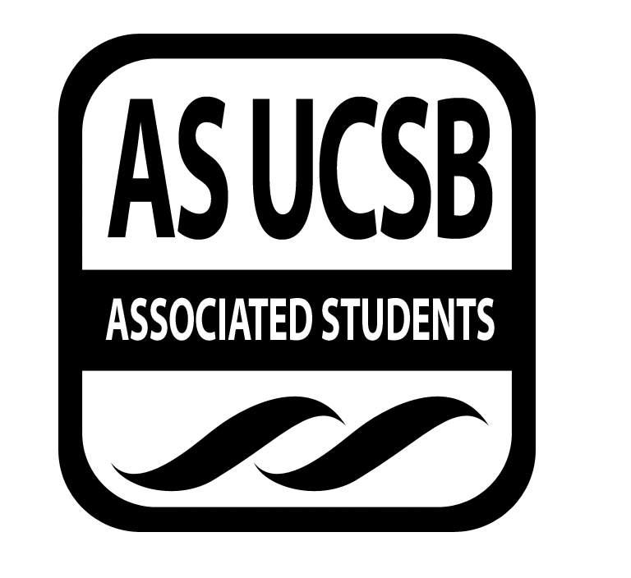
Associated Students
June 2nd, 2014, 5:00PM
SB Harbor Room
CALL TO ORDER: 5:02PM

A. MEETING BUSINESS
- Roll Call
Name | Note:  absent (excused/not excused)  arrived late (time)  departed early (time)  proxy (full name) | Name | Note:  absent (excused/not excused)  arrived late (time)  departed early (time)  proxy (full name)
Adi Sharma |  | Jena Pruitt
Amalia Gudino |  | Justin Stasiuk
Alex Hubert |  | Karen Masumoto
Ben Simons |  | Kimia Hashemian
Brandon Pineira |  | Leonardo Vargas
Charly Chambers |  | Omar Miranda
Chioma Nwuzi | absent | Sean Nolan
Chris Cubbison |  | Sophia Barkhudarova
Christina Laskorunsky |  | Serena Sogules
Chrystal Anderson |  | Tyler Washington
Colton Bentz | absent | Zach Barrett

- Acceptance of Excused Absences and Proxies
MOTION/SECOND: Hubert/Pineira
Motion language: Motion to accept Leo and Sean’s lateness as well as Chioma, Colton, Kimia, and Tyler’s absence.
ACTION: Vote: 14-0-0 to APPROVE

B. ACCEPTANCE of AGENDA/CHANGES to AGENDA
MOTION/SECOND: Hubert/Pineira
Motion language: Motion to accept agenda as amended.
ACTION: Vote: 14-0-0 to APPROVE

C. ACCEPTANCE of ACTION SUMMARY/MINUTES
1. Approval of our Action Summary/Minutes
MOTION/SECOND: Cubbi/Stasiuk
Motion language: Motion to approve minutes from two weeks ago, May 19th, 2014
ACTION: Vote: 14-0-0 to APPROVE

D. PUBLIC FORUM

E. ANNOUNCEMENTS
Cubbi- Wordstock got canceled. They’re doing a mini Wordstock Wednesday night at Gio’s.

F. WEEK IN REVIEW
1. Mean Girls (5/20)
Laskorunsky- Had a pretty small turnout, passionate but small. 21 people in the first show and 120 in the next. People wore pink. It was awesome.
2. Shlohmo @ The Hub (5/21)
Cubbi- Originally we were worried about what time they were going to show up because they planned on leaving L.A. pretty late. They were really easy to work with. Probably one of the easiest Hub shows to work. The final turnout was about 480 people. Happy with this for being a Wednesday. There was a really calm crowd.
Chambers- Crowd was into it. Really well done.
Simons- sets the precedent that we can still do something after Extravaganza.
Gudino- should probably look into how close to Extravaganza we do a Hub show. A lot of us tend to fall behind on school work because of X, so we need to take that into consideration. Other than that, it’s a good idea to follow up X with another show.
3. Reel Loud Film Festival (5/23)
Nolan- It was interesting to see how people reacted. The show happened, everything went fine. Really hard to find crew when you have four shows happening around the same time. Michael was a champ. Timmy helped out. Just wanted to thank you for helping out.
Stasiuk- This was a good example of worst possible case scenario when something like what happened on that Friday occurs and we should be able to be the calm person in the room. Luckily we received information very quickly and we were able to take the right steps to ensure the safety within the theater. We should know how to react in such situations.
4. WordStock (5/24)
Nolan- Did not happened. It was rescheduled for this Wednesday at Gio’s.
5. 300: Rise of an Empire (5/27)
Laskorunsky- We decided to cancel that in light of the events. Mean Girls was perhaps the better final movie.
6. Cults @ The Hub (5/29)
Barrett- Show was canceled for obvious reasons and the show was also lacking ticket sales. We should have a set publicity plan for any of the shows that are after Extravaganza because X takes away from everything that’s going on before and after. We just need to take this into consideration. Their agent was really understanding. Still wants to work with us in the future.
Nolan- Definitely a great show, just horrible timing with the ticket sales. This show should happen at some point next year, especially since we already have a relationship with the agent.
Marilyn- we did have about $3000 in cancellation fees.
Pruitt- when thinking about doing shows after X you need to keep in mind the timeline for publicity, especially since our facebook page gets so much traction after X goes live.
7. IV Surfrider (5/31)
Chambers- that was a good event. It was well organized. It didn’t seem too full but there was a really good lineup. Good event. Cubbi came out, Ben was there.
Nolan- after everything that happened, we weren’t sure if this event was even going to happen. In the past few years every time we have Surfrider we have a good turnout.

G. PREVIEW OF THE WEEK
1. Bagel Day
Sogules- Bagel Day is happening!
Hubert- It’s the Monday and Tuesday of finals week and we buy a lot of bagels and give them out for free. Not much required on our part, other than stocking up.

H. OLD BUSINESS
- Zombie Debates
Sogules- The event got canceled due to what happened in IV. Professors were uncomfortable with the morbid concept. We should definitely consider this for next year.

I. NEW BUSINESS
- Ice Chest
Marilyn- wanted an “okay” from everybody to purchase a new ice chest due to what happened at Extravaganza.
J. ACTION ITEMS

K. FINANCIAL ACTION ITEMS
- Bagel Day
MOTION/SECOND: Sogules/Cubbi
Motion language: Motion to pass $2,000 for Bagel Day on Monday June 9th, and Tuesday June 10th.
ACTION: Vote: 16-0-0 to APPROVE
Staff/Advisor Instruction/Request: Insert if Applicable
Responsible for Follow-through: Serena
Additional approval required: YES (Senate)

- Ice Chest
MOTION/SECOND: Pineria/Cubbi
Motion language: Motion to pass $50 for a new ice chest to replace the toxic waste one.
ACTION: Vote: 16-0-0 to APPROVE
Staff/Advisor Instruction/Request: Insert if Applicable
Responsible for Follow-through: Marilyn
Additional approval required: YES (Senate)

L. REPORTS

Thursday Page/Slides
The Marilyn Report –good luck to everyone as they move on with their careers. Come by when you’re in town. Remind everyone to join the Program Board Alumni Page. Claudia on payroll is retiring. Come to the barbecue on June 27th.

The Commissioner's Report – This is my last report. Thank you all for a good year and I have a few gifts for some of you. Thank you guys for being an awesome family.
Deputy Commissioner’s Report- Feeling very Drake, nothing was the same. You all have been splendid to me and it has been a joy working with you all.
Coordinators’ Reports
Adi-
Alex- Old board, it’s been an absolute blast working with you all. Looking forward to next year. Be sure to “hit me up.” Even Omar was okay to work with.
Chioma-
Chris- Wednesday I’m playing at Gio’s. It’s been really nice working with you guys. Prior to joining I had a lot of free time and I’m thankful that I joined Program Board. It’s interesting because on Board it’s very much like passing down knowledge. Some advice: it’s always important to try something new. Always look for ways to do something new.
Christina- Program Board, you’re all the best. So happy to have met you. You’re all so cool. This isn’t goodbye yet. See you later.
Chrystal- I didn’t go to the brunch, but I’ve had a great year. I’ve learned a lot. Met some kick ass people. I’m excited for next year. If you put positive energy into the world, it will come back to you.
Jena- Stay up y’all. One love. POSTER!!!! That’s all.
Justin- Every year everyone is sad, now it’s my turn to freak out and worry about life after Program Board. Really stoked to see what you guys do next year.
Karen- Honestly, being on Program Board it has made me realize how many beautiful amazing people there are here. You are all amazing. So glad to have met you all.
Leo-
Sean- First off, I refuse to say goodbye to any of you. This is not goodbye, this is not “us” leaving and that’s it. I’d like to think that the stuff we have done here will leave a mark here. Don’t care about getting a job after this. Don’t want anybody here to see this job, our time here as a means to anything. Mainly because what we’re doing is living our lives. I really appreciate everything everybody has done here. Really want to thank you guys for caring enough. Take advantage of the time you have in this place.
Serena- Thank you for the beginning and for what’s to come.
Assistants’ Reports
Ben- This is definitely passing on tradition. We build on traditions. This is not goodbye, we are still living through this. Want to thank Cubbi for being a pioneer. You had a vision and saw it through. I’m going to miss you. Sean scared me when I first met him. It was your intuitive passion that taught me so much. Really hope that this isn’t goodbye. Want to thank Justin, you’re just a fuzzy teddy bear inside: all love. You taught me so much. You’ve always been a solid voice through everything. Thank you for promoting family through all of this.
Brandon- If I wasn’t a twenty year old assistant, I would give all of you jobs. I don’t want to never see you guys again. Let’s hang out every time you’re in the area.
Charly- It’s been a fun year. Especially Sean and Tyler, we’ve spent a lot of time together. I’m excited to see everyone. Want to thank MD for all of the work you’ve put in. Thank you and good luck with everything.
Sophia- It’s been an awesome quarter. It’s sad that half of you are leaving, but best of luck. Can’t wait to do great things next year.
Tyler- We are like a family. Honestly, my first year being on board I saw so much potential in everybody. The things that we’ve accomplished have been amazing. So excited to see what you do next year. You guys are a family. I appreciate all of you.
Zach- I think that Program Board is a big growing experience, especially for me. Always have loved music but it was never an active experience. Getting an opportunity to do this has really given me a better view of the world. It’s really something that I’m considering doing for the rest of our life.
Senators:
Colton, Kimia
ADJOURNMENT : 5:55PM

