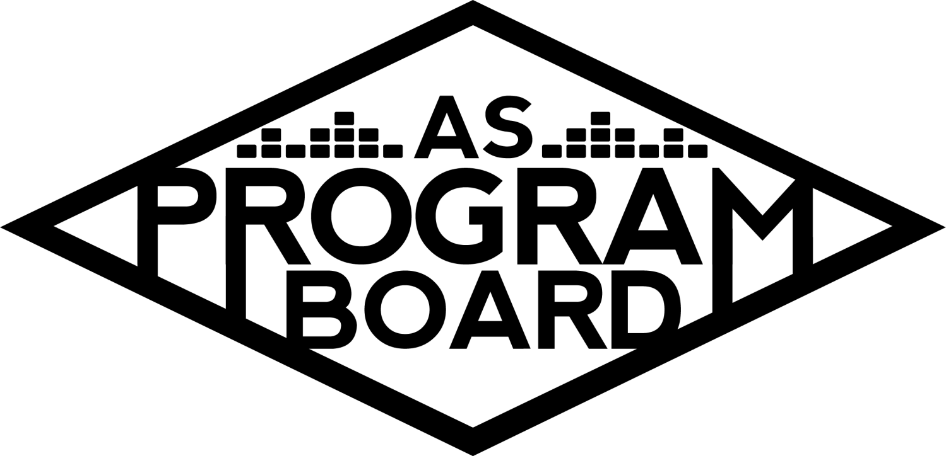
Program Board Agenda

Associated Students
April 6, 2020
Remote

CALL TO ORDER: 5:04PM by Kiyomi Morrison
A. MEETING BUSINESS
- Roll Call
Name | ote:  absent (excused/not excused)  arrived late (time)  departed early (time)  proxy (full name) | Name | Note:  absent (excused/not excused)  arrived late (time)  departed early (time)  proxy (full name)
Adam Salton
Alexis Xa |  | Kathryn Quinones
Bethel Tammerat |  | Kiyomi Morrison
Brenna Collins |  | Lucas Jackson
Brett Friedman |  | Mikio Sacramento
Carlos Aviles-Sullivan |  | Mitchell Lewis
Conner Jones | Absent | Nathaly Pacheco
Enaiya Judkins |  | Sarah Danielzadeh | Late 5:06
Erica Ko |  | Benjamin Chocron
Esteban Alvarado
Gabriel Reyes

Acceptance of excused absences, absences, early departure and proxies
Motion by Bethel, second by Nathaly. Consent with 16 present.

B. PUBLIC FORUM

C. ACCEPTANCE of AGENDA/CHANGES to AGENDA
Motion by Gabe, second by Bethel. Consent with 17 present.

D.ACCEPTANCE of ACTION SUMMARY/MINUTES
Motion by Nathaly, second by Carlos. Consent with 17 present.

E. ANNOUNCEMENTS
- Reaffirmation
  - We are up for reaffirmation this year- $16/quarter/student- students have to vote every 2 years to keep this fee
  - We do a campaign during other AS campaigns
    - Advertising ASPB and why they should reaffirm

F. WEEK IN REVIEW

G. PREVIEW OF THE WEEK

H. OLD BUSINESS
- Remote Programming Ideas- we want something before 4/23
  - Movies
    - Looking into swank for academic films but they are strict about it being “academic”
    - Reached out to the MCC because they’re still doing films- they’re using zoom with split screen function but swank was adamant that zoom can’t be used
    - Hoping to get around home rights issue- good faith
    - Want to get newer movies but can look into older ones
    - Netflix party- can’t use it with that many people
  - Podcast
    - Came up with ideas but realized they would overlap with other groups- thinking of interviews and short performances
    - Nat has a bunch of phone calls with agents tomorrow
    - Anchor- app to upload to Spotify. But some podcasts may be better on Youtube with a visual performance
      - Will also need someone to edit podcasts
    - Also have university webinar platform- can host up to 5000 people, login with school ID
      - Or google meet
      - Speaker logs in from home
    - Improvability has been letting people ask questions on their instagram and they are posting things they’re doing
      - Each coordinator/assistant could take over the instagram and talk about their position
    - Could look into making podcasts into more of a series
    - Need to make podcasts as specific as possible to the student body since a lot of artists are already doing live streams
    - We could post audio of us talking with someone
    - Call tomorrow to discuss podcast/youtube
    - Results from instagram vote from students
      - Bingo, concerts, playlists
  - Playlists
    - Made a spreadsheet with different playlist ideas- everyone in committee will be responsible for updating a different playlist
      - Will be updated every Wednesday
      - Can include one for student submissions
    - Students will have access to all of them all the time
    - Playlist covers- do we want to make graphics for the covers?
      - Can include people outside of graphics because it’ll be a lot of work
    - Used to use split 4 image cover Spotify makes and posted them on the Instagram
    - Updating them on different days of the week?
      - Think people won’t pay as much attention to them unless they’re all done on the same day
      - Can feature them on random days on socials
  - Workshops
    - Reached out to some people for workshops but it’s difficult because a lot of classes are premade. Reached out to online artists.
    - DJ workshops- A lot are with Paradigm and haven't responded yet
      - Want us to pick our top 4 performers
    - UCSB professors for workshops?
      - AS annex does workshops-we could help them out- they are planning them virtually
      - Could also have students to them
      - Looking into art (digital painting), cooking

  - Lectures/Comedy
    - Agents are booking people for lower than asking but prices are still high. Able to host 3000 person live streams and moderate them (UTA only). Dates aren’t really an issue
      - Can try to negotiate prices. We are also going to be providing the platforms so they won’t need to
    - Other UC’s- other boards can’t put on events. Will be in contact with them soon
    - We will still be sending out offers
    - It would be cool to do a comedy series. Could also have 2 comedians on at the same time
      - Can also look into weekly music acts
    - Artist A Livestream
      - Can include in general budget
    - Comedy livestream performance budget
  - Concerts
    - Live Stream Performance Budget
      - Noon Storke shows- help bands out. Could do streams with bands in IV
        - Brenna can help coordinate this
      - Artist B is a pianist-looking into acoustic sets
      - Financial streams- Artist D with advice and tips
    - Metastream- can stream sets that are already online- UCSB students can talk about sets while they watch them
    - Will need to communicate more than Monday meetings to coordinate these
    - Concerts talk is happening in main Slack channel
    - Send suggestions to Nat!
    - Artist C
      - We still have them confirmed, could look into having them do a livestream. We are going to pay them anyway
    - Looking at bigger names because it may be challenging to get people to login to a live stream in general
  - Social Media
    - Weekly features in insta stories, something featuring students- can also be part of reaffirmation campaign
      - Takeover Tuesdays, students share pics of them at ASPB events, general Q&A, a compilation of board members, ASPB tiktok account, links on website for events going on, could make compilation of past ASPB events, compilation with UCSB in general (cute), Full House intro video
        - Could plan specific days for features or post things randomly
- Hiring
  - Aiming to get applications ready by Wednesday- applications on website
  - Graphics in progress
    - Moving graphics- Sungod graphic
    - Mitchell will be busy
  - Can post on socials, make FB event, live streams, insta takeovers, live info sessions (4/16 & 4/17, but possibly earlier that week)- will want all of board to be on call for info sessions
  - Recruitment- If you know people that would be a good fit, tell them about ASPB!

I. NEW BUSINESS
- REAFFIRMATION
  - Need to start campaigning soon- starts April 12 8PM, voting is April 20-23. Must all be online. Current fee: $16.75/student/quarter (not the highest of all the fees, smh rec cen)
  - Advertising: Can’t say “vote yes”, have to say “Vote on Gold” on AS platforms, but can say that on own platforms! Can have a campaign that talks about events we usually do and what we’re doing now, FB frames that say vote on Gold, class announcements, #’s, mock X lineup that people would have wanted to see then they can share it
    - Could use ASPB bingo- becoming popular on Instagram. Need more ideas for boxes
- Production & Event safety hours
  - No remote work is offered for production and event safety- idea to pay each employee for 10 hours of work (~$6,500) total. Thought it would be helpful for them to get some hours this quarter. Will motion for an amount not to exceed $7,000.
    - A lot of other campus jobs are looking into paid leave options

J. ACTION ITEMS

K. FINANCIAL ACTION ITEMS
- Artist A Livestream
  - Motion to table. Motion by Gabe, second by Brett, consent with 16 present.
- Live Stream Performance Budgets
  - Motion to pass $30,350 for live stream performances, date TBD. Motion by Nathaly, second by Brett, consent with 16 present.
- Comedy livestream performance budget
  - Motion to pass $25,250 for a livestream comedy performance, date TBD. Motion by Gabe, second by Brett, consent with 16 present.
- Production and Event safety hours
  - Motion to pass $7000 for lost wages for hourly staff. Motion by Bethel, second by Gabe.
    - Vote: Y: 13, N: 0, A: 3. Motion passes.

L. REPORT
Facebook Factory / Tuesday Slide / Thursday Ad
- Free & For Sale post
Kudos
Everyone for working hard and looking at artists on the fly!, Enaiya gave Gabe rice- that’s nice, MD for bringing up the idea of hours for hourly staff, Mitchell and Mikio for working hard on graphics, pub for doing so much and keeping everyone’s spirits up!, Enaiya for keeping it real, and Kiyomi for keeping the energy up!, me hehe, and Kiyomi because she’s wearing a cool shirt

The Marilyn Report
Think about what we were going to spend on X and what we’re not spending now- we could do more artists. Talking about AS banquet- should we have awards banquet on Zoom? Slack is the best way to contact her.

The Kris Report
Looking forward to live streams and willing to help out with groups!

Commissioner's Report
Think that talking more than just at the Monday meeting will be helpful. Excited for everything coming up.

Deputy Commissioner’s Report
Excited to see ideas come to life. Trying to get a poetry workshop with a professor. Send her songs you like to sing in the shower.

Coordinators’ Reports
Adam- Trying to keep up with the technology behind live-streams. Looking to put forward a budget for a live show. Down to do a playlist.
Brett- Excited for events. Getting Disney+
Carlos
Conner
Erica- Send pub ideas and is willing to help with planning events.
Esteban- Looking into queer actors or directors because we did not have pride week film and will make budget soon. Has a very cute dog.
Gabriel- Reaching out to agencies. Send suggestions that aren’t on the roster.
Mitchell- Working on hiring graphics, open to ideas.
Nathaly- In charge of the new music playlist, send suggestions. Trying to get as many artists as possible. Could look into artists on the rise and acoustic sets. Virtual X?! Making of coachella video is coming out and we could all watch.

Assistants’ Reports
Alexis- Working on a poetry workshop, the professor said yes! If you know students interested in student advocacy let her know
Brenna- Going to reach out to bands for a weekly storke show live stream
Enaiya- Willing to help out where she can. Send her suggestions for Twitter
Kathryn- Excited for podcast ideas
Lucas- Excited to work on great ideas
Mikio- Will send what is done for the bingo- looking for more ideas

Senator’s Reports
Benjy- Willing to help out if needed
Sarah- Put her name down for study playlist and is willing to help out

ADJOURNMENT: 6:57PM by Kiyomi Morrison

Artists mentioned: Mark Cuban, Sadgirl, Roddy Rich, Tiny Meat Gangg

