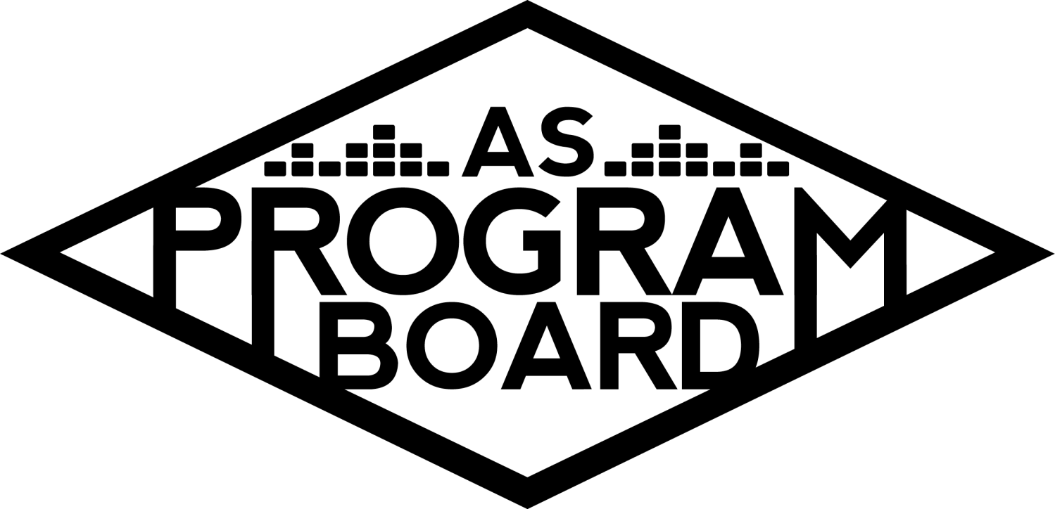
Program Board Agenda

Associated Students
April 20, 2020
Remote

CALL TO ORDER: 5:02PM by Kiyomi Morrison
A. MEETING BUSINESS
- Roll Call
Name | Vote:  absent (excused/not excused)  arrived late (time)  departed early (time)  proxy (full name) | Name | Note:  absent (excused/not excused)  arrived late (time)  departed early (time)  proxy (full name)
Adam Salton
Alexis Xa |  | Kathryn Quinones
Bethel Tammerat |  | Kiyomi Morrison
Brenna Collins |  | Lucas Jackson
Brett Friedman |  | Mikio Sacramento
Carlos Aviles-Sullivan |  | Mitchell Lewis
Conner Jones |  | Nathaly Pacheco
Enaiya Judkins |  | Sarah Danielzadeh
Erica Ko |  | Benjamin Chocron | Absent
Esteban Alvarado
Gabriel Reyes

Acceptance of excused absences, absences, early departure and proxies
Motion by Nathaly, second by Carlos. Consent with 17 present.

B. PUBLIC FORUM

C. ACCEPTANCE of AGENDA/CHANGES to AGENDA
Motion by Nathaly, second by Bethel. Consent with 17 present .

D.ACCEPTANCE of ACTION SUMMARY/MINUTES
Motion by Gabe, second by Bethel. Consent with 17 present.

E. ANNOUNCEMENTS
- Reaffirmation THIS WEEK
  - Voting opened today! Closes on April 23
- Position Guides
  - Will be making position guides this year in lieu of usual duties. These will need to be sent in when stipends need to be turned in (next week or week after that).
    - There are some past guides as examples
- Working through COVID
  - We’re not in our strict jobs anymore, but we hope you are still putting in work. Please do your best to stay on top of everything and participate!
    - Coffee videos
    - Important if you want recommendations in the future

F. WEEK IN REVIEW
- Poetry Workshop with Rick Benjamin - 4/20
  - Went well! 12 people attended, ~5 were UCSB students. Rick was great and conversations flowed. Everyone got to write a poem and shared it.
  - People joined the call in the beginning and started saying absurd things and we had to restart the call- may have lowered the total number of attendees.
    - Need 2 hosts- need to kick out unwanted people quickly
    - Didn’t know how long to wait for people to join to start the call
  - In the settings- you can select if you want authenticated users only. This was unchecked and that’s how random people were able to join the call
  - When setting up future meetings, Alexis can help out with logistics and setting up the actual call
    - Removing people from call
  - Should we plan a way to thank him?
  - Should make a doc with what settings were used for future calls

G. PREVIEW OF THE WEEK
- Noon Storke Show - 4/21
  - Looking like we will have to push it back- still need to figure out contract
  - Performers don’t need insurance (only for Storke shows)
  - If contract can go out tomorrow, we could probably do this week- Thu or Fri at noon
  - Still using Instagram live
    - ASPB could go live then invite the performer on
  - Let’s shoot for Fri at noon but need to see if contract will be ready
    - But Thu is last day for reaffirmation
  - Hoping to have graphic done by Wed
- Artist A Live Stream - 4/22
  - Probably not able to get contract ready in time for this date
  - Could move it to Fri?
  - Need insurance for this event
  - Don’t have a platform (“venue”) right now
    - We have Thu booked for Artist B but it might be too tight
  - “Room” size- how big of a room do we need?
    - 1k or 3k limits
      - Need to check if 3k option is available
      - Looks like right now only 1k option is available- may change once we confirm an event
      - We have 1k reserved for Thursday- is that enough time to get the contract back?
        - Yes if they don’t make changes and can get insurance back quickly
  - May need to push all events back- could use dates for farther shows for this
  - Need to plan in the future and stick to dates because we need to buy licenses for certain dates
  - We can flip Artist c and Artist d so we don’t have to purchase a license for May 1 and we can plan more for May 8
  - Should have a show with a cap soon so we can gauge attendance for future events
    - Can also help us find out what to expect in general for later events
  - Tough situation because we are all waiting on info
  - Can call agent during meeting if Thursday is looking like a possibility for Artist A
    - If we can send an offer in the next 30 minutes, we could get it accepted by tomorrow morning with fewer changes
  - Artist E- haven’t confirmed but can look into changing dates for Artist A
    - Artist A next Wednesday then Artist E next next Wednesday may be ideal timing
    - Want to have smaller event before larger one because running video platform is new and large event may be too much to have at first
    - Could make Artist A 1k and see how it goes?
      - May have people come and go and not have 1k people on the video at once
  - May be best not to have any events this week- Artist E on the 6th and Artist A on the 13th?
    - Need to be careful with reserving dates then not using them- may not get larger sizes on dates we want in the future
  - Will try to make it happen this week
- Artist B Live Stream - 4/23
  - Same situation as Artist A- will likely take a long time to get everything processed now that we know what’s required
  - Can try to have these events later in the quarter and will keep working at them
  - Told agent it probably won’t happen Thursday but they are willing to reschedule

H. OLD BUSINESS
- Podcast/Youtube Channel
  - More of a Youtube channel now
  - Almost done with some cooking videos and working on film review for next week
  - Goal was to upload Tue and Thu every week but since coffee video didn’t go up, we could post videos at different times
  - If anyone has skin care videos, they can be edited into the video
  - Could try to post Tue or Wed even if not everyone has submitted something
  - Planned out schedule for posting videos until mid May but were waiting for large ASPB coffee video to post first since it was supposed to show everyone
    - We could do the coffee video without everyone’s videos
    - First week can be different than other weeks’ schedules
- Playlists
  - Done, just a matter of posting them and pubbing them. Still taking suggestions
  - Missing one playlist cover
  - Will be highlighted on stories by pub
- ASPB Applications- open until May 1
  - Make sure to share application and invite people to event
  - Make sure to submit an application if you are staying!
  - Info Sessions 4/21 & 4/22-5PM on Zoom
    - Doing panel zoom- wil unmute people as needed
    - Will be using presentation used in the past
    - Post about them if you can!
    - Good if we can get a lot of people to attend these
  - Hiring Committee
    - Kiyomi will reach out to you all soon to set up a meeting
- Reaffirmation
  - Made a post on Free and for Sale
  - If you can, make a post about why we are important and that this vote affects the next two years
  - Gabe is using hisTiktok fame to keep us around
  - Tips:
    - Have individual members make posts
    - Make a compilation of bigger shows
      - Nathlaly made a bank of all the bigger shows that we’ve had in the past
    - Get a prominent student leader on campus to make a post/statement about APSB
- Live & On The Rise
  - Got a list back of artists on the rise that are within $5k
  - Would want live set or Q&A
    - Putting up poll right now
  - Staying true to “artists on the rise” or seeing if we could get bigger names?
- Friday Night Vibes
  - Wanted to have some contingencies for shows
  - Artist d- May 1
  - Artist c- May 8 (may need to push back)
  - Artist F as contingency for Artist d
    - Wanted it to be less of a live stream and more of takeover
      - Could be difficult to do through Instagram
      - She could do performance or Q&A
    - Even if he confirms we could have her do something too
  - Artist G as contingency for Artist c
    - He could also lead a painting class
    - Very well known Artist And has great personality
  - Artist H Joshua Tree Livestream
  - Artist I workout livestream
    - There are still things that need to be figured out to get this to work
    - Could be passed as own separate event instead of contingency
  - Aiming to pass Artist F as contingency for Artist d, passing Artist G as contingency for Artist c, and passing Artist I as her own event while holding off on Artist H event
  - Artist J was also discussed on list- she would be down to do a performance or a Q&A
  - If we push back dates, we may have more time to look at other artists
  - Artist F for both contingencies?
    - We could also make a separate event for her
- Films
  - Talked to swank and moving forward with getting resident’s life cinema- anyone on campus has access to a streaming service that has newer films
    - Need to confirm certain number of students on campus
    - Need to be on campus wifi. Could we use people’s perm numbers?
      - Runs into issues with home viewership rights
    - Wouldn’t need to help moderate this- once they get info they can sign in on their own
  - Will also be showing movies for people off campus
    - Little Women

I. NEW BUSINESS
- Artist K Livestream - 4/28
  - There is an offer out for $9k- waiting to hear back
  - Cooking- more popular cooking Youtuber
- Panel on the music industry after COVID
  - May be easy to do because people may be willing to do it without compensation and contracts
  - Reaching out to ASPB alumni
  - Will also be looking into more free livestream options like poetry workshop

J. ACTION ITEMS
- Extravaganza Seniors entry
  - Y: 14, N: 0, A: 3. Motion passes.

K. FINANCIAL ACTION ITEMS
- Reaffirm Email Votes
  - Motion to change the date of “ Live Stream Performance Budget” to 4/22/2020 with Artist A headlining starting at 10k ending at 20k.
    - Motion by Nathaly, second by Erica. Consent with 17 present.
  - Motion to pass Artist E as the first artist for the artist on the rise live stream starting at 3k ending at 6k.
    - Motion by Nathaly, second by Carlos. Consent with 17 present.
  - Motion to pass Artist L as the artist for Comedy Performance Livestream on April 30, 2020. Offer starting at $15k and ending at $25K.
    - Motion by Gabe, second by Conner. Consent with 17 present.
  - Motion to pass Artist K: Live on April 28, 2020 for $13,300. Offer starting at 7k and ending at 13k.
    - Motion by Nathaly, second by Brett. Consent with 17 present.
- Live & On the Rise
  - Motion to table Live & On the Rise vote until next meeting.
    - Motion by Brett, second by Erica. Consent with 17 present.
      - Please respond in Slack- vote may be going out tonight.
- Friday Night Vibes
  - Motion to pass Artist F as the contingency for the Artist d live stream show on the originally planned date starting at $45k and ending at $60k.
    - Motion by Nathaly, second by Conner. Consent with 17 present.
  - Motion to pass Artist G as the contingency for the painting session on May 8th starting at $40k and ending at $55k.
    - Y: 15, N: 2, A: 0. Motion passes.

L. REPORT
Facebook Factory / Tuesday Slide / Thursday Ad
- Free & For Sale post
Kudos
- Everyone for hanging in there- we’re leaving a legacy! To Bethel for working on the poetry workshop and Kris for attending the sub-committee meeting. Pub for keeping up with events every day and Mitchell for the awesome graphics! Alexis and Bae-thel for their first event! Marilyn for working tirelessly. Nathaly, Gabe and Brett for always being on the phone and responding to emails. Conner for work on the website. Kiyomi for being the middleman. Gabe for being on it for cultural events and for Tiktok (of course). Alexis for being so amazing to work with and everyone for submitting videos.

The Marilyn Report
- Elections have a higher turnout on the first day than last year. Other AS groups are doing fun themed meetings. Also, is anyone comfortable being a co-host for webinars? -Kiyomi is a maybe

The Kris Report
- Love the ideas and is looking forward to helping out.

Commissioner's Report
- Working a lot on applications and reaffirmations and everyone’s little groups. We need everyone right now given all the craziness.

Deputy Commissioner’s Report
- Excited to make whipped coffee. Had a good time at the poetry event and is looking forward to the next events.

Coordinators’ Reports
Adam- Get your videos in for the coffee video by Wed. Excited to work on video.
Brett- Smino dropped a mixtape today
Carlos- Looking forward to hiring and hoping for reaffirmation
Conner- Website is different now- check it out and give feedback
Erica- If anyone wants to do a takeover Tuesday, let her know. Share all events coming up and get coffee videos in.
Esteban- Hates school. Working on getting films out and working with Gabe on exciting cultural event.
Gabriel- Working on Artist B and future script to screen event for pride month.
Mitchell- Working on graphics
Nathaly- Working on things that were passed. Starting to get things done!

Assistants’ Reports
Alexis- Poetry workshop was good. Will look into Bon Appetit and zoom document
Brenna- Storke tower performer can do Thu so if we can get the contract in we should be good to go
Enaiya- Thank you for helping with pub
Kathryn- Great job, excited for big show
Lucas- Glad we got first livestream set up
Mikio- Wants to be on the hiring committee. Looking forward to the compilation video. Playboi Carti’s album might drop tonight. Finished bingo will send to pub

Senator’s Reports
Benjy-
Sarah- Yield

ADJOURNMENT: 7:34 PM by Kiyomi Morrison.

Artists mentioned: Kehlani, Rufus Du Sol, Lil Nas X, Eric Andre, NGHTMRE, Lil Yachty, Steve Aoki, Doja Cat, Channel Tres, Binging with Babish, David Dobrik

