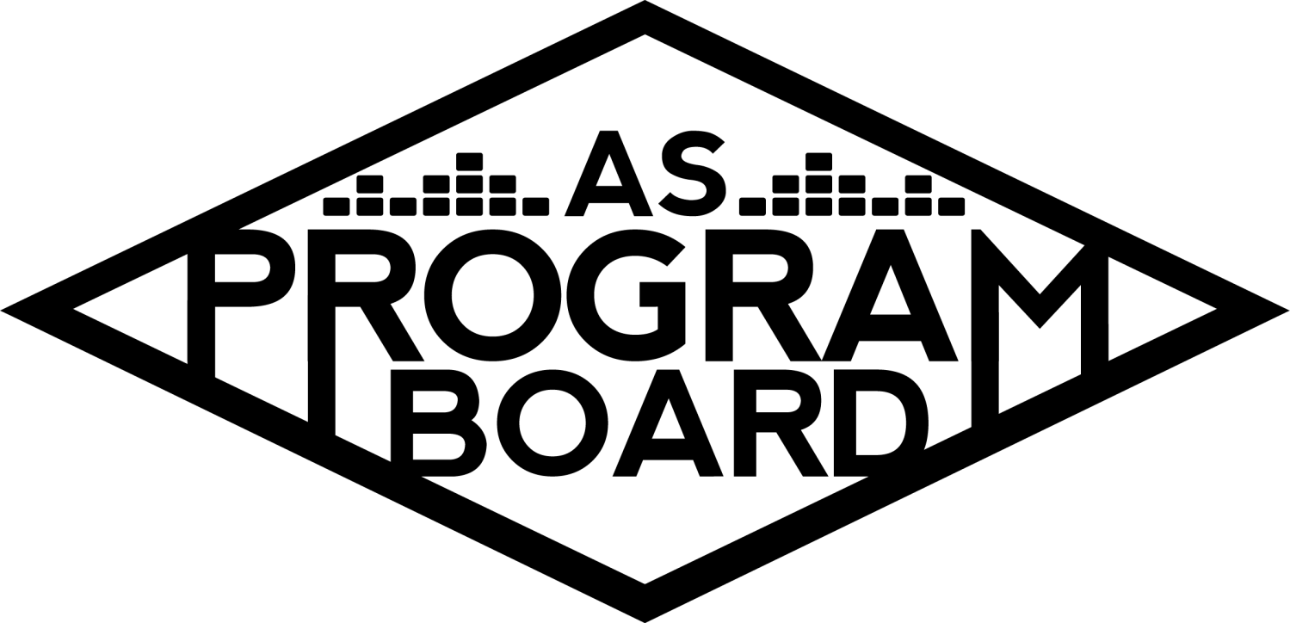
Program Board Minutes

Associated Students

April 12th, 2021

Remote Meeting

CALL TO ORDER: 5:02 PM by Kathryn Quinones
A. MEETING BUSINESS
- Roll Call
Name | Note:  absent (excused/not excused)  arrived late (time)  departed early (time)  proxy (full name) | Name | Note:  absent (excused/not excused)  arrived late (time)  departed early (time)  proxy (full name)
Adam Salton
Alexis Xa |  | Kathryn Quinones
Celine Liu |  | Kathryn Supple
Emily Duong |  | Kim Kryshak
Emily Kocis |  | Lucas Jackson
Enaiya Judkins |  | Sophia Castro
Gabriel Reyes |  | Hayley Slater
Halle Dawite |  | Bee Schaefer | absent
Jake Einsiedl

Acceptance of excused absences, absences, early departure and proxies
Motion to excuse the absence of Bee . Motion by Adam, Second by Gabe. Consent with 14 present.

B. PUBLIC FORUM

C. ACCEPTANCE of AGENDA/CHANGES to AGENDA
Motion to accept the agenda. Motion by Jake, second by Sophia. Consent with 14 present.

D.ACCEPTANCE of ACTION SUMMARY/MINUTES
Motion to accept 4/5/2021 minutes. Motion by Alexis, second by Jake. Consent with 14 present.

E. ANNOUNCEMENTS
- Land Acknowledgement

G. WEEK IN REVIEW
- Free Tuesday Film: Twilight 4/6
  - Only 60 people registered out of 200 people that we paid for
  - Only 38 people actually accessed the link
  - Continue with newer movies -- these are more expensive, towards 1k
  - Some interaction with the live tweets, some people commented positively about it
  - Lucas - would rather push toward drive in movies if we continue
  - Jake - seems like the most cost effective event we’ve done so far
  - Emily - maybe whole households watched together so instead of 38 people it could be 38 households
  - Enaiya - there were also free tuesday film shows last year in person that didn’t do as well
  - Sophia - some people were only following along with the tweets, events are still good to put on, a giveaway will be more enticing and better for our overall pub
  - Alexis - a lot of us will know the artists we book, but there's a large population of students that care more about movies and film than they do music
  - Gabe - lag every 15 minutes for at longest 1 minute

H. PREVIEW OF THE WEEK
- Yung Baby Tate 4/15 at 8 pm
  - 30 minute performance with 20 minute Q&A and manifestation board making
  - Emily K and Kat monitoring chat
  - Halle and Sophia moderating the conversation
  - Sound check day and time hopefully sometime in the afternoon
  - Sent Q&A questions for approval
  - Also waiting on insurance
  - The link is in our social bios or registration
  - No one has submitted any student questions yet but Jake has enough questions
  - 15 people registered so far
  - Halle will make a vision board along with YBT

I. OLD BUSINESS
- Ambassadors
  - There is a ambassador meeting this week wednesday from 5:30-6:30
  - Today started new music monday for every off week from the playlists
  - Kathryn is going to the next meeting to discuss blog posts about new things like podcasts and stuff like that
  - Picked up shirts for people outside of iv for them to be mailed
- Spotify Playlists
  - https://docs.google.com/spreadsheets/d/1Ob7DQoIy3dos4jwvwJyzfKt9f05FbTCAiTIsmWgQbEw/edit?usp=sharing
  - If you have any playlist suggestions send them to Sophia
- ASPB Sweaters
  - Ordering update
  - Should hear back from IV Screen Printing tomorrow about a quote
  - Got the finalized design over the weekend
- Extravaganza 5/15-16
  - Day One: Saturday
    - Artist
      - Only waiting on logistical stuff for contract
    - Event Structure
      - 15 min Keynote followed by 45 min q and a
      - Started working on the questions
      - Could do college hot takes
      - Keynote could focus on the student loan debt that they testified in front of congress for
      - Will start at 7:30pm
  - Day Two: Sunday
    - Artists
      - Offer for Artist A is out but unlikely to confirm because of their lack of interest in Virtual shows
      - Artist B is available for this event
      - Jake- Artist C is everywhere on social media. She could perform multiple songs
      - Lucas- Artist D,E, B or Artist F
      - Adam- Artist D is blowing up and hearing them everywhere in IV especially with people i wouldn’t think to listen to him. Also if they had a band that would go really well.
      - Halle- still very down for Artist E because students have shown a lot of interest
      - Gabe- we should solidify if we want Artist B first then build off of that
      - Adam- would Artist E and D be pulling from the same crowd?
      - Enaiya- Artist B is great for representation and the other artists are growing enough into other groups that it should not create an issue
      - Jake- this combo of groups could be OOR
      - Alexis- did the addition wrong. But could probably confirm Artist E for around 15k so it is still doable
      - Adam- what is Artist F asking?
      - Alexis- should be around the same. Can’t see why it should’ve increased. We should start with the headliner and a contingency
      - Gabe- we should have Artist D as contingency for Artist A and Artist B as contingency for Artist D. They are our best options for this show
      - Jake- Artist D as contingency for Artist A and just get Artist B no matter what
      - Lucas- we should get Artist D as contingency and Artist B for 2nd contingency and if D confirms just add B as second slot
      - Gabe- Artist G could be a great headliner and great female empowerment with Artist B
      - Sophia- could also bring Artist H for third slot and round out the female empowerment theme
      - Enaiya- dont really hear of Artist G outside of Program Board
      - Adam- her set is really concert based and might not translate well to zoom
      - Alexis- she is one of the biggest female edm artists. Also feel kind of wishy washy about her though.
      - Adam- would only really feel comfortable with Artist F for an opener if edm
      - Jake- can really only think of Artist I being bigger than Artist F and he is OOR
      - Gabe- Artist J could be really interesting and other schools have been having success with edm
      - Jake- the only dance type act that a lot of people in IV know would be Artist K
      - Emily K- Artist J has crazy numbers for her asking and a lot of people in IV listen to her
      - Alexis- Artist L’s asking has doubled from what it was before and idk if it has increased since then
      - Kim- could’ve sworn that Artist M is doing school shows but might be oor
      - Alexis- he headlined x a couple of years ago
      - Enaiya- what are the odds we send an offer to Artist N. Lowkey if we are just working with what we have then i don't see why we dont just bring an artist that people want to see if we pull 10k from what is left of Gabe’s budget
      - Alexis- Artist N is not happening. Please give some more thought to a 2nd contingency for next monday
      - Alexis- it would be more worth it to get a pre recorded performance of an artist we like then settle for an artist for a live set
      - We could get them UCSB merch and have them say UCSB in the pre recorded set if it comes to that
    - Event structure
  - Theme: springtime background colors and trees but showing iv and the neighborhood with a more retro artistic style
    - If we want to do something more than shirts we have to decide now
    - Decided on shirts and stickers
- Swank Films Future Showings
  - Showing for 4/20
    - Is this the best day to do it
    - Students usually forget
    - Move to a new date that same week
    - Move the showing to Friday the 23rd of April
  - Student Poll
  - Giveaway goodie bags
  - Film and Goodie Bags Budget
- Cultural Events
  - Artist O 5/6
    - Will call he agent to check in
    - Shared doc with Emily K and Lucas
    - If anyone has suggestions please let Gabe know
    - Probably just going to be q&a style
- Storke Shows
  - Proposed dates
    - 4/22 which is Earth Day, 4/28, and still working on dates for may
  - Kim's Research
    - Artist P is more likely to happen in may. Asking for $800. They have 340k on Spotify
    - Artist Q was in discussion before but fell out but they are more willing now.
      - They are always interested and back out last second.
      - Could give them an ultimatum and make this their last chance to do a show with us because of how flaky they have been before.
      - Adam would still not be able to be on site with the artist yet
    - Christian Seiber is still interested in doing a make-up show for what happened last quarter
    - Also looking at Artist R to play on Earth Day
    - Time for the storke shows would depend on how much music they have and how big they are
    - For the local bands looking at 35-40 min
    - Could do themed stroke shows for the events and Earth Day would be the first vibe
- Hiring for 2021-2022
  - Hiring committee: Celine, Sophia, Jake, Gabe, Adam, Hayley, Bee
  - Sent out a when to meet to make schedules for Hiring and there would be consistency with who the group is
  - Graphics is working on the graphic and will be more ready to finish
  - Hoping to post by the end of the week
  - Gabe will post times on the hiring Slack

J. NEW BUSINESS
- Bagel Day
  - Sophia and Alexis are working on doing the Tuesday of Finals week for bagel day this quarter
  - Want to do prepackaged bagels and cream cheese for each house
  - Want to do 9am-12pm in little acorn park
- IV Arts Collaboration
  - They want to do an event with us
  - Didn't really specify what they wanted
  - Lucas is going to their meeting tomorrow and will ask more questions

K. ACTION ITEMS

L. FINANCIAL ACTION ITEMS
- Motion to pass Artist D as headliner contingency for Extravaganza Day 2 up to $75k. Motion by Alexis, Second by Jake. Consent with 14 present.
- Motion to pass Artist B for Extravaganza Day 2 Slot 2 starting and ending at $50k.Motion by Alexis, Second by Gabe. Consent with 14 present.
- Motion to pass Artist R for 4/22 Storke Show starting and ending at $200. Motion by Kim, Second by Gabe. Consent with 14 present
- Motion to pass Artist P for 4/28 Storke Show starting at $750 and ending at $850. Motion by Kim. Second by Kathryn S. Consent with 14 present.
- Motion to pass $1,260 for the week 4 Films budget. Motion by Lucas, Second by Enaiya. Y 9 N 1 A 4

M. REPORT
Facebook Factory / Tuesday Slide / Thursday Ad/ Free & For Sale post

Kudos
Enaiya for live tweeting
Everyone that helped with the giveaway last week
Emily for helping write manifestation questions
Alexis for all the work that goes into artist research for extrav
Everyone for hanging in during long meetings
Emily K for having a reaction to meeting Kat
Jake for having hot takes
Kim for planning stroke shows
Kathryn for consistency
Everyone that volunteered to post
Gabe for helping the hiring comittee

The Marilyn Report
AS is working on a strategic plan and looking for input for AS groups. Have the security meeting on Wednesday. Will be out tomorrow and Friday
The Kris Report
Not much to report. Sorry if it looks like I'm sitting in the dark. Looking forward to thursday and will help with soundcheck
Commissioner's Report
Can't believe it is week 3. Time is crazy. Getting nervous the closer we get to hiring. Glad to see you doing things and bringing back events
Deputy Commissioner’s Report
Excited to do more films and see how they go
Coordinators’ Reports
Adam- got the vaccine last saturday. Cottage has appointments for everyone that needs it. Working on the storke show and hiring committee
Alexis- if you want to pick up merch items let her know thank you to those that signed up, glad TWU is over, thank you to everyone
Celine-This weekend I did a 48-72 hr designathon so I am exhausted but my app prototype looked good :,)))). I am currently working on the Extrav theme and hopefully by the end of the week, I’ll have some graphics to post in the slack. I’m taking some of the ideas we talked about last week and making the theme so that getting approval from artists will be easier. Looking forward to YBT!
Enaiya- looking forward to another film, pub scheduling meetings for the quarter, ambassador did takeover today which is cool, will harass us all to sign up for takeovers, pub YBT
Gabe- Today was the first time I could go on a run without feeling like I was dying. Working on the scripts for Artist O and Artist S. Figuring out hiring time slots with everyone. Picked up grad stuff today! Excited for YBT
Jake- will let us know with sound check details, deleted instagram so will figure out how to repost
Kathryn- will probably send out a newsletter on thursday! Getting the second dose this week and going to the library tomorrow!!

Assistants’ Reports
Emily D- not really up to much but if you need help let her know!!
Emily K- fun tabling, excited for YBT, looking at Artist O and S docs to put some stuff in there
Halle- 50% vaccinated. Posting. Life. stress. Getting freebirds, finding a back up show for bwhc
Kim- working on storke show stuff, nice to meet everyone, dropped a class so that's fun
Sophia- working on how to do closed captioning for the takeover tomorrow. Please let her know playlist ideas.

Senator’s Reports
Bee-
Hayley- rep to a meeting next thursday 2-3, fill out what AS should look like in the future

ADJOURNMENT: 7:36 PM by Kathryn Quinones

Artists mentioned: Ashnikko, Olivia Rodrigo, NIKI, Playyard, Try Guys, Louis the Child, Hasan Minhaj, Jasmine Sullivan, The Marias, Chika, The Neighbourhood, Miguel, Greer, Happy Medium, Dominic Fike, Alison Wonderland, Fisher, Silk Sonic, Flume

