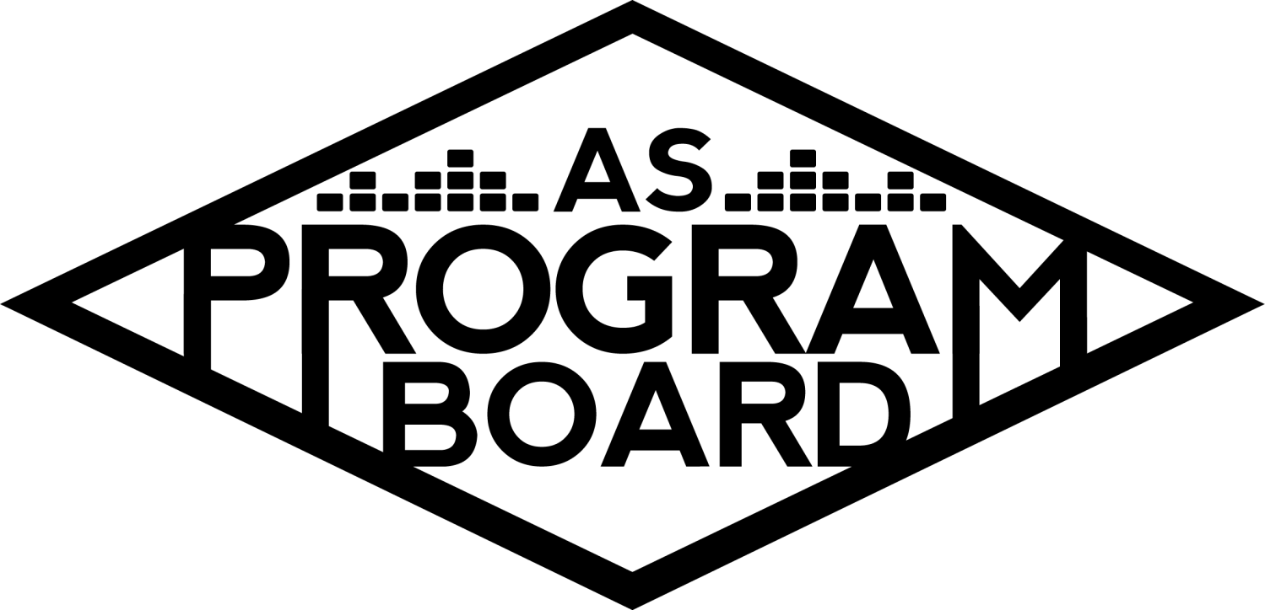
Program Board Minutes

Associated Students

November 30th, 2020
Remote

CALL TO ORDER: 5:0PM by Kathryn Quinones
A. MEETING BUSINESS
- Roll Call
Name | Note:  absent (excused/not excused)  arrived late (time)  departed early (time)  proxy (full name) | Name | Note:  absent (excused/not excused)  arrived late (time)  departed early (time)  proxy (full name)
Adam Salton
Alexis Xa |  | Kathryn Quinones
Celine Liu |  | Lucas Jackson
Emily Duong |  | Sophia Castro
Emily Kocis |  | Sophie Sharma | Excused
Enaiya Judkins |  | Hayley Slater
Gabriel Reyes | Early Departure 6:50 pm | Bee Schaefer | Absent
Halle Dawite
Jake Einsiedl

Acceptance of excused absences, absences, early departure and proxies
Motion to accept the early departure of Gabe and absence of Sophie and Bee. Motion by Alexis, Seconded by Jake, Consent with 12 present.

B. PUBLIC FORUM

C. ACCEPTANCE of AGENDA/CHANGES to AGENDA
Motion to accept the agenda. Motion by Sophia, second by Gabe. Consent with 12 present.

D.ACCEPTANCE of ACTION SUMMARY/MINUTES
Motion to accept 11/23 minutes. Motion by Emily, second by Lucas. Consent with 12 present.

E. ANNOUNCEMENTS
- Land Acknowledgement
- Appreciation Gifts!
  - It’s hard to appreciate the work you do but the students and everyone else here at ASPB are proud of you! Great job everyone!!

G. WEEK IN REVIEW

H. PREVIEW OF THE WEEK
- Storke Show ft. Artist A 12/1 @ 7 pm
  - Announcement up today!!
  - Posting after meeting
  - Should play for an hour
  - Contract issues so the show is up in the air, look out for updates

I. OLD BUSINESS
- Storke Shows
  - Artist B actually responded to Adam and are talking about 12/18
  - That would be the last day of the quarter and the Friday of finals week
  - Could have it as like a last show of the quarter send off
  - Lucas has not heard back from the artist he reached out to
  - Might push this back to early winter quarter to give more time for the contract
  - Alexis has a couple artists lined up and there is a google doc showing the artists
  - Also looking into another DJ not on the sheet yet
  - Artist C and Artist D are both asking for 1k even though Artist C is a bit bigger
  - Might want to only book one artist for that much per quarter
  - Artist E is great for representation and diversity in culture and music
- Instagram Filter
  - Celine and Emily have been working on a Winter filter so it is not holiday specific
  - Will have snowflakes and our logo small in the corner so it is cute to use but still has an ad for us
  - Hopefully available to use on Saturday of this week
  - Need models to be the cover photo of the filter
  - Halle will model the first one
  - Everyone better using it
- TWU 4/3/2021
  - Artists
    - Looking good for Artist F they are excited to do it
    - It looks like Artist G’s price went up if it needs to include a live performance
    - Might move on because of the increase
    - Artist H as a contingency?
      - Could be great support
      - Co-headline show would be fun
      - Could bring in a slightly different crowd than Artist F
    - Artist I
      - Smaller than Artist H
      - Newest album got an 8.7 on pitchfork
      - 4 Grammy nominations
      - Not as popular as Artist H yet
    - Artist J
      - Within budget
      - Listened to more outside the US
    - Artist K
      - Brought into discussion many times before
      - Seems like most are in favor
  - Shirts
    - The company had some questions for Lucas
    - They should respond to him soon
    - Will hopefully reach out to graphics by Wednesday
- Winter Quarter Show
  - Do we still want to go with R&B or move directions
  - Offer for Artist L is out
  - Reggae
    - Big presence at UCSB
    - Artist M which is one of the biggest names came out of UCSB
    - Artist N would be great and she gives back to the community
    - Artist N could be a good fit even with Artist L
  - Artist O
    - Not as up and coming as Artist I
    - Often requested by students
  - Artist P is going through a lot of changes on her team and is unlikely she will be represented by the same team
  - Unlikely to book for Winter Quarter due to these changes
- Winter Quarter Hub Shows
  - Talking to Artist Q agent and the price was off
  - Likely 10-15k in actuality
  - Will adjust the starting and ending prices
- Ambassadors
  - Starting winter quarter the ambassador meeting will include the coordinators and assistants from positions
  - One group per week
  - They want to know more about us so this is for them to hear about what we do and if they want to apply for our positions
  - Will schedule with the coordinators and assistants what week they will show up
- ASPB Masks & Sanitizers
  - Masks came in and hand sanitizers should be here soon!!

J. NEW BUSINESS
- ASPB Sweaters
  - Hoodie? Crewneck?
  - Lucas is looking into Merch for us to wear!

K. ACTION ITEMS
- Motion to change Artist L to Winter Quarter Show headliner. Motion by Alexis, second with Lucas. Consent with 12 present.

L. FINANCIAL ACTION ITEMS
- Motion to pass Artist E for a Storke Show on 1/21 starting and ending at $180. Motion by Sophia second by Gabe. Consent with 12 present.
- Motion to pass Artist Q for a Hub Show starting at 8K and ending at 15K. Motion by Jake second by Emily D. Consent with 12 present.
- Motion to pass Artist R for a Storke Show on 1/13 starting and ending at $550. Motion by Gabe. Second by Jake. Consent with 12 present.
- Motion to pass Artist C for a Storke Show (date TBD) starting at $900 and ending at $1000. Motion by Gabe, second by Halle. Consent with 12 present.
- Motion to pass Artist S for a Storke Show (date TBD) starting and ending at $200. Motion by Sophia. Second by Enaiya. Consent with 12 present.
- Motion to pass Artist H for TWU Co-Headliner on 4/3 starting at 40k and ending at 45k and Artist K for TWU Co-Headline contingency starting at 45k and ending at 50k.Motion by Emily. Second by Gabe. Consent with 12 present.
- Motion to pass Artist O for Winter Quarter show support up to $20k. Motion by Alexis, second by Halle. Consent with 12 present.

M. REPORT
Facebook Factory / Tuesday Slide / Thursday Ad
- Free & For Sale post

Kudos
Everyone for getting through the quarter
Celine and emily for working on the filter
Alexis for helping Sophia
Sophia for helping Alexis
Kat for being available and being a good leader
Everyone for having a fun meeting
Emily K for being in the office with Enaiya
Kat for being the best
Everyone for being the best
Halle for giving Enaiya Kudos
Enaiya for doing THAT
Gabe for being older than he was at the last meeting
Halle for being a hype woman and having great energy
The Marilyn Report
Please wear masks and wash your hands! Be Safe!!
The Kris Report
Would be cool to bring athletes for cultural! Excited for next meeting!
Commissioner's Report
So proud of everyone! We are the trailblazers! Good luck on finals!
Deputy Commissioner’s Report
Proud of everyone and excited for the future! Good luck on Finals!
Coordinators’ Reports
Adam-Working on storke shows and the website! Good luck in 2 weeks on finals
Alexis- Stay safe!!!!! Thanks for everything this quarter! Might have longer meetings to discuss extrav! Good luck and stay safe!
Celine- Excited for the filter. Also working on the website with Adam.
Enaiya- Always pubbing stuff!!
Gabe-all the shows this quarter were fun! Thanks for all the help! Working on collabs for winter quarter!
Jake- sent the Artist A contract to Kat and Kris for tomorrow

Assistants’ Reports
Emily D- stay safe! Especially in SoCal! Good luck on Finals! Working on the filter and playlist
Emily K- Really cool and fun first quarter on board! Excited for next quarter
Halle- Good luck on finals!! Stay safe!
Sophia- Use the filter!! Shout out to Halle for being the model! This weeks playlist is KPOP! Ambassadors are great
Senator’s Reports
Bee-
Hayley- Loved meeting and getting to know everyone! Good luck on finals and have a good break!

ADJOURNMENT: 7:01PM by Kathryn Quinones

Artists mentioned: NIKI, Flo Milli, ROLE MODEL, Wallows, Rebelution, The Marias, Playyard, Art Official, Giveon, DC Sings, DJ Jesse, Lunar Vacation, Early Eyes, Ruel, Denzel Curry, Koffee, Willow, Phoebe Bridgers, HOAX

