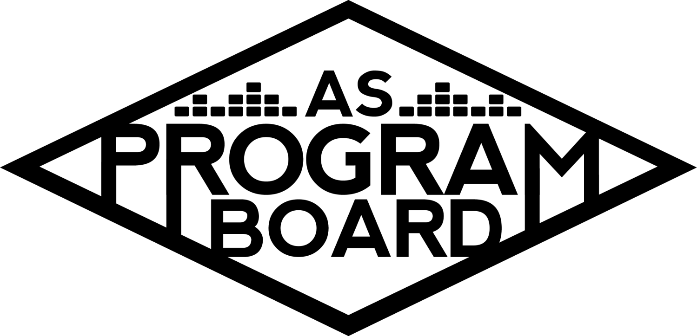

Program Board Minutes

## Associated Students

## November 16th, 2020

Remote

**CALL TO ORDER: 5:01PM by Kathryn Quinones**

**A. MEETING BUSINESS**

1. **Roll Call**

|  |  |  |  |
| --- | --- | --- | --- |
| **Name** | **Note:**  absent (excused/not excused)  arrived late (time)  departed early (time)  proxy (full name) | **Name** | **Note:**  absent (excused/not excused)  arrived late (time)  departed early (time)  proxy (full name) |
| Adam Salton |  |  |  |
| Alexis Xa |  | Kathryn Quinones |  |
| Celine Liu |  | Lucas Jackson |  |
| Emily Duong |  | Sophia Castro |  |
| Emily Kocis |  | Sophie Sharma |  |
| Enaiya Judkins |  | Hayley Slater | Early Departure 7 pm |
| Gabriel Reyes |  | Bee Schaefer |  |
| Halle Dawite |  |  |  |
| Jake Einsiedl |  |  |  |
|  |  |  |  |

**Acceptance of excused absences, absences, early departure and proxies**

Motion to excuse the early departure of Hayley @ 7pm. Motion by Gabe, Seconded by Jake, Consent with 13 present.

**B. PUBLIC FORUM**

**C. ACCEPTANCE of AGENDA/CHANGES to AGENDA**

Motion to accept the agenda. Motion by Alexis, second by Lucas. Consent with 14 present.

**D.ACCEPTANCE of ACTION SUMMARY/MINUTES**

Motion to accept 11/9 minutes. Motion by Alexis, second by Lucas. Consent with 14 present.

**E. ANNOUNCEMENTS**

1. Land Acknowledgement

**G. WEEK IN REVIEW**

1. Raveena 11/12
   1. Overall went really well
   2. 98 people tuned in
   3. Students respond well to activities and liked the guided meditation
   4. Raveena liked the student question and wanted to do more
   5. Team was easy to work with
   6. Emily did great as a moderator and the hiccup with wifi went unnoticed

**H. PREVIEW OF THE WEEK**

1. Storke Show Live with Artist A 11/18
   1. Confirmed
   2. Graphic looks great
   3. Announcing tomorrow
2. Virtual Q&A with John Mulaney 11/19
   1. Got the coi in
   2. Waiting on the contract
   3. Sent over the questions
   4. Emily K will be the back up if anything happens with Gabe
   5. Student response is great
   6. No student asked questions
   7. 525 students registered so far

**I. OLD BUSINESS**

1. Storke Show ft Artist B TBD
   1. Looking at tuesday 12/1 for the rescheduled show
   2. Jake still has the forms but will re do the contract with the updated date
2. Storke Shows
   1. Lucas is working on the pricing with Artist C
   2. Adam is working on Artist D show and they have a new single coming out on 12/1
3. Festive Programing ideas
   1. “Happy Holidays from ASPB” snapchat filter
      1. Maybe do a filter that is more interactive
      2. Not geotagged and it is connected to the ASPB instagram account
      3. Maybe like “which delirium artist would you share a yerb with?”
      4. Can be subtle and used with a little but of our pub
   2. DIY kits
      1. People really enjoyed the pumpkin diy kits
      2. Alexis will look into some
      3. Cocoa kit could be nice because it is not specific to a holiday
      4. Could do an instagram live cocoa time with aspb
      5. Could do a cocoa bomb that is filled with marshmallows
4. TWU 4/3/2021
   1. Artists
      1. Artist E
         1. Highly requested by students
         2. Would be a good headliner for the event
         3. Almost 9mil listeners on Spotify
      2. Artist F
         1. Reason we did not book for welcome back because he was focused on doing a pre recorded show
         2. His live shows might not be up to the standard
      3. Artist G
         1. Could be similar audience to UMI
         2. Might be good to reach out to this crowd again
         3. Has a big audience in SB
   2. Shirts
      1. It is more expensive to add more colors
      2. Around $0.25 more per color per shirt
5. Winter Quarter Show
   1. Want to do a different genre than TWU
   2. Chill vibes rnb simpy maybe?

**J. NEW BUSINESS**

1. Quarter Reports
   1. Quarter reports are to show that you deserve your stipend
   2. Due by Thursday at 5pm
   3. Talk about everything you did during the quarter your job specific duties and your board duties
2. Pub Sign Ups
   1. Might be a good idea for people to sign up to post in different groups or social media areas
   2. Would help enaiya and pub so that they are not having to be the only ones posting everywhere

**K. ACTION ITEMS**

**L. FINANCIAL ACTION ITEMS**

1. Motion to pass Artist D for a Storke Show on date TBD during Week 8 starting at $300 and ending at $500. Motion by Adam Second by Halle. Consent with 14 Present.
2. Motion to pass Artist E as TWU Headliner on 4/3/2021 starting at $45k and ending at $60k. Motion by Gabe, Second by Alexis. Consent with 14 present.
3. Motion to pass Artist G as opener for TWU on 4/3/2021 starting at $23k and ending at $30k. Motion by Gabe, Second by Alexis. Consent with 14 present.

**M. REPORT**

**Facebook Factory / Tuesday Slide / Thursday Ad**

* **Free & For Sale post**

**Kudos**

Both emilys for helping with John Mualney Q&A

Gabe and emily K for consistently moderating events and its hard

Emily for always making graphics quickly and being nice about it

Emily for killing the Artist A graphic

Enaiya for making the suggestions sheet

Md for helping with the contract drama for Raveena

Sophia for cool ambassador ideas

Alexis for her great spread sheets

Jake for jumping in and being a great concerts coordinator

**The Marilyn Report**

Everyone needs a festive background and there is only two meetings left in Fall! Be careful with Covid! The quarter report should not be super stressful it's just a summary of what you did this quarter and if you need an extension let MD know.

**The Kris Report**

Keep checking in with Kris and be ready to start talking about winter

**Commissioner's Report**

Talk to your loved ones good luck on second round of midterms if you have them

**Deputy Commissioner’s Report**

Masks and hand sanitizer should be here soon

**Coordinators’ Reports**

Adam- working on finalizing storke show and will look into the Snapchat filters

Alexis- doing amazing and excited to work on TWU. STAY SAFE

Celine- Drawing up filters and working on TWU shirts. Get tested

Enaiya- nice to see what the people actually want from the polls. Pub meeting tomorrow at 5

Gabe- Excited for John Mulaney on Thursday! Life is in full throttle so gabe is taking care of himself

Jake- artist research and budgets are done for a winter quarter show

Sophie- stepping down from board to direct attention to more important opportunities that have come up. It's been fun!

**Assistants’ Reports**

Emily D- wishing Sophie the best. Working with Sophia on iv playlists. Take care of Yourselves!!!!!

Emily K- Excited for Artist A and John Mulaney. Excited to go forward with Artist E

Halle- posting about John was crazy because of great engagement. Self care is crucial. Wishing sophie the best

Sophia- this week is the first iv playlist IV sunsets. Add songs so it is one cohesive playlist. Excited to work on Snapchat filters. Manifesting to plan a Storke show

**Senator’s Reports**

Bee- agree with Hayley

Hayley- Senate did not meet last week. Keep up the good work.

**ADJOURNMENT:6:57 PM by Kathryn Quinones**

**Artists mentioned: NIKI, Wallows, Sitting On Stacy, Still Woozy, Playyard, Luna Luna, Art Official**