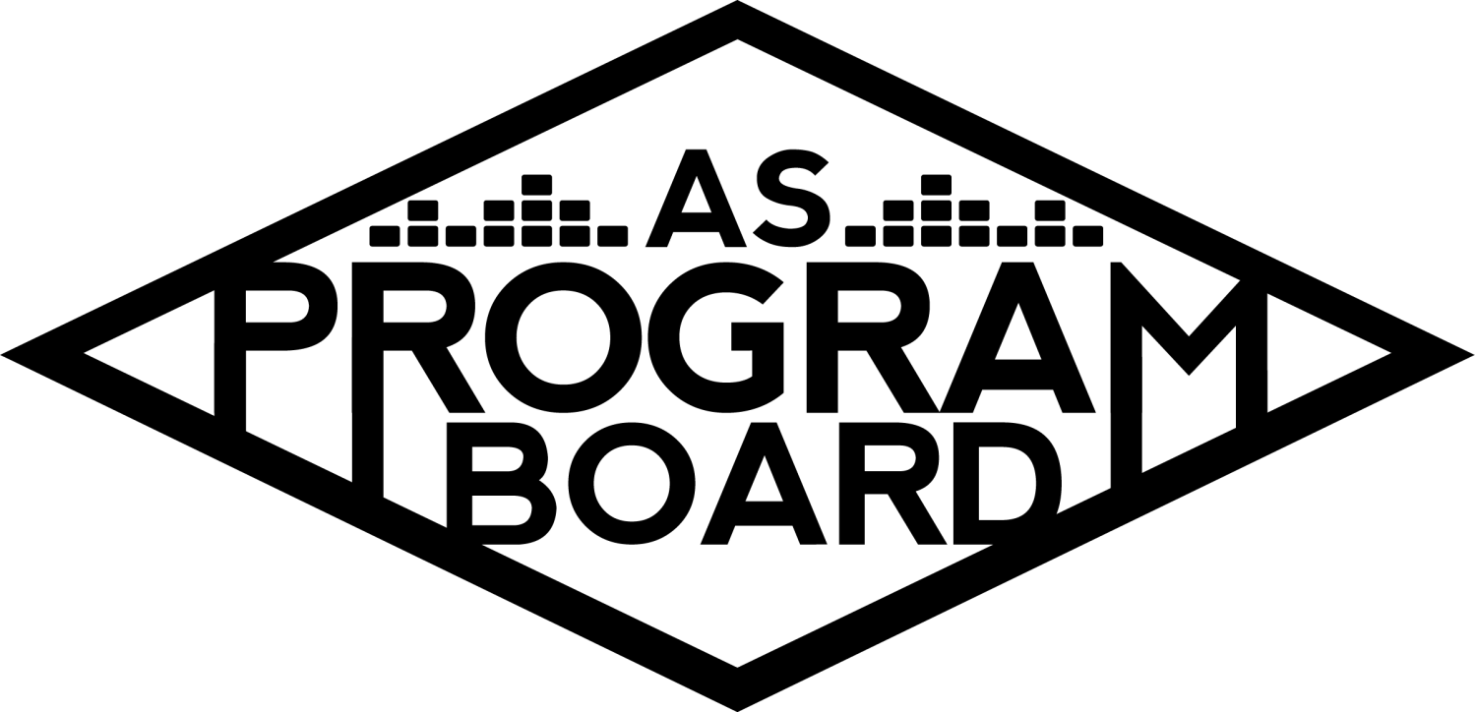
Program Board Minutes

Associated Students

October 19th, 2020
Remote

CALL TO ORDER: 5:03PM by Kathryn Quinones
A. MEETING BUSINESS
- Roll Call
Name | Note:  absent (excused/not excused)  arrived late (time)  departed early (time)  proxy (full name) | Name | Note:  absent (excused/not excused)  arrived late (time)  departed early (time)  proxy (full name)
Adam Salton
Alexis Xa |  | Kathryn Quinones
Celine Liu |  | Lucas Jackson
Emily Duong |  | Sophia Castro
Emily Kocis |  | Sophie Sharma
Enaiya Judkins |  | Hayley Slater | Late Arrival @ 7pm
Gabriel Reyes |  | Bee Schaefer
Halle Dawite
Jake Einsiedl

Acceptance of excused absences, absences, early departure and proxies
Motion by Jake, second by Gabe. Consent with 13 present.

B. PUBLIC FORUM

C. ACCEPTANCE of AGENDA/CHANGES to AGENDA
Motion by Jake, second by Alexis. Consent with 13 present.

D.ACCEPTANCE of ACTION SUMMARY/MINUTES
Motion to accept 10/12 minutes. Motion by Lucas, second by Gabe. Consent with 13 present.

E. ANNOUNCEMENTS
- Land Acknowledgement
- Movie Screenings
  - Movie Agency is reaching out and offering virtual films
  - We can do virtual screenings and can live chat comments along with the film
  - Might not be worth it without that because viewers might get it on other streaming platforms
  - Maybe we can do a drive in at westwind drive in theater
  - If you have movie suggestions talk to Sophia

G. WEEK IN REVIEW
- An Evening with Ramy Youssef 10/15
  - Cool event with a cool dude
  - 70 people attended
  - Pretty good for basically 2 days to pub
  - Thanks to everyone that helped
  - Lots of positive feedback from people that attended
  - When meeting with the students, one student just kept talking and went over
  - Overall student live questions went well
  - Ramy was almost Gabe’s first event last year so glad we got to do it this year

H. PREVIEW OF THE WEEK

I. OLD BUSINESS
- Delirium 10/30
  - Confirmed
  - Sent graphics and pub all the info with bios and headshots
  - Gabe has a call with the team tomorrow
  - Pub them separately or together?
    - Should be individual posts for the events but show they are connected
    - Last time there was 2 major announcements but they were on the same poster
    - Unfortunately since we only have one night confirmed then we should pub them separately
    - Try to get a save the date out by wednesday or thursday
  - Opener
    - Might be a lot for there to be 2 back to back q and a’s
    - Might deflate the headliner’s performance
    - Continue without an opener
- Delirium 10/31
  - Headliner
    - Contingency
      - Artist A
        - Song w/ Artist B is huge
        - More vocal but in same genre as Artist C
        - One of the first artists to do a virtual show
        - Big name pull
  - Support
    - Artist D
      - Enaiya’s great slack info
      - Talked about a lot
      - One of the most requested artists by students
      - Has an event on 10/28 but is still available on our date
    - Artist E
      - Might have a more diverse event than just a Q and A
    - Artist F
      - Recently released an album
      - Brings a lot of the same things as Artist D
      - Lots of people request them
  - Giveaway
    - Went to AS Finance and Business meeting today and should hear back tonight or tomorrow
    - We want to announce the winners and keep people at home
  - Promotion
    - Quarter sheets are difficult to acquire
    - Might be a waste of money to do it this year
    - Was going to use tabling and postering as a way to reach those that do not follow us on the socials
    - Maybe we can follow freshman on Instagram as an act to get them to follow us back
    - We will have ambassadors by then
    - Maybe do a compilation video of past shows
- Hub Show 11/12
  - Offer is out and expires on Wednesday
  - Might not confirm this offer but are definitely interested
- Cultural Event 11/19
  - Confirmed and getting everything ready
  - Focusing on delirium
- Ambassadors Program
  - Apps closed on friday night
  - 30 applicants
  - 18 interview offers
  - Hopefully will narrow it down to 10 or 12
  - Next tuesday is the first ambassador meeting
- SASA Event
  - Cannot exclude people from the event when using AS funds
  - Gabe is going to help them look for talent

J. NEW BUSINESS
- Storke Shows
  - Adam and Emily will both be doing Storke shows

K. ACTION ITEMS

L. FINANCIAL ACTION ITEMS
- Motion to reaffirm 10/15 phone vote to pass Artist C as headliner for Delirium on 10/31/2020 starting at $50k and ending at $55k. Motion by Alexis, second by Lucas.
- Motion to Pass Artist D as Delirium 10/31 Support with Artist F as contingency, starting at 10k and 25k and ending at 15k and 30k . Motion by Alexis, Second by Gabe.
- Motion to pass Artist A as contingency for Delirium Headliner on 10/31 not to exceed $50k. Motion by Alexis, Second by Sophie.

M. REPORT
Facebook Factory / Tuesday Slide / Thursday Ad
- Free & For Sale post

Kudos
MD
Enaiya for dealing with so many things always
Emily for making a graphic for spotify playlists
Sophia for making great documents
Alexis for trying to negotiate with Artist C
Alexis for being special events
Gabe for the awesome ramy event
Sophia for creative ideas
Adam, Emily, Lucas, and Jake for wanting to do storke shows
Gabe for going to starbs with adam
Halle and enaiya for being twins and funny
Celine and Emily for doing great graphics
Halle and Enaiya for being amazing

The Marilyn Report
Sorry for the crazy schedule. meeting tomorrow about Halloween. Messages can also go to Kris for stuff because he has a lot of answers too

The Kris Report
Hit Kris up if you have any question
Commissioner's Report
Lucidity wants us to pub their event and grand prize for the costume contest is $1000. thanks for being efficient
Deputy Commissioner’s Report
Keep up the great work!!!

Coordinators’ Reports
Adam- Storke shows will be happening and Adam is going to great american little town
Alexis- thanks for the great discussion and delirium is coming up
Celine- have stuff ready for feedback
Enaiya- excited to announce everything coming up
Gabe- working on Artist G and then Artist H and sasa event so hes got a lot on his plate
Jake-will keep us updated on Artist I
Sophie- Ambassador interviews this week and still does not have the email list but is working on it

Assistants’ Reports
Emily D- working on spotify playlist cover tomorrow and wants to be ready for Storke Shows
Emily K- Excited to start working on artist G and then Storke shows
Halle- another week in the books and delirium should be fun
Sophia- next tuesday is the first ambassador meeting and interviews should be fun! This weeks playlist is 2000s hip hop and r&b
Senator’s Reports
Bee- excited for delirium and senate is going well
Hayley- tiana sent out and email for honoraria requirement makeups

ADJOURNMENT: 7:17PM by Kathryn Quinones

Artists mentioned: Gus Dapperton, Pete Davidson and Alex Moffat, John Mulaney, Post Malone, Raveena, Swae Lee, Benee, Omar Apollo, Gunna

