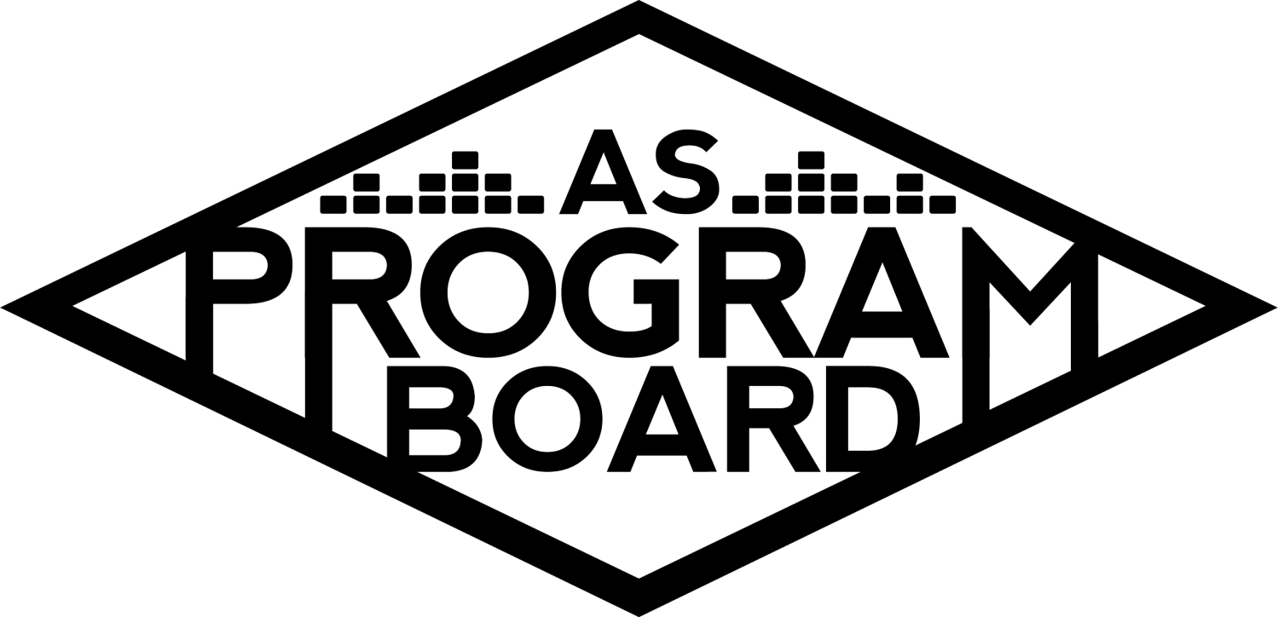
Program Board Minutes

Associated Students

January 11th, 2021
Remote

CALL TO ORDER: 5:03PM by Kathryn Quinones
A. MEETING BUSINESS
- Roll Call
Name | Note:  absent (excused/not excused)  arrived late (time)  departed early (time)  proxy (full name) | Name | Note:  absent (excused/not excused)  arrived late (time)  departed early (time)  proxy (full name)
Adam Salton
Alexis Xa |  | Kathryn Quinones
Celine Liu |  | Lucas Jackson
Emily Duong |  | Sophia Castro
Emily Kocis | Early Departure 6:00 | Hayley Slater | Excused
Enaiya Judkins |  | Bee Schaefer | Absent
Gabriel Reyes | Early Departure 6:45
Halle Dawite
Jake Einsiedl

Acceptance of excused absences, absences, early departure and proxies
Motion to accept the early departure of Emily K and Gabe and the Absence of Hayley and Bee. Motion by Jake, Second by Emily D. Consent with 11 present.

B. PUBLIC FORUM

C. ACCEPTANCE of AGENDA/CHANGES to AGENDA
Motion to accept the agenda. Motion by Alexis, second by Gabe. Consent with 11 present.

D.ACCEPTANCE of ACTION SUMMARY/MINUTES
Motion to accept 1/4/2021 minutes. Motion by Gabe, second by Lucas. Consent with 11 present.

E. ANNOUNCEMENTS
- Land Acknowledgement
- Office Hours
  - Deadline was Saturday 1/09/2021
  - Kat checked on Saturday and if you still have not put them in DO IT
  - Kat is tracking who goes to their office hours through Discord
  - BE HONEST ABOUT YOUR HOURS
- No meeting next week
  - MLK day holiday so no meeting next week

G. WEEK IN REVIEW

H. PREVIEW OF THE WEEK
- HOAX 1/13
  - First event of the quarter
  - Everything is good to go
  - Enaiya just posted the graphic on Insta
  - Please like and share the post
- Artist A 1/21
  - Talked about the graphic with Emily
  - Been working on the contract with MD
  - Alexis was super helpful to Sophia in planning the show

I. OLD BUSINESS
- Storke Shows
  - Artist B
    - Emily is aiming for week 7 (15 or 19 of Feb)
    - Will start on the contract once there is more of a set date
  - Artist C 2/3
    - Only thing left is contract and Graphic
  - Artist D
    - Have not heard from them but Adam has reached out to a different DJ for a sunset set
  - Artist E 1/28
    - Going good only Graphic and contract left
  - Storke Show lineup
    - Do we want a graphic that shows the storke shows week by week?
    - We can announce four of the shows all at once
    - Talk to graphics so they know when to do it by
- Instagram Filter
  - What ASPB playlist are you?
    - Shout out to everyone that used it so far
    - Surprisingly a lot came from Facebook
    - Ambassadors used it a lot
    - Went pretty smoothly
- TWU 4/3/2021
  - Artists
    - Working on getting the offer for Artist F out hopefully tomorrow morning
    - The offer expires next monday
    - Will focus on headliner before we go onto opener in case we have to go a separate route
  - Shirts
    - Reached out to graphics to give them a better time frame for the designs
- Winter Quarter Show
  - Artist G
    - Contract should get back to Alexis tomorrow
  - Artist H
    - Her asking has increased to be higher than Artist G
    - We cannot send an offer higher to the opener than to the headliner
    - We sent the offer for 10k less than her new offer
    - If she passes we will move on to Artist I
  - Gabe suggested the name Chill Sesh
  - Enaiya- should we do insta or Facebook ads?
    - Adam, Aexis, and Jake think it's worth it
    - They are already budgeted for
    - $250 over 6 days would reach between 35k to 90k people on ig
    - It can be limited to location interests and age
    - Also we are not using the money for printing so we can use this as a substitute
- Winter Quarter Hub Shows
  - Artist J 2/18
    - Confirmed for a full band 40min performance and 20min q and a starting at 8pm
    - Want to announce on 2/8
    - Chat monitors: Celine and Emily D
    - Get moderator for Q&A next meeting
  - Artist K
    - Just sent the offer to MD for 3/4 for 9k
    - Would be a full band performance
    - 40 min performance and 20 min q and a starting at 8pm
- Ambassadors
  - Meetings
    - Thanks Jake and Emily for doing the first one
    - Jake- it was a good meeting very fun
    - Emily- they were a little quiet but still a good meeting
    - Discussed new ideas for filters
    - Could be an interesting idea to do a podcast playlist
    - Would not have enough podcasts to do very specific playlists for podcasts
    - Valentine’s week might be a Love/hate playlist or maybe two separate playlists
    - We could do a edm week playlist
    - Childhood playlist could be fun
    - Skater music playlist?
- ASPB Sweaters
  - Reached out to graphics to give them a better time frame for the designs
  - Current ASPB logo on the chest?
  - Festival lineup vibe with our names? Biggest artists we’ve had in the past?
  - Big design would go on back and small logo on front
  - Maybe embroidery on sleeve like champion does
  - Would be nice to do an image instead of just a line up of names
- Festive Programming
  - No major updates but hopefully can order the items soon
  - As soon as we order the items we will discuss a date in the slack
  - Lucas- wants to bring Yerba Mates to help bring people to the event
- Extravaganza
  - How many days do we want?
    - Jake- 2 would be good if we can do a mix of events with cultural like delirium was
    - Gabe- we could do a similar thing to what we did for delirium
    - Lucas- agrees that 2 days would be good
    - Sophia- an in conversation on the first day could be fun
    - Halle- was initially going to say 1 day to recreate vibe of in person event but 2 days went well for delirium
    - Emily K- thinks 2 days would be good especially if it's a mix of events
- Website
  - Celine and adam met during office hours and it is almost functioning for what we have right now
  - Will do a total overhaul after so that it would look better after we make sure it works
  - There is an issue with all of the AS servers so it will not go live today
  - Judy Ann said she will try to recreate what Celine and Adam made but we will see how that goes
- Swank Films
  - Lucas tried to get a quote but they said there was too many variables to give a solid quote
  - Lucas and enaiya have been going through the catalog to figure out what we might want to go with
  - Might want to do a movie around Valentine’s and show a chick flick
  - Next meeting we will come back with a list of 4 movies for board to pick from
  - We can do an IG poll to see what the students want to watch
- Cultural Event
  - Gabe working on getting quotes and lots of people have increased their asking
  - Looking at Artist L, Artist M, and Artist N
  - Could be cool to do a mini Hot ones with Sean Evans
  - We have a lot of responses to the poll and a lot are about SNL affiliated people
  - Artist O could be an interesting event but Gabe does not know who manages them
  - An athlete could be a fun and motivating event (ex. NBA players, Artist P, or Artist Q)
    - Artist Q might be better for a smaller event where they lead a workout on like a saturday morning
    - Enaiya- was responsive and willing to do an event
  - Halle- sees Artist R requested a lot on the polls
  - Sophia- A chef could be great like the chefs that are/ used to be associated with Artist S
  - Artist T asking is around 75k from what Gabe remembers but could be a great event

J. NEW BUSINESS
- Winter Quarter Hiring
  - We are going to be hiring a DMC and special events assistant
  - Hoping to put apps out tomorrow
  - It will be on the old website
  - Keep the apps open until the 17th
  - Emily D can make the graphic tonight
  - Hoping to pub tomorrow evening
  - The app will go through a google form because it will export onto a spreadsheet easily
  - Might cut down on the questions and add a spot for a resume to be added
  - Ambassador apps were open for 12 days and got 30 applicants
  - Keeping the apps open until the 22nd might be better
  - The questions can be shortened and leave some questions for the interview instead
  - Need to get a committee together to help hold the interviews
    - Alexis, Lucas, and Enaiya will be available to help
- Payment Change
  - MD, Kris, and Kat discussed changing stipends for assistants to be $1,000 as well and possibly increasing everyone's stipends for spring to be $1,200 because of how much more work Spring is
  - Will be discussing further on the 25th

K. ACTION ITEMS

L. FINANCIAL ACTION ITEMS

M. REPORT
Facebook Factory / Tuesday Slide / Thursday Ad/ Free & For Sale post
- IG Filters

Kudos
Kat, MD, Kris, and both Emilys for helping alexis with no assistant
Alexis for being great and doing so much work without having an assistant
Emily k for taking over the Artist B storke show
Emily d for the hoax graphic
Enaiya for being a great coworker and a fast responder
MD for meeting
The hiring committee

The Marilyn Report
Dont forget to vote in the AS election. The UC made an announcement that he intends to be in person in Fall. Do not let up with Safety because it is very important
The Kris Report
Out till Wednesday
Commissioner's Report
So excited about uc announcement and excited to see what everyone is working on. Excited for hiring and the interview process
Deputy Commissioner’s Report
Excited to keep working with enaiya and excited for future events because we are working on cool stuff
Coordinators’ Reports
Adam- continuing to work on the website with celine and a storke show
Alexis- excited for everything, and first storke show, pledging a frat, feel free to call or text
Celine- excited to make more progress on the winter show also very excited for twu. Officially maxed out on units for the quarter so very busy
Enaiya-really excited for the Hoax show. Also excited for office hours tomorrow. Let her know if there is something weird in posts
Gabe- yield
Jake- will keep us updated on future shows. Give him suggestions for spring

Assistants’ Reports
Emily D- working on weekly stuff and very excited for Artist G. Good job finishing week 1
Emily K- excited for everything coming up especially for alexis to get an assistant, also started working in person
Halle- post stuff for hoax and lots of replies to the poll so far
Sophia- doing playlists and we are the most consistent with posting playlists of the ucs. Please talk about podcasts to her
Senator’s Reports
Bee-
Hayley-

ADJOURNMENT: 7:02PM by Kathryn Quinones

Artists mentioned: Dan Levy, Tony Hawk, DJ Jesse, Role Model, Nick Kroll, Andy Samberg, Art Official, Still Woozy, Try Guys, Phoebe Bridgers, DC Sings, Sean Evans, Chloe Ting, Giveon, Lunar Vacation, Gus Dapperton, Bon Appetit, Playyard, Jordan Peele, Pink Sweat$

