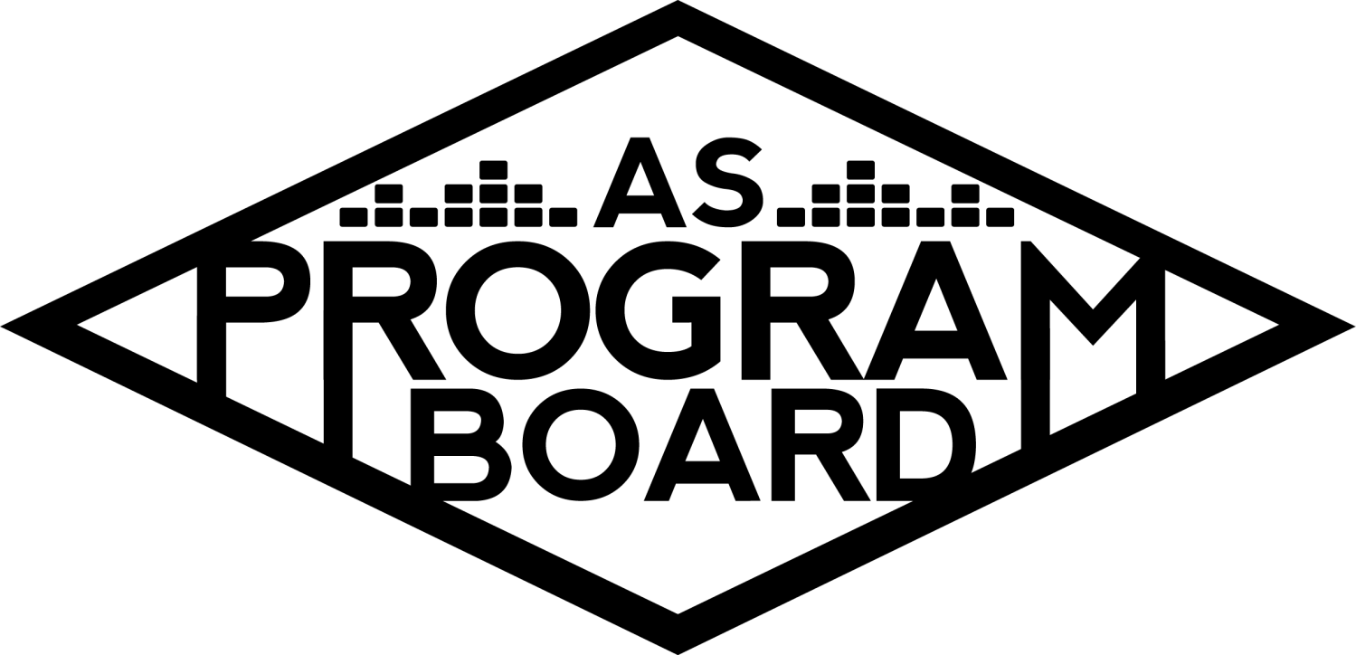
Program Board Agenda

Associated Students

January 4th, 2021
Remote

CALL TO ORDER: 5:02PM by Kathryn Quinones
A. MEETING BUSINESS
- Roll Call
Name | Note:  absent (excused/not excused)  arrived late (time)  departed early (time)  proxy (full name) | Name | Note:  absent (excused/not excused)  arrived late (time)  departed early (time)  proxy (full name)
Adam Salton
Alexis Xa |  | Kathryn Quinones
Celine Liu |  | Lucas Jackson
Emily Duong |  | Sophia Castro
Emily Kocis |  | Hayley Slater
Enaiya Judkins |  | Bee Schaefer
Gabriel Reyes
Halle Dawite
Jake Einsiedl

Acceptance of excused absences, absences, early departure and proxies
N/A

B. PUBLIC FORUM

C. ACCEPTANCE of AGENDA/CHANGES to AGENDA
Motion to accept the agenda. Motion by Jake, second by Gabe. Consent with 13 present.

D.ACCEPTANCE of ACTION SUMMARY/MINUTES
Motion to accept 11/30 minutes. Motion by Gabe, second by Alexis. Consent with 13 present.

E. ANNOUNCEMENTS
- Land Acknowledgement
- WE BACK BOII
- Office Hours
  - Please have your set office hours by this saturday at 5pm
  - Do your office hours this week
  - New office hour switch to Discord

G. WEEK IN REVIEW

H. PREVIEW OF THE WEEK

I. OLD BUSINESS
- Storke Shows
  - Artist A TBD
    - There were a lot of issues last quarter but they said they will contact Jake for this quarter
    - He will reach out to them and touch base with them
    - See if they want to reschedule the show or not
  - Artist B 1/13
    - Their agent has been less responsive than before
    - no graphic yet
    - As soon as Alexis has images she will send them to Emily
    - Working on contract
  - Artist C 2/3
    - Alexis will confirm a time with them
    - Emily already has the graphic from Alexis
    - Once the time is received, the contract can be made
  - Artist D TBD
    - Have not really heard anything and they have not reached out to Adam
    - Adam is instead reaching out to other artists to see if they would be interested in doing a Show
    - Possibly some DJ sets
    - Other local IV artists
  - Artist E
    - Scheduled to play on Thursday 1/21
    - Sophia is working on the contract with MD
    - Will be getting the graphic to Emily soon
  - Artist F
    - Will perform before Lunar Vacation on 1/28
  - We could release a Storke Show lineup with all of the artists that we have confirmed so far
  - Get your times and W9s to MD as soon as you can so she can get the contracts put together
- Instagram Filter
  - Celine made a great winter filter to use during finals week
  - A lot of people including the ambassadors used it
  - Halle was a great model
  - Sophia learned Spark AI and is working on “what spotify playlist are you” filter
  - Might work on a “What ASPB event are you?” filter
  - “What ASPB artist alum are you”
  - Send sophia ideas for new filters
- TWU 4/3/2021
  - Artists
    - Would be great to solidify an artist choice
    - A good part of the board is discussing Artist G
    - Sent the offer to Artist H right before the holidays but it doesn’t look good in Alexis’ opinion
    - Artist G
      - Agree that they are a good choice but hesitant because of Gunna’s turnout
      - Their hype was more over summer than it is right now
      - Still a chance that their performance could be pre recorded
      - Adam thinks it will be a repeat of Gunna as well
      - We should also consider artists that people feel a more personal connection with
      - Has notability but unsure about turnout
    - Artist I
      - His asking in now 50k
      - He has gotten a lot of requests by students
      - Was written on artist request sheets a lot
      - Did not feel comfortable with 50k but Omar brought so many people as a lower name artist
      - Would prefer pre recorded but if we gave a strong enough offer he would do live
    - Artist J
      - Might be too similar to Omar Apollo who we recently had
      - He blew up and became a lot more mainstream in the last couple of months since his album dropped
    - Artist K
      - Turned us down because we didn’t send a strong enough offer
      - We can still submit a higher offer
      - Might have a bigger following at UCSB than Artist G
  - Shirts
    - Companies said they can’t give a solid quote until we have a design
- Winter Quarter Show
  - Artist L
    - The contract is out but we have not heard back
    - And we got an image to Celine
  - Openers
    - Artist M passed because they had deadlines they had to meet with their recording company
    - Artist N
      - 5mil monthly listeners and a lot are in LA
      - Fans would want to interact and see her do a live show
      - Was on Artist O most recent album
      - Will probably perform with a band
      - Has an interesting personality
      - Nominated for multiple grammys
    - Artist P
      - Asking price is kind of high
      - Less heard of than other artists
      - Enaiya had no one she knew who was listening to him but knew people that were listening to Artist N
    - Artist Q
      - Could be great for representation
      - Also on the smaller side
      - An opener’s opener
    - Artist R
      - Only people that listen to them are people who are pretty into music
      - Could make it a smaller crowd
    - Artist S
      - Not good live

- Winter Quarter Hub Shows
  - Artist T 2/18
    - Confirmed for a full band 40min performance and 20min q and a
    - Want to announce on 2/8
  - Other offers
    - Asked about Artist U and is hoping to book for 3/4
- Ambassadors
  - Sophia will send a link in the chat for meetings with the ambassadors
  - They want to meet us!!
  - Message Sophia if want something on the agenda to talk to them about something
- ASPB Masks & Sanitizers
  - Lucas has them to distribute and use for anything we want!
- ASPB Sweaters
  - Companies would want a design first before giving a better quote
- Festive Programming
  - Would want to hand them out safely at a park with masks and sanitizers too

J. NEW BUSINESS
- Board Collaboration Meeting & Recap
  - Kat had a meeting with Georgetown’s ASPB over break
  - They have a pretty different board structure to us and have a much lower budget
  - Marketing tactics focus on social media and word of mouth
  - Average around 100 people or less for their events unless it was a really well known artist
  - Most events are smaller with orgs on campus
  - For comedy they had the audience had their mics and cameras on to get live reaction
  - Had a max of 400 attend an event
  - From this collab Kat is beginning to see the attendance at our events as a win
- Website!!!!!!
  - Celine can edit the website before it goes live
  - Almost done and just needs to work on the event page
  - Send Celine the photos so she can make the About us page
- Swank Films
  - MD met with an advisor from UCR and they get movies through Swank
  - Kat sent the info flyer in the meeting email
  - You buy a license for the movie and you have access to the link for 24 hours
  - Expanded to off campus as well as on campus for the movie screenings
  - Everyone watches the movie separately and there is no chat feature yet
  - We could do it through livetweet or maybe discord
  - Lucas and Enaiya will spearhead
- Cultural Event
  - Budget is for 2 weeks before finals week
  - Gabe is still brainstorming ideas
  - Could be cool to do a political commentator
  - Or could be fun to do more actors
  - Hoping to have something solidified by the end of the week
  - Also looking into Artist V
  - Gabes top two are Artist W and Artist V
- Winter Pub Budget
  - Similar to last quarters pub budget
  - Cut down the postering section
  - Left money for snapchat filters and digital ads
- Extravaganza
  - Probably will not have a full blown lineup with 5 or 6 artists
  - Rude to make someone sit in front of a screen for that long
  - Might not want to call it Extravaganza so we do not get backlash
  - Especially because the university mentioned the seniors could come back
  - Even the ambassadors were coming for our throats
  - Could do smaller artists on multiple days leading up to a bigger artist at the end
  - We are limited to the top price we can pay an artist so we can’t pool the budget together for a crazy huge artist
  - Leaning more towards one day
  - Maybe other bookers can help alexis
  - Since we’re not calling it extrav we might not need to do 3 days of events

K. ACTION ITEMS

L. FINANCIAL ACTION ITEMS
- Motion to pass up to $30k for Artist N as opener for Winter Quarter Concert on 1/29. Motion by Alexis, Second by Gabe. Consent with 12 present.
- Motion to pass Artist I as headliner for TWU on 4/3 starting at 40k and ending at 50k and Artist K as headliner contingency for TWU on 4/3 starting at 45k and ending at 50k. Motion by Alexis, Second by Emily. Consent with 12 present.
- Motion to pass Artist X as opener contingency for Winter Quarter Concert on 1/29 up to 25k. Motion by Alexis, Second by Emily. Consent with 12 present.
- Motion to pass $500 for festive programming items (date TBD) starting and ending at $500. Motion by Alexis, Second by Jake. Consent with 12 present.
- Motion to pass $25k for Cultural Event on 3/2.Motion by Gabe, Second by Emily. Consent with 12 present.
- Motion to pass $1,650 for Winter pub budget. Motion by Enaiya, Second by Sophia. Consent with 12 present.

M. REPORT
Facebook Factory / Tuesday Slide / Thursday Ad
- Free & For Sale post

Kudos
Jake and emily k for going first for ambassador meeting
Sophia for being creative and a go getter
Alexis for having so much on her plate and still being amazing
Celine for the great website
Graphics for T-shirt designs
Halle for modeling for the graphic
Everyone that has cameras on

The Marilyn Report
Welcome back everyone! Happy New Year! Send MD the times for events for contracts! There is an AS special election next week. Kat will work on the budget for next year with MD
The Kris Report
Excited for a potential event next week. Kris is out for meeting next week. Will post office hours on slack
Commissioner's Report
Excited for using discord for OH this week. Trying to actualize requests from last quarter. Wants to start an event sheet with attendance.
Deputy Commissioner’s Report
Excited for the quarter! Keep up the great work everyone!
Coordinators’ Reports
Adam- Excited with the switch to discord! Working on the website and storke shows
Alexis-Suggest names for the winter quarter event! Great discussion today! Wishing everyone a great winter quarter
Celine- please send photos for the website!
Enaiya-Excited to be working with Lucas on an event! Let her know if you need her help! Excited for the quarter
Gabe- excited to work on events during his last academic quarter at UCSB. remind him if you need him
Jake- Artist T show looking good. Will keep us updated on Artist U

Assistants’ Reports
Emily D- Excited to be back for winter quarter. Working on designs for shirts and sweaters.
Emily K- excited to see what everyone is working on for this quarter! Great discussion everyone
Halle- happy first day of winter quarter! Excited to pub events! Dont stress Enaiya out
Sophia- playlist of the week is hidden gems! Please send them through discord. Also please send playlist ideas to Sophia. Contacted businesses to play our playlists. Thanks for signing up to go to ambassador meetings
Senator’s Reports
Bee-
Hayley-special elections for as president so look at candidates! Voting is on the 11th

ADJOURNMENT: 7:37PM by Kathryn Quinones

Artists mentioned: Art Official, Don Toliver, Phoebe Bridgers, Peach Tree Rascals, Dominic Fike, Lunar Vacation, Kid Cudi, Role Model, Willow, Dan Levy, Dj Jesse, Gus Dapperton, Still Woozy, DC Sings, HOAX, The Marias, Giveon, Niki, Berhana, Keshi, Alina Baraz, Playyard, Evan Peters, Pink Sweat$

