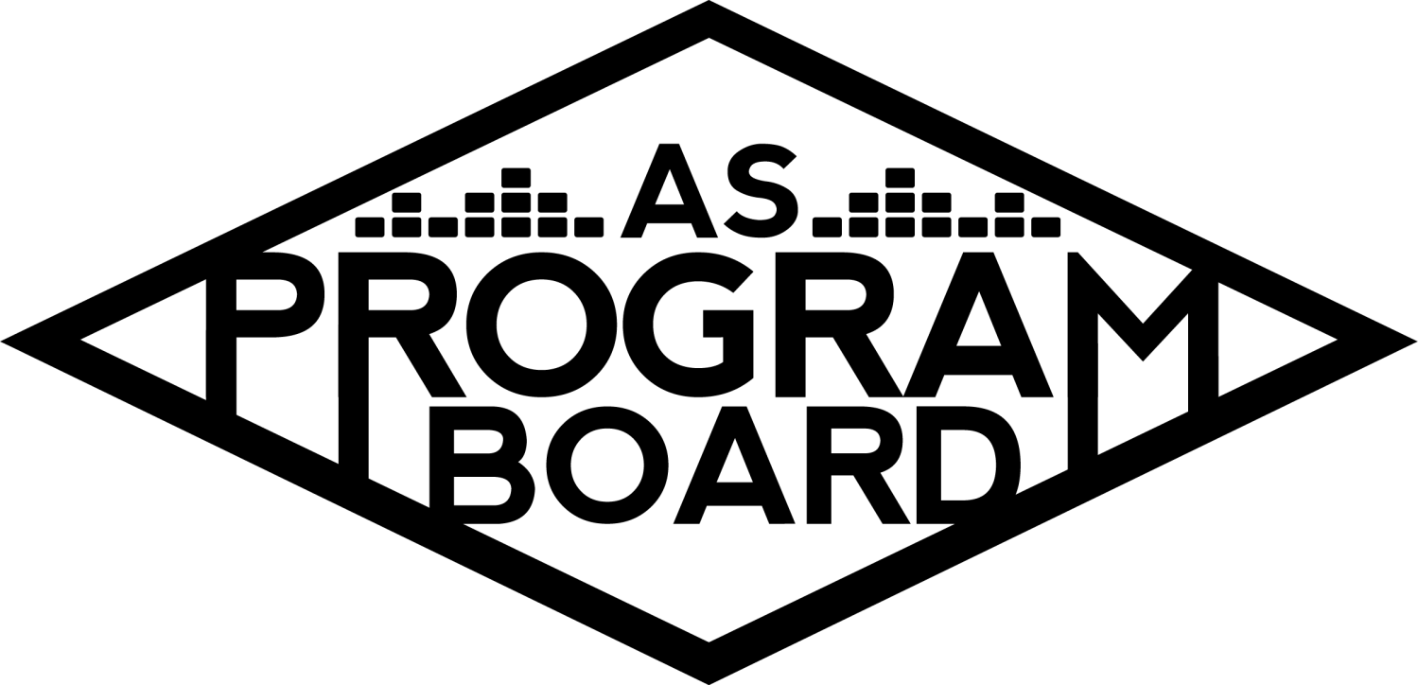
Program Board Minutes

Associated Students

April 5th, 2021

Remote Meeting

CALL TO ORDER: 5:03 PM by Kathryn Quinones
A. MEETING BUSINESS
- Roll Call
Name | Note:  absent (excused/not excused)  arrived late (time)  departed early (time)  proxy (full name) | Name | Note:  absent (excused/not excused)  arrived late (time)  departed early (time)  proxy (full name)
Adam Salton | Late Arrival 6:45 pm
Alexis Xa |  | Kathryn Quinones
Celine Liu |  | Kathryn Supple
Emily Duong |  | Kim Kryshak
Emily Kocis |  | Lucas Jackson | Late Arrival 5:08
Enaiya Judkins |  | Sophia Castro
Gabriel Reyes |  | Hayley Slater | Absent
Halle Dawite |  | Bee Schaefer | Absent
Jake Einsiedl

Acceptance of excused absences, absences, early departure and proxies
Motion to excuse absence of Hayley, Bee & late Arrival of Adam and Lucas. Motion by Jake, Second by Emily K.. Consent with 11 present.

B. PUBLIC FORUM

C. ACCEPTANCE of AGENDA/CHANGES to AGENDA
Motion to accept the agenda. Motion by Jake, second by Halle. Consent with 12 present.

D.ACCEPTANCE of ACTION SUMMARY/MINUTES
Motion to accept 3/29/2021 minutes. Motion by Halle, second by Jake. Consent with 12 present.

E. ANNOUNCEMENTS
- Land Acknowledgement
- Check In: How did you spend your day today?

G. WEEK IN REVIEW
- The Warm Up 4/3
  - Artists Performances
    - 451 total people with 231 max at one time
    - Lower compared to other concerts
    - Late cancellation from NIKI and contract from Flo Milli
    - Her performance was 22 minutes and prerecorded
    - The q and a went slightly longer to make up for the time lost to the short performance
    - Q and A went really well with Enaiya and Halle
    - People could not really tell that Flo Milli’s set was pre recorded
    - Flo Milli was absolutely zooming through the questions and it might be good to establish a protocol for if they go too fast
      - Gabe- its better to have more questions than needed. For Quinta gabe was live editing the question doc
      - Jake- we could pull more from the students like the chat and the q&a portion of the zoom
      - Enaiya- the student questions were not that great and her manager was answering them in the q&a box
      - MD suggests having as many questions as there are minutes in the q&a so that even if they only take a minute per question we will have enough questions
      - We could also ask the artists to elaborate on their answers to try to get more out of them
      - Could have a general question doc in the drive that does not pertain to anyone specific but we could use if we have extra time
      - Gabe- gabe can upload his q&a docs to the drive for inspiration or reference for future q&a’s
    - Adam and Gabe did a test run of the pre recorded set and it went well
    - When NIKI cancelled they agreed to perform at a later date after she recovers from the wisdom teeth surgery
      - It would be an extra event it would still also be 50k out of our budget
      - A lot of people were excited for NIKI and are upset about the cancellation so it will be good to still have the show happen
  - Giveaway
    - Went smoothly and the first winner did not claim the prize but the second did
    - Had less entries this time than for the other giveaway
    - Not enough people signed up to give away the merch so we will have left over merch bundles
  - Merch (T-shirts, tote bags, dad hats)
    - We will have extra merch bundles than people because not enough people signed up
    - Some students like older designs so maybe we can give them away at a later date
    - Depending on how many we want to save then we can open it up to more people that want to get them
    - Maybe require people to follow us on social media
    - We can save them to give away during tabling or during other events
    - People will be cut out of shifts because there is more people than necessary

H. PREVIEW OF THE WEEK
- Free Tuesday Film: Twilight 4/6
  - There are not that many people registered already
  - We can have up to 200 people
  - On shoreline you sign in with your UCSB
  - When do we want to start sending out links? The link is active for the entirety of Tues
    - We can send out the movie link but the passphrase later or tomorrow
    - Send out the links tomorrow after the pub push tonight
    - Emily D- we want to create a community so maybe put them out around when we will live tweet it
    - Celine- would rather choose my own time to watch it with my friends
    - Brand it as a watch with us at 7 but allow them to watch at any time before midnight
  - One issue that we have was having everyone watch together when it is open but we want people to have everyone watch together with us as Enaiya live tweets

I. OLD BUSINESS
- Ambassadors
  - Last week was a great meeting with Enaiya and Halle
  - Got to talk about the film and what they want to get out of the live tweets
  - Putting out a playlist on friday and a new music monday on the following monday to be more interactive with the playlists
  - Also great to have them involved on the insta
  - Blogs -- one following TWU?
    - Still working on who is doing them and when
    - Maybe Kathryn can discuss it with them at the next ambassador meeting
    - Also a great way to introduce DMC to the ambassadors
  - If anyone wants to go to ambassador meetings to discuss anything please let Sophia know
  - Meeting time for this quarter will be finalized soon
- Spotify Playlists
  - https://docs.google.com/spreadsheets/d/1Ob7DQoIy3dos4jwvwJyzfKt9f05FbTCAiTIsmWgQbEw/edit?usp=sharing
- ASPB Sweaters
  - Design
    - Finalized today and emailed to Lucas
    - Will be a transparent background
  - Ordering
    - Lucas will start to look into companies today to get quotes
- Extravaganza 5/15-16
  - Day One: Saturday
    - Artist
      - Asked about a 6pm start time
      - Everything is going swimmingly and will start on questions soon
      - Emily K and Lucas will help with questions
    - Event Structure
      - Keynote followed by q and a
  - Day Two: Sunday
    - Artists
    - Event structure
      - Drove to the drive in yesterday about the possibility of the concert
      - Kind of at a stand still because of having to hear back from the drive in itself
      - We should talk about headliner, contingency, and slot 2
      - Now just waiting on a response from the Drive in corporate team
      - MD-Should we wait on the response from the team or are they holding us back too much? We could use the drive in for a different event
        - If we don’t use it for extrav we can use it for a later date
        - Holding a movie would be a simpler event
        - Extrav might be too lofty of a goal to do at the drive in
        - A smaller caliber event would also be simpler because of what we want out of an extrav because of the time constraints
        - Jake- one of the main reasons i pushed the drive in was because of the artists suggested and because a band would do well and be engaging
        - Sophia- lots of people have been to drive in concerts and it might be hard to match that. Also be more fulfilling to do a movie because we can turn out an event that will match expectations
      - Should we do a comedy act at the drive in?
        - Would not do as well as the band
        - Not as intimate as other comedy venues
        - People going for a comedian but would need to be for a high caliber talent
  - Theme
    - Celine wants ideas for the theme for Extrav for this year
    - Extrav will still be named Extrav because of how we named the other events
    - Something simple
      - Beach themes
      - Spring flowery
      - Could be like a cute garden theme
      - Mad hatter/alice in wonderland
      - Candyland/wonderland
      - Carnival theme
      - Space Jam
      - Retro theme- like throwback
      - Time travel theme with different decades- futuristic and past clash
      - Safari theme
      - Cartoony theme of IV with the neighborhood of IV
      - Springtime background colors and trees but showing iv and the neighborhood with a more retro artistic style

- Swank Films Future Showings
  - Next date
    - Hopefully 4/20
  - Next movie & pub
    - Want to poll students with movie choices to see what students want
  - Could do like little goodie bags with a bag of popcorn and some candy or a few bigger ones
    - Maybe one house or apartment wins something together
    - Voted on doing multiple
      - Popcorn bucket, popcorn bag, candy, maybe popcorn seasoning, licorice
- Cultural Events
  - Artists A TBD
    - Just got an email back confirming the May 6th date @ 7pm
    - Will reach out to Lucas and Emily K for help
- Spring Hub Shows
  - Yung Baby Tate 4/15 8 pm
    - 30 minute performance with 20 minute Q&A and manifestation board making
    - Emily kocis and Kat monitoring chat
    - Halle & sophia moderating and making vision boards
  - Graphic approved and planning to announce tomorrow
  - Contract is also approved
  - Was able to get the insurance minimum reduced
  - Shared the q&a brainstorm with Halle and Sophia
  - Will try get a sound check day and time finalized
- Artist B Updates
  - Asking price shot up pretty high
  - They might not be together
  - Not moving forward with the event
  - Gabe has taken the date
  - Giving out money is not part of the ASPB mission so that is why we push for groups to reach out to others first
- Storke Shows
  - Hoping to have a more confirmed schedule but there was a conflict last minute
  - Want to have a more defined schedule next week
  - Want to plan them in the pocket between other events
  - The first one is planned for 4/22
  - Contracts take time so plan ahead
  - Send suggestions to Kimberly if you can think of any artists
- Hiring for 2021-2022
  - Hiring committee: Celine, Sophia, Jake, Gabe, Adam, Hayley, Bee
  - Sent gabe question docs from last years
  - Sent Kris some scheduling items
  - If you are part of the committee and need stuff from the commissioner drive let Kat know
  - Want to release applications as soon as possible by next wednesday at the latest and have them open from 2-3 weeks
  - Gabe will set out a time to edit the talk in a meeting with MD and Kris
  - Emily D will make a hiring graphic once she has more info
  - Make sure the job descriptions are detailed enough that the people actually understand what they are applying for

J. NEW BUSINESS

K. ACTION ITEMS

L. FINANCIAL ACTION ITEMS

M. REPORT
Facebook Factory / Tuesday Slide / Thursday Ad/ Free & For Sale post

Kudos
Everyone that helped with twu
Enaiya for comoderating with Halle
Halle for doing the most and being amazing
Kathryn for the beautiful newsletter
Graphics for the young baby tate graphic
Enaiya for being a great films partner
Ambassadors for watching Enaiya and Halle lose it in their meeting
Halle and Emily for trying to put on an event
Gabe for graduating
Gabe and jake for funny filters
The Marilyn Report
Glad to hear everyone is getting the vaccine. Heard some interesting news about changes for the campus about our ability to hire outside security
The Kris Report
Great to see everyone!
Commissioner's Report
Great work on TWU everyone. Hope your week 1 went well and you figure out your schedule. Finalize office hours

Deputy Commissioner’s Report
Excited for the movie please register and pub. Enaiya’s live tweets will be funny
Coordinators’ Reports
Adam- 6 hour drive, help him find a vaccine
Alexis- glad TWU is over, excited for twilight, hope everyone gets their vaccines and stays safe
Celine-really happy for twu graphics and learning new techniques to hopefully use on Extrav. The YBT graphic looks great. Also part of a design-a-thon so will be busy
Enaiya- excited for twilight, excited for LUCAS to do the takeover tomorrow, excited for yung baby tate, finalized office hours
Gabe- Working on Artist A and Artist C Logistics. Have to buy graduation stuff that is expensive
Jake- gonna keep working on YBT
Kathryn- working on website, blogs and what not

Assistants’ Reports
Emily D- Excited to watch twilight for the first time.
Emily K- so excited for lucas’s takeover, excited to tweet at halle and enaiya tomorrow, excited for hub show
Halle- excited to moderate yung baby tate and to make a vision board for it. Excited to do class and get back on track. Shout out to the Flomillitia
Kim- working on storke shows, learning a lot from alexis, hoping to be more productive the next few days
Sophia- Suggestions for the get ready with me playlist on wednesday and be out on Friday

Senator’s Reports
Bee-
Hayley-

ADJOURNMENT: 7:28 PM by Kathryn Quinones

Artists mentioned: Hasan Minhaj, Chloe x Halle, Try Guys

