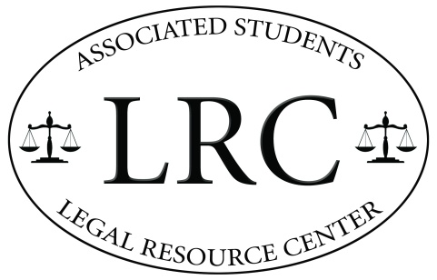
Winter 2015 Meeting Minutes
1 May 2015
1:00 pm – 2:00 pm
Pardall Center | LRC Office
MINUTES

- Meeting Start: 2:00 pm

- Roll Call: ✗✓
Amanda Dillon – Legal Assistant ✓
Connor Boehm – Legal Assistant ✓
Clara Perez – Legal Assistant ✓
Danielle Santucci – Legal Assistant ✓
Delaney Moore – Legal Assistant ✓
Jacie Valentine – Legal Assistant ✓
Marsha Levinson – Legal Assistant ✗
Richard Nellari – Legal Assistant ✓
Dylan Lynch – Web Developer ✓
Kevin Dibb – Student Director ✓
Corydon Graves – Caseworker ✓
Robin Unander – Attorney ✗

- Guests:
n/a (ig. Someone comes to photograph us, non-LRC person comes to present an idea)

- Officer Reports:
Danielle Santucci: Added Zona Seca info to Intern Manuel // Organize case information into a table?

Dylan Lynch: Intake Update

Kevin Dibb: $80 for 20 50pg pads (LRC Branded Notepads) // Sign $750 and $700 for installation, want to spend more money for a more asthetically pleasing sign

Corydon Graves: 2 Things // Review how to fill out the hour log & handle intakes // Small claims next Wednesday at 1:15PM! //

- Action Items:
- Approve Funding for LRC Branded Notepads
The advisory board recommends proceeding with the purchase of LRC branded notepads.

- Information Items:
- Brainstorm Intern Projects // Assign Projects!
- Our Own Phone Line
- Tabling for This Quarter
- Notary Service?
- Photos from Andy // May 15th
- Beachside Café Celebration! // June 5th 5:00pm

- Adjournment: 3:00 pm

Minutes/Agenda handled by Dylan Lynch, please email dlynch305@gmail.com with any comments/concerns.

