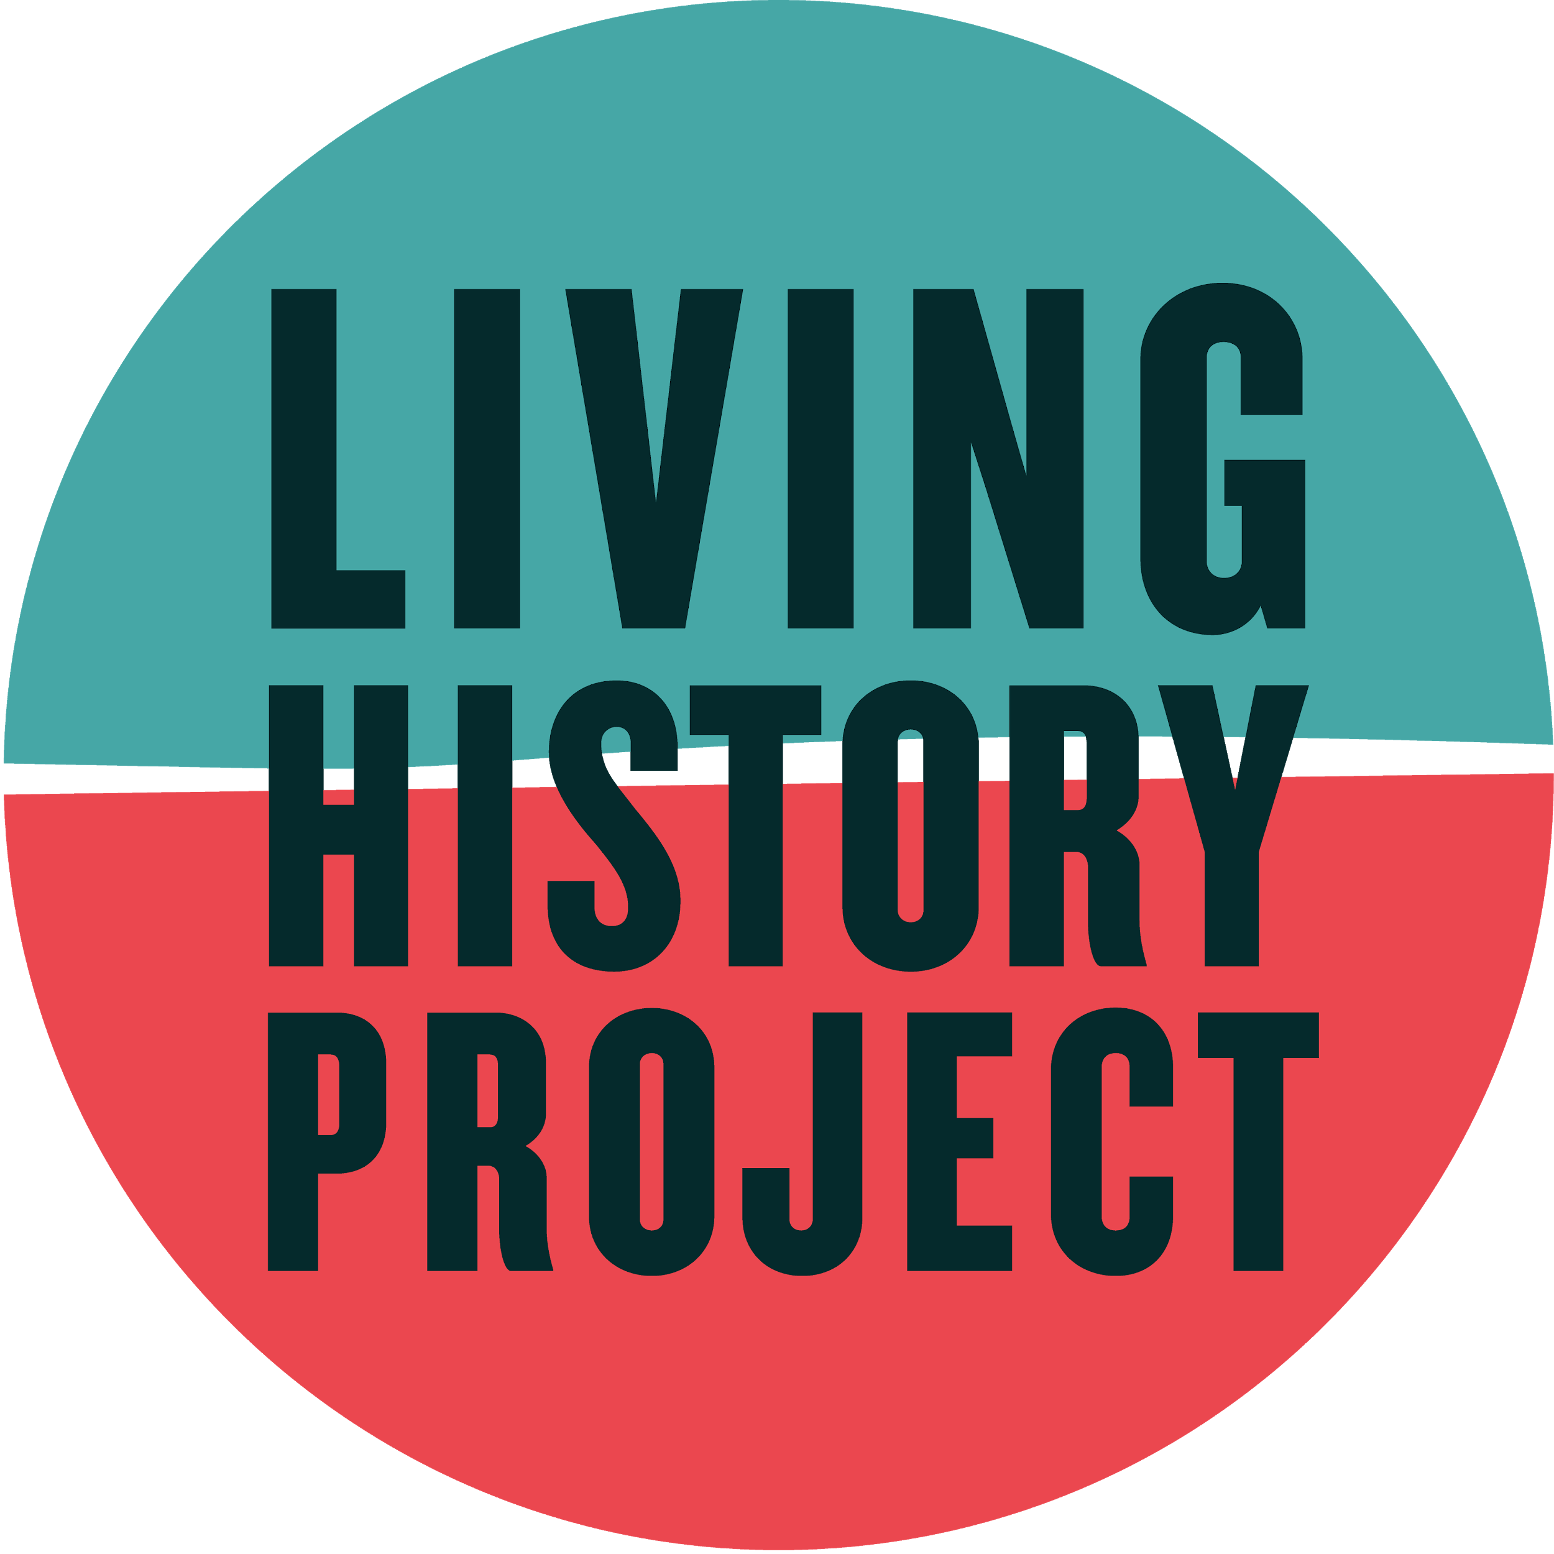
Living History Project MINUTES

Associated Students
DATE: 9/26/20
LOCATION: Zoom Minutes/Actions recorded by: Frances Woo

CALL TO ORDER: 5:00 by Frances Woo, Chair

A) MEETING BUSINESS
A-1. Roll Call

Name | Note:  absent (excused/not excused)  arrived late (time)  departed early (time)  proxy (full name) | Name | Note:  absent (excused/not excused)  arrived late (time)  departed early (time)  proxy (full name)
Frances Woo | X
Jillian Wertzberger | X
Katelyn Wong | X
Alana Ulloa | Absent (excused)
Shuo Chen | X

A-2. Acceptance of Excused Absences
MOTION/SECOND: Woo/Wertzberger
Motion Language: Excuse Alana’s absence
ACTION: Vote: 4-0 to APPROVE.
Attendance:

A-3. Acceptance of Proxies

B. PUBLIC FORUM/OPEN FORUM

C. REPORTS -
C-1. Advisor’s Report -
(if you’re comfortable) chat a little and give us a room tour !! if you’re not comfortable sharing your room, you can share a story from this past week (good/bad/exciting/ranting/etc.)!

C-2. Chair Report

- Executive Meeting Dates/Times - Fridays:
- Fridays, 4:45-5:45
  - Sept. 26, 5-6pm
  - Oct. 3, 5-6pm
  - Oct. 10, 5-6pm
  - Oct. 17, 5-6pm
  - Oct. 24, 5-6pm
  - Oct. 31, 5-6pm no meeting, ~*Halloween*~
  - Nov. 7, 5-6pm
  - Nov. 14, 5-6pm
  - Nov. 21, 5-6pm
  - Nov. 28, 5-6pm ~Thanksgiving Break~
  - Dec. 5, 5-6pm
    - Final meeting - mostly housekeeping
  - Dec. 12, 5-6pm
  - Total: 10 Meetings

- General Meeting Dates/Times - Mondays:
  - Oct. 5, 5-6pm
    - Executive Board Introductions
    - Icebreaker Question:
      - What’s a documentary you like?
      - What made you interested in coming to this meeting?
      - Room tour !!
    - Brief history of LHP
    - Brief explanation of what we do/what the researchers will be doing
    - Activity
    - Discussion
  - Oct. 12, 5-6pm
    - In-depth info about LHP
    - Assign topic list selection
  - Oct. 19, 5-6pm
    - Research Updates
    - Podcast Workshop
      - Interview workshop; add to or make new one
  - Oct. 26, 5-6pm
    - Research Updates
    - Professor Bergstrom (public history program; tips for writing historical content for public consumption; making history accessible)
    - Des
  - Nov. 2, 5-6pm
    - Research Updates
    - Professor Bergstrom (public history program; tips for writing historical content for public consumption; making history accessible)
    - Des
  - Nov. 9, 5-6pm
    - Research Updates
    - Free-write
  - Nov. 16, 5-6pm
    - Practice Presentation/Peer Review
  - Nov. 23, 5-6pm ~Thanksgiving Break~
  - Nov. 30, 5-6pm
  - Total: 8 Meetings
  - Dec. 7, 5-6pm - Deadweek
  - Dec. 14, 5-6pm Finals Week

Meeting Direction:
- Understanding archives/research are not objective spaces
- Reflection on research and research presentation process
Meeting Ideas:
- Guest Speakers:
  - Professor Bergstrom, Head of History of Public Policy Program at UCSB
    - Info session on Historiography?
  - Discussion Point (for guest speakers to unpack): ways to look to past activism and move forward in the UCSB and outside communities
  - Des - Resident Librarian
    - Research Justice Presentation
- Practice Presentations/Peer Reviews
  - Peers can workshop each others presentations
  - Analyzing previous articles on website, discussing what could have been done better, applying that critical lens to each other’s works
- Podcast Workshop
  - Ask Des to come in, or Lis from KCSB?
- Free Write:
  - What does the history of activism mean to you?
- Research Updates:
  - Popping into room and asking for updates

Research Direction
- Documenting current activism through interviews and collaboration with student organizations and activist networks, oral histories
- Possibly update/reflect on past LHP articles with new information and insight. Connect new and past activism
- Format:
  - Articles and podcasts
  - Practice reflexivity during research
  - Incorporating historical background, but mainly focused on current activists (due to lack of Special Collections resources)
- Available Resources:
  - The Strategic Hamlet online archives - old UCSB activist newspaper
  - The Bottom Line online archives - UCSB student-run newspaper
  - Daily Nexus online archives - UCSB student-run newspaper
  - Scalar Website - previously compiled information by Mahader (founder of LHP)
  - UCSB AD&A Museum Archives- primary source pictures, docs available online
- Selected Topics:
  - Black Student Union - 1960s
  - Zen / LGBTQ+ Organizing
  - Asian American Studies Foundation / Department Foundations / Fight for Indigenous Studies (real-time documentation)
  - Asian American Student Organizations

- End-of-Quarter Event:
  - Ideas:
    - MCC collaboration
    - Student org collaborations
    - History Undergraduate Research journal (submitting articles)
      - Quarterly submissions- Winter and Spring
    - Undergraduate Research and Creative Arts Colloquium/Slam
      - Not until Spring
      - (table for later quarters !!)
    - Fundraiser for Mutual Aid fund
      - Panel discussion with student leaders + Zine release (pay what you can!)
- Collaborative Mural/Zine Project - Mikio:
  - Meeting Date/Time
- LHP/UCSB Podcast Format/Brainstorm:
  - Discussing with other friends their research
    - Informing people who have no previous knowledge about it
    - After accomplishing a quarter of research
  - Different activists groups on campus create their own content and send it in
    - Do research to introduce certain orgs
    - Have organizations speak on their current work
    - “Story time” - podcast
  - Ask people from previous quarters to come back
  - Podcast Platforms:
    - Podbean, Buzzsprout
  - Schedule:
  - Drop a couple during the beginning, draw in more interest
  - Begin formulating content this quarter; release next quarter
  - External - outreach to student orgs on campus
    - Get information of social media managers for other orgs; dual promotions
  - Scheduling:
    - People turn articles into podcasts?
    - Interview style?
    - Make podcasts transferable
    - One for interviews, one for articles
  - Orgs interested - G4T, SASA, UCSB Pan Asian Network
  - Discuss present/contemporary work

C-3. Vice-Chair Report
- Another online resource that can help with re-examining articles and writing new ones is the digital archives of the Museum of Art and Architecture at UCSB. It includes a bunch of photographs of old UCSB and Isla Vista. Many take during protests by UCSB alumni, and works by alumni in the fine arts collection. Also design plans of UCSB and Isla Vista in its architecture collection
https://oac.cdlib.org/institutions/UC+Santa+Barbara::Architecture+and+Design+Collection,+Art,+Design+and+Architecture+Museum
https://www.museum.ucsb.edu/collections
- URCA (Undergraduate Research and Creative Arts) journal, grant and colloquium
Journal published in spring last year, 10 page paper including bibliography. Get published!!
Grant- Opens Oct 2 and closes Nov 20, must have faculty supervisor and present research at end of school year. Get $750 to do some research!
Colloquium- open to all undergraduates doing research, can be in groups or individual. Poster based
Slam- 3 minute individual oral presentation in front of panel of judges with cash prizes, open to all undergraduates- research presentation skills! Workshop idea fun!!
Colloquium and Slam are in spring quarter so this is a ways off
- Undergraduate Journal of History- says papers must be completed for a class but I emailed Professor Bergstrom about this for collaboration or spot feature. Winter issue in January and summer issue in July

C-4. Social Media/Marketing Coordinator
C-5. Internal Student Coordinator
C-6. External Student Coordinator
- Orgs that want to participate!
  - Gauchos 4 Transparency
  - Students Against Sexual Assault
  - UCSB Pan Asian Network
- Details
  - Any particular questions we want answered
  - Scheduling/time frames
  - Formatting/Involvement of general members?
C-7. Group Project/Member Report(s)

D. ACCEPTANCE of AGENDA/CHANGES to AGENDA -
E. CONSENT ITEMS
- Approval of our Action Summary/Minutes from:

E. ACTION ITEMS
E-1. Old Business -
- Brief description and dates item continued from agenda
MOTION/SECOND: Last Name/Last Name
Motion Language
ACTION: Vote: X-X to APPROVE/DENY.
Advisor/Staff Instruction/Request: INSERT if APPLICABLE
Responsible for Follow-through: NAME of PERSON/GROUP/N/A
Additional approval required: YES (Finance and Business Committee or Senate?)/NO

E.2 New Business -
Brief description from agenda
MOTION/SECOND: Last Name/Last Name
Motion Language
ACTION: Vote: X-X to APPROVE/DENY.
Advisor/Staff Instruction/Request: INSERT if APPLICABLE
Responsible for Follow-through: NAME of PERSON/GROUP/N/A
Additional approval required: YES (Finance and Business Committee or Senate?)/NO

F. DISCUSSION/REMARKS

ADJOURNMENT
MOTION/SECOND TO ADJOURN MEETING:
Adjourned at 00:00pm

Action Items:
- Everyone:
  - Brainstorming bonding activities for researchers
  - Brainstorm (general) free-write
- Chair:
  - Reach out to Mikio
  - Attend budget/check-in meeting
  - Update exec meeting times
  - Send in meeting notes lmAo
- Vice-Chair:
  - Attend budget/check-in meeting
- Social Media/Marketing Coordinator:
  - Exec Introduction Campaigns
- Internal Student Coordinator:

- External Student Coordinator:

