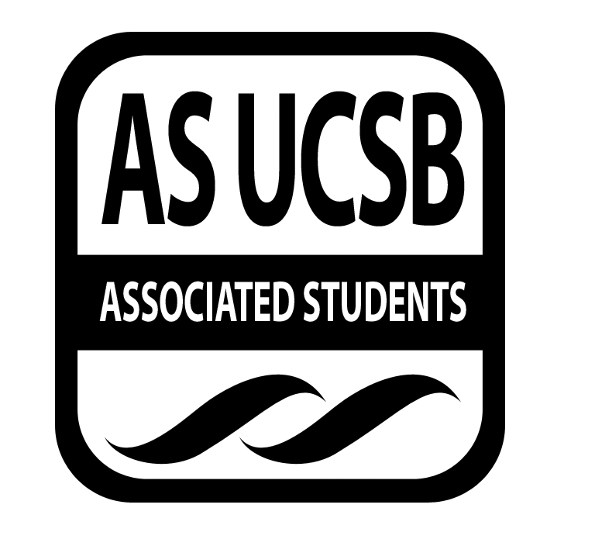
Isla Vista Tenants Union Minutes

Associated Students
10/08/2018, 7:18 PM
Pardall Center

CALL TO ORDER by Anna Henry at 7:19pm

A. MEETING BUSINESS
- Roll Call

Name | Note: | Name | Note:
Anna Henry | Present
Marisa Navarro | Present | Solon Tan | Present
Andrew Chhur | Present | Alex Young | Present
Diana Collins Puente | Excused
Teresa Figueroa | Present
Christian Ornelas | Present
*
Ice Breaker: How's everyone week?

MOTION/SECOND:
Motion to
ACTION: Vote:
B. PUBLIC FORUM

- REPORTS

- Advisor’s Report
  - Diana Collins Puente

  - Teresa Figueroa IVTU Coordinator/Caseworker
    - Hoping to finish filling in tote bags
      - 1000 left
      - Circulating schedule
      - Gave Andrew the requisition forms
      - Working on MYND/Pardall Carnival
      - Casework
      - Attending Property Providers meeting
- Executive Officer’s Report(s)

  - Anna
    - Please send me office hours by Wednesday
    - Fill out doodle for tabling at Pardall Carnival which is this Saturday from 12-4 (will need some help at 11:30 for set up)
      - https://doodle.com/poll/utwezqmf79psbyf9
      - If available i would like everyone to do 2 hours
    - Property Providers Meeting from 9 - 11 am tomorrow
      - Every board member will be assigned a meeting that they will attend and then report back on
      - Is anyone available?
    - Retreat-- please fill out doodle, we need like 6 hours in total whether this is broken up in chunks or in totality
    - Everyone please get IVTU emails--- make an appointment with Carmen
      - https://docs.google.com/a/ucsb.edu/spreadsheets/d/11aQRr8E19iFFpk5Gj_cZhpLxU1NEU-YA-V94mW9F1CQ/edit?usp=sharing
    - Positions being advertised on Facebook, please share or let your friends know
      - https://coc.as.ucsb.edu/my-positions/
    - Budget approval of $40.00 for crafts (crafts to welcome students back to UCSB)

  - Andrew
    - Going to get budget report

  - Solon

  - Marisa
    - Going to email volunteers for Beloved Community Outreach
  - Alex

- Group Project/Member Report(s)
- Senator - Rafael
  - AS elections October 15th-18th
  - https://docs.google.com/forms/d/e/1FAIpQLSfTjJmQen0sfX-hs2t6EQ8DvFVEcNx1TAD8tDNtCwOw-QgfrA/viewform?usp=sf_link
  - Survey on birds
  - Minute taking workshop every Tuesday from 11-12
    - Contact Holly, legislative liaison for senate , hollym@as.ucsb.edu

- Senator - Christian
  - Introductions!
  - Mold issue, more research
    - Survey to see how many residents are affected by this
    - Work with landlords to come up with uniform lease amendment
- EVPLA -

- ACCEPTANCE of AGENDA/CHANGES to AGENDA

MOTION/SECOND: Andrew/Alex
Motion to accept today’s agenda.
ACTION: Vote: Consent

- ACCEPTANCE of ACTION SUMMARY/MINUTES

- Approval of our Action Summary/Minutes from 10.01.18

MOTION/SECOND:Rafael/Alex
Motion to approve minutes from 10.01.2018
ACTION: Vote: Consent

- ACTION ITEMS
F-1. Old Business:
F-2 New Business:

MOTION/SECOND: Marisa/Andrew
Motion to allocate $40.00 for welcome back crafts
ACTION: Vote: Consent

MOTION/SECOND: Alex/Marisa
Motion to relieve Kalina from her duties as community resident director and accept her resignation
ACTION: Vote: Consent

- DISCUSSION ITEMS
  - Students Against Sexual Assault reached out for possible collaboration

- REMARKS

ADJOURNMENT

MOTION/SECOND: Alex/Rafael
Motion to adjourn the meeting at 7:56 pm
ACTION: Vote: Consent

