
Isla Vista Tenants Union Minutes

Associated Students
10/01/2018, 7:15 PM
Pardall Center

CALL TO ORDER by Anna Henry at 7:24pm

A. MEETING BUSINESS
- Roll Call

Name | Note: | Name | Note:
Anna Henry | Present
Marisa Navarro | Present | Solon Tan | Excused
Andrew Chhur | Excused | Alex Young | Present
Kalina White | Present
Diana Collins Puente | Present
Teresa Figueroa | Present
*
Ice Breaker: What did everyone do this summer?

MOTION/SECOND: Anna/Alex
Motion to excuse Andrew and Solon
ACTION: Vote: Consent
B. PUBLIC FORUM

- REPORTS

- Advisor’s Report
  - Diana Collins Puente
    - Welcome!
    - As leadership retreat this weekend October 6th and 7th
      - OSL program takes place on Saturday morning 1pm- 4:30 pm
      - AS program the remainder of the time 9 am - 4:30 pm
        - Located at Corwin Pavilion
        - RSVP by tonight
        - https://docs.google.com/forms/d/1kgTvvLfaNT68lZIfOH3DhYmFg9gnJapUfP67JS02wAg/viewform?edit_requested=true
    - Special election taking place for EVPSA
      - Elections take place from Monday October 13th- Thursday October 18th
      - Candidates forum will take place this Friday at 9:30 am located in the Hub
    - Safety information
      - Adjusted Pardall Center hours
      - Resources available feel free to reach out to Diana if you need
    - Travel trainings need to be completed
    - Awards banquet for the Spring May 30th
    - Halloween will look similar to prior years
      - Website with information
      - PC will be safe space
    - Minute taker worksop Tuesday and Wednesdays at 2 pm
  - Teresa Figueroa IVTU Coordinator/Caseworker
    - Welcome!
    - Busy working with students and community members working on issues with security deposits, leases, evictions, roommate issues, among other things
      - Has seen almost 50 cases
    - Collab with EVPLA on beloved community guide
      - Delivering 5000 guides and tote bags
      - Filling in tote bags, 3-6 pm this week at St. George Youth Center
    - Chelsea Lyon said she will train us !
- Executive Officer’s Report(s)

  - Anna
    - Welcome!!
    - Meet Your Neighbor Day
      - October 13th, 12-4
      - IVTU will be tabling!
      - Will be sending out a doodle for your availability
    - New marketing and outreach director
      - If you know anyone interested, please let them know
      - Applications are open
    - Retreat
      - I will send out a doodle to see your availability
      - Legal code requires we gold retreat within the first three weeks of the quarter
      - We will be going over IVTU projects, goals, etc
    - Beloved Community Guide
    - history of IV: a history of student activism
      - Oct. 4 at 5:30 PM
      - Is anyone available?
    - Office hours
      - Including meeting with Teresa an hour a week

  - Andrew

  - Kalina

  - Solon

  - Marisa

  - Alex
    - Email from Jonathan Abboud
      - Housing vouchers

- Group Project/Member Report(s)
- Senator - Rafael
  - Working with Senator Hernandez on a resolution to unify all food insecurity groups into one committee
Sending out applications to groups
Opening it to students, staff, and faculty
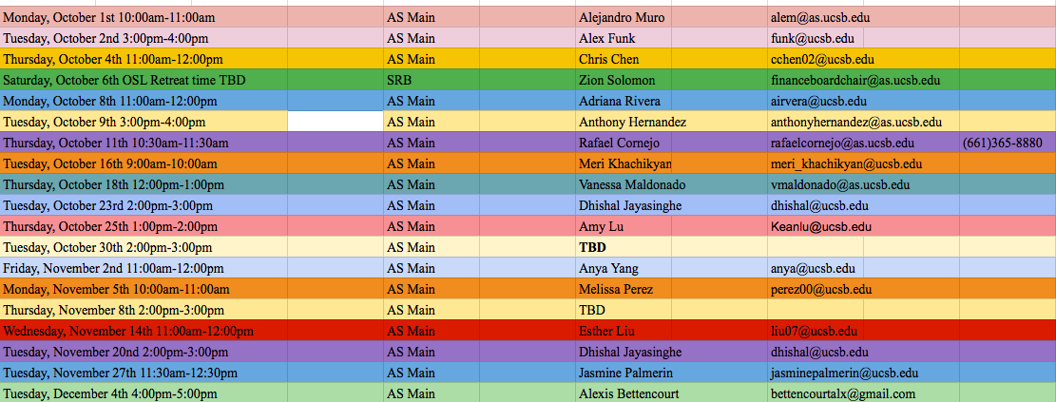

- Senator -

- Senator -

- EVPLA -

- ACCEPTANCE of AGENDA/CHANGES to AGENDA

MOTION/SECOND: Anna/Alex
Motion to accept today’s agenda.
ACTION: Vote: Consent

- ACCEPTANCE of ACTION SUMMARY/MINUTES

- Approval of our Action Summary/Minutes from

MOTION/SECOND: Kalina/Anna
Motion to approve from 8.24.2018
ACTION: Vote: Consent

- ACTION ITEMS
F-1. Old Business:
F-2 New Business:

MOTION/SECOND: Kalina/Marisa
Motion to allocate 7,000 for printing fund at AS Publications
ACTION: Vote: Consent

MOTION/SECOND: Alex/Kalina
Motion to $200 to provide lunch to our teen volunteers
ACTION: Vote:Consent

MOTION/SECOND: Marisa/Kalina
Motion to alleviate Angelica Goetzen from her duties as marketing director and to accept her resignation
ACTION: Vote:Consent

MOTION/SECOND: Marisa/Kalina
Motion to alleviate Gordon Hahn from his duties as outreach director and to accept her resignation
ACTION: Vote:Consent

- DISCUSSION ITEMS

- REMARKS

ADJOURNMENT

MOTION/SECOND: Kalina/Alex
Motion to adjourn the meeting at 8:33 pm
ACTION: Vote: Consent

