Human rights board Phone Vote

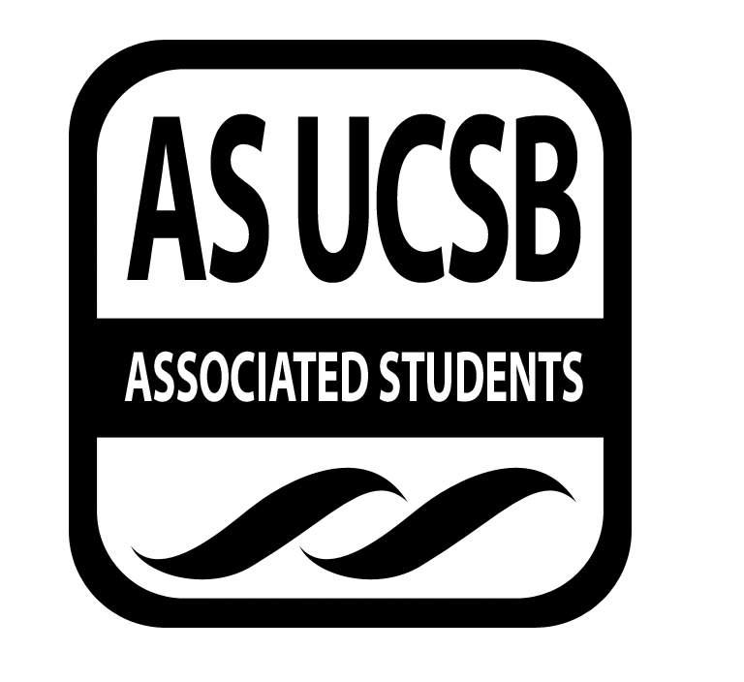
Associated Students
June 4, 2014

Mario: motions to allocate $150 for the HRB transition meeting
- Karen: seconds
- Dana: calls to question
- Vote: 11 yes, 0 no

