Human rights board minutes

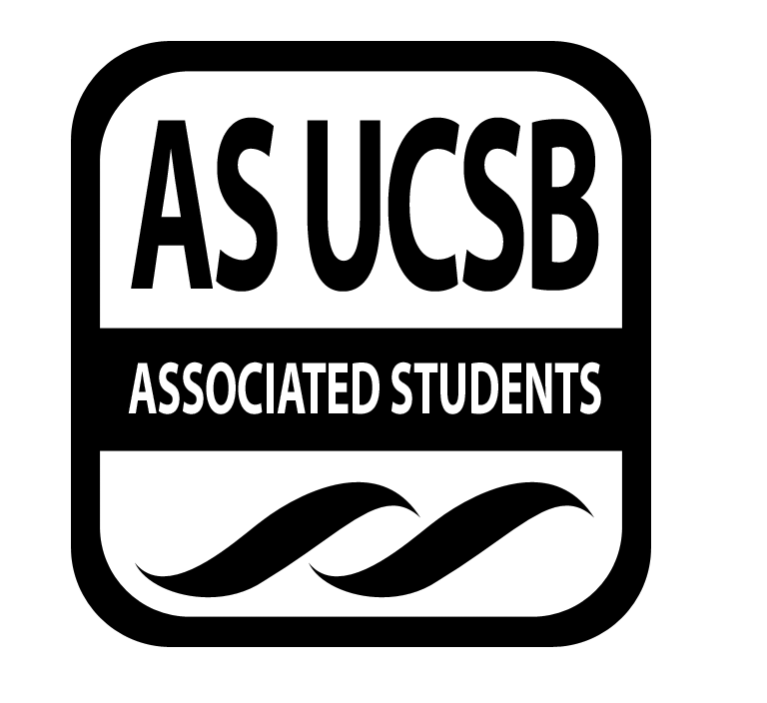
Associated Students
February 19th, 2014, 8pm
SRB: Chican@ Resource Center

CALL TO ORDER

A. MEETING BUSINESS
- Roll Call

Name | Note:  absent (excused/not excused)  arrived late (time)  departed early (time)  proxy (full name) | Name | Note:  absent (excused/not excused)  arrived late (time)  departed early (time)  proxy (full name)
Anisha Ahuja (Co-Chair) | Excused (absent) | Dana Patterson (Treasurer) | Present
Amanda Manalo (Vice-Chair) | Present | Tara Atrian | Absent
Ansel Lundberg(Publicity) | Absent | Raufin Khan | Present
Carly McMaster(Events) | Present | Mohsin Mirza | Present
Mario Vasquez (Outreach) | Present | Annie Chen | absent

- ACTION ITEMS

F-2 New Business

Announcements:
- SCORE: Facing Race, this Saturday all day
  - Register on Facebook!
  - Fighting Racism from within
- 777 Camino Pescadero
  - Interfaith Co-op will have the officials from the Church of Scientology to talk
  - 4pm, meals will be provided
- SCORE & IDEAS: Undocumented student scholarship lock-in fee
  - could use more volunteers helping out
    - class raps, tabling, etc.
    - talk to Mohsin, Raufin, Hani, etc
    - need more signatures
    - gonna be dorm-storming this weekend
- USAS is holding a mini-action in the arbor
  - interested in volunteering
  - getting student signatures for when approaching
Zine:
- Gonna scan the pages, upload it by tomorrow to the page and get comments/suggestions
- Post on the page about costs and allocating money
Prisoner Pages:
- Talked to a lot of people
- Getting letters of requests for books soon
- Table in beginning of March
- Asks liaisons to visit and talk about pp/disorientation guide
- Talk to the library, because it’s like illegal in the university to give the books away
- Stay updated on the facebook to help donate/volunteer!
- Look to write a resolution on it
- For now, donate books at the meeting
- Class raps/ talk to professors?
- Blast on Facebook!
- Talk to someone about having a drop-box in the SRB and maybe in the MCC
Odyssey Project:
- Wait to vote on sponsorship
- No idea about it,
- We like the idea, and we will talk about it when there’s more tangible footage, etc.

- REMARKS

ADJOURNMENT

