Human rights board minutes

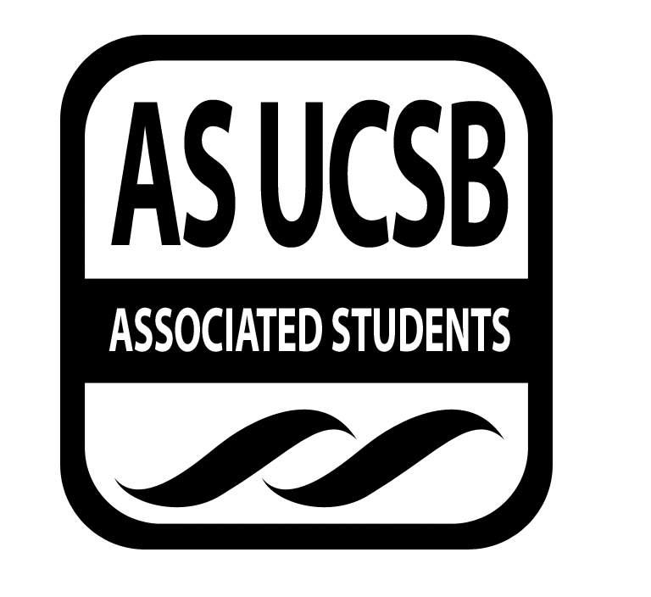
Associated Students
May 14th, 2014, 8pm
SRB: Chican@ Resource Center

CALL TO ORDER

A. MEETING BUSINESS
- Roll Call

Name | Note:  absent (excused/not excused)  arrived late (time)  departed early (time)  proxy (full name) | Name | Note:  absent (excused/not excused)  arrived late (time)  departed early (time)  proxy (full name)
Anisha Ahuja (Co-Chair) | Present | Dana Patterson (Treasurer) | Present
Amanda Manalo (Vice-Chair) | Absent (Excused) | Tara Atrian | Absent
Ansel Lundberg(Publicity) | Present | Raufin Khan | Absent
Carly McMaster(Events) | Absent | Mohsin Mirza | Present
Mario Vasquez (Outreach) | Present | Annie Chen | Present

- ACTION ITEMS

F-2 New Business
Announcements
- APIPA
  - night may 30, hub, free, performers
- Transvisible
  - may 21st
  - trans latina activist, Bamby, coming, free, all can attend
- ONE campaign
  - awareness about extreme poverty
  - events happening all week with other groups
  - Student Lobby
    - grass roots organizing weekend (GROW)
    - learn skills to better organize, strategize, USSA organizers will be
    - Saturday, may 17th, 9am-7:30 and Sunday,
Sbstudentloby

Funding requests
- UN Girl Up Club
  - funding education for girls throughout the world
  - request $300 for travel expenses
  - to send to Washington DC
  - June 16-18th
  - need $916 in total
  - are fundraising for three students
  - have requested from Womyn's Comm and CIRC
  - 4 year UN initiative
  - clubs help develop girls as leaders to then give back
- mario motions to give $100 with attached letter explaining our problems
- dana seconds
- alonso calls the question
- ansel consents

De Colores
- Transvisible
- Wed, may 21st
- requesting $400
- for lodging and travel for performers
  - dana made a motion to fund
  - alonso seconds
  - ansel calls the question
  - phoebe consents

ONE
- 3rd world countries advocacy
- grassroots organization, lobby, petition
- philanthropy week
- five events on different topics relation to poverty
  - foreign aid budget, etc.
- each event has some sort of action that goes with it
- hunger banquet, electrify africa act, stroke plaza concert
- $555 total, only need $355
- requesting $355 for pizza at concert
  - mario makes a motion to fund $100 with letter enclosed
  - alonso seconds
  - mohsin calls the question
  - phoebe consents

Vietnamese student association
- student out reach program
- may 24th
- 50-60 students coming for the day to be exposed to college etc.
- bus funding
- requesting $100 for bus funding
- asking for involvement and adding activism tour to their itinerary
  - dana makes motion to automatically fun $100 once we find out budget
  - mario seconds
  - alonso calls the question
  - phoebe consents

HRB Work

Zine Launch Party
- week 9
- ask carly to invite people
- food, talking about zine ideas, end of the year social and transitional meeting

Prisoner Pages
- got letters from books to prisoners, sending them resource directories.
- not sure if we can send books, maybe only through amazon
- is an approved vendors list, team up with
  - Stuffing Directories

- REMARKS

ADJOURNMENT

