Human rights board minutes

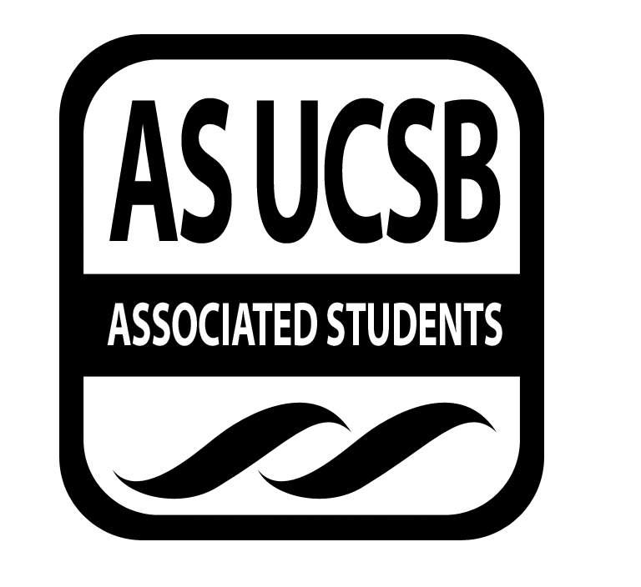
Associated Students
April 9th, 2014, 8pm
SRB: Chican@ Resource Center

CALL TO ORDER

A. MEETING BUSINESS
- Roll Call

Name | Note:  absent (excused/not excused)  arrived late (time)  departed early (time)  proxy (full name) | Name | Note:  absent (excused/not excused)  arrived late (time)  departed early (time)  proxy (full name)
Anisha Ahuja (Co-Chair) | Present | Dana Patterson (Treasurer) | Present
Amanda Manalo (Vice-Chair) | Present | Tara Atrian | Present
Ansel Lundberg(Publicity) | Present | Raufin Khan | absent
Carly McMaster(Events) | Present | Mohsin Mirza | present
Mario Vasquez (Outreach) | Present | Annie Chen | absent

- ACTION ITEMS

F-2 New Business

- Announcements:
  - Environmental Conference May 2-4 around Storke Plaza: Coalition Building
    - if you want to host an hour-long workshop, the apps are online
    - convergence of students from all over CA, 400-600 students
    - network with students
    - talk to Alexandra
    - look for the links on HRB FB page
    - HRB could do a corporatization/militarization of the UC teach-in (interested? let Mario or Anisha know)
  - USAS is having another action soon so talk to Dana
  - KCSB is having a town-hall meeting tomorrow in storke plaza concerning Deltopia
    - check for link to website to document your experience with the riots
- Funding Requests:
  - Funding Saturday morning breakfasts for the homeless in IV
    - if we do fund, let’s all go together
    - make it an HRB project?
    - 10am at People’s Park till about noon
    - Requesting $500 for the rest of the quarter
    - Dana motions to fund in full
    - Carly seconds
    - Amanda calls to question
    - Mario calls consent
    - No objections
  - Vietnamese Student Assoc: May 24 Student-Initiated Outreach program
    - host workshops, tours, presentations, and lectures
    - inviting high schoolers from the area that are Vietnamese-Americans from low-income or first-generation students
    - Main fees are the bus, dining commons, and t-shirts
    - If you’d like to volunteer, contact VSA!
    - Received $200 from the MCC
    - Requesting $400
    - Amanda motions to fund in full
    - Mohsin seconds
    - Dana calls to question
    - Mario calls consent
    - no objections
  - APIPA: culture night, May 30th?
    - Blue scholars are performing
    - Asking for $2000
    - Mario motions to allocate $300
    - Ansel seconds
    - Phoebe calls to question
    - Amanda calls consent
    - No objections
- Tabling:
  - Next week!
  - Required of the execs
  - Passing out the zine, advertising Prisoner Pages
- Prisoner Pages:
  - Mario has over 80 letters
  - try to fulfill the requests
  - A.S. Recycling has a lot of books in a shed
  - Dana will e-mail the ARDs
  - Phoebe will get boxes
- Zine:
  - Zine launch party instead of our meeting week 5!
  - photo campaign
  - prisoner pages advertisement
  - Mario motions to allocate $1000 for the zine/distribution
  - Phoebe seconds
  - Ansel calls to question
  - Mohsin calls consent
  - No objections
- Action:
  - school to prison pipeline/ prison-industrial complex
  - build a representational “pipeline”, create visuals (Anisha and Amanda)
- Artivism at TBTN rally:
  - April 22nd, Tuesday

- REMARKS

ADJOURNMENT

