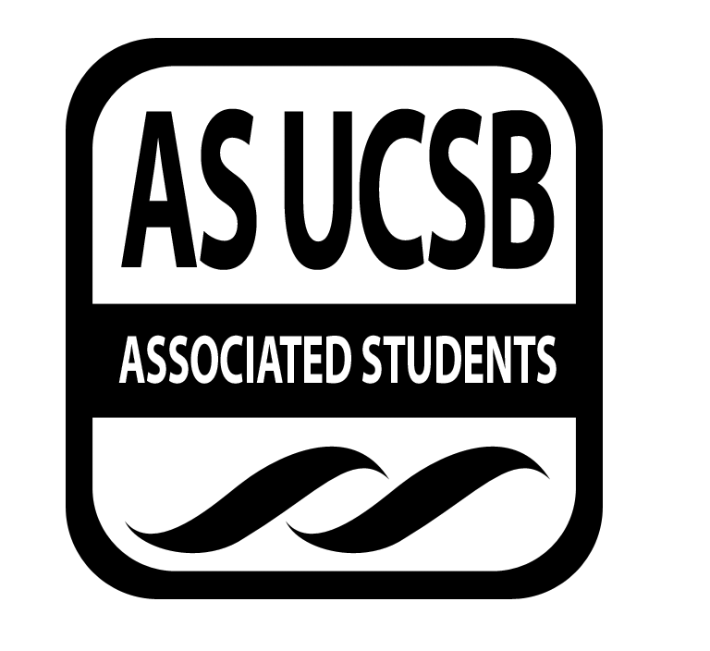
Human Rights Board Minutes

Associated Students
March 30th 2016
SRB Minutes/Actions recorded by: Phillip Thompson

CALL TO ORDER 7pm by Teresa Campa, Chair

A. MEETING BUSINESS
- Roll Call

Name | Note:  absent (excused/not excused)  arrived late (time)  departed early (time)  proxy (full name) | Name | Note:  absent (excused/not excused)  arrived late (time)  departed early (time)  proxy (full name)
Teresa Campa | Present | Jackie Rojas | Present
Evelyn Diaz | Present | Stephanie Truong | Present
Olushay DaSilva | Present | Chandler Philips | Present
Phillip Thompson | Present | Erica Kaplan | Present

B. PUBLIC FORUM

- Introductions, How was break, how do you feel about this quarter??

- REPORTS

- Chair
- RYSE is next week, we need to coordinate this.
- Reach out to BPRO/Theta Nu Kappa for panel speakers
- Human Rights Week: Shirts and shirt designs

- Vice Chair
- Potential speaker in May, for race matters series at MCC, on Environmental Racism.
- Asking $200 for speaker fee, we will get private meeting before talk with Professor + Credit on the event.
- Outreach
- Getting in contact with other orgs for HRW,
- Financial
- Have preliminary budget, still need to allocate from requisitions to find real #

- ACCEPTANCE of AGENDA/CHANGES to AGENDA
The Chair may, with members’ consent, add items to the agenda for consideration at the current meeting if they meet one of the following criteria:
a) Emergency Situation -- the issue falls within ten days from this meeting.
b) Deadline -- if the issue arose after the agenda deadline and must be acted on before the next scheduled meeting.

MOTION/SECOND: Campa/Thompson
Motion to accept agenda
ACTION: Vote: Consent

- ACTION ITEMS
These are generally financial approvals. Detailed information and staff recommendations/reports are provided in attachments. Approvals of allocations of funds require Senate approval. Travel requests and exceptions to policy require Finance Board approval

- New Business:
- RYSE: Provide a meal at DLG dining commons for 25 people, including all visitors, HRB execs, and panel speakers.
MOTION/SECOND: Campa/DaSilva
Motion to allocate $300 (25 people x $12) for meals at DLG
ACTION: Vote: Consent
- Re-useable water bottles from UCSB Bookstore instead of purchasing a case from Costco.
MOTION/SECOND: Thompson/Diaz
Motion to allocate $150 (10 bottles x $14.50) for reusable water bottles
ACTION: Vote: Consent
- HUMAN RIGHTS WEEK: Shirts and pamphlets needed for outreach.
MOTION/SECOND: Diaz/Campa
Motion to allocate $250 for fair trade, non-sweatshop shirts
ACTION: Vote: Consent

MOTION/SECOND: DaSilva/Truong
Motion to allocate $40 for pamphlets tri fold with schedule of speakers for Human Rights Week
ACTION: Vote: Consent
- Spring Rec Fair (Taste of A.S.): We need to bring food for the potluck
MOTION/SECOND: DaSilva/Truong
Motion to allocate $100 for food for the AS potluck
ACTION: Vote: Consent

- DISCUSSION ITEMS
Items on which we may make a decision in the future. Public testimony is welcome. We will not make decision motions but may instruct members/staff to do research and/or place item on future agenda.

- REMARKS

ADJOURNMENT

MOTION/SECOND to ADJOURN: Campa/Thompson
ACTION: Vote: Consent
Vote Taken: 6:41pm

