Human rights board minutes

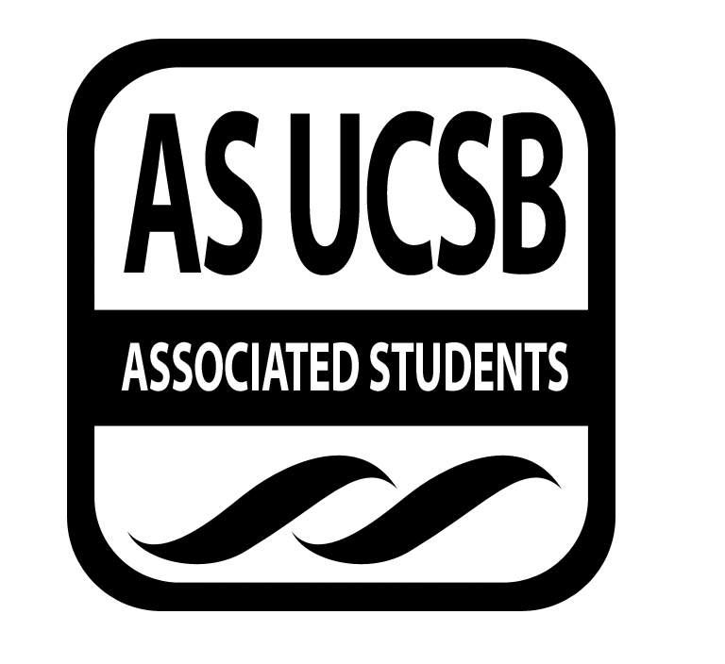
Associated Students
January 22, 2014, 8pm
SRB: Chican@ Resource Center

CALL TO ORDER

A. MEETING BUSINESS
- Roll Call

Name | Note:  absent (excused/not excused)  arrived late (time)  departed early (time)  proxy (full name) | Name | Note:  absent (excused/not excused)  arrived late (time)  departed early (time)  proxy (full name)
Anisha Ahuja (Co-Chair) | Present | Dana Patterson (Treasurer) | Present
Amanda Manalo (Vice-Chair) | Absent (excused) | Tara Atrian | Present
Ansel Lundberg(Publicity) | Present | Raufin Khan | Present
Carly McMaster(Events) | Present | Mohsin Mirza | absent
Mario Vasquez (Outreach) | Present | Annie Chen | absent

- ACTION ITEMS

F-2 New Business
Announcements:
SASA – Decolonizing the Textbook
Mahader’s art exhibit – 6:30pm
Check out living history
January 30th – ASA sit in about Armenian Genocide, roundabout, wear black
10am-3pm

Funding:
Adeel – Movie screening and Panel Discussion for SJP
San Cat Fiesta Room Jan 27th, 7pm
Panel
$200

Mohsin – motion fully fund the event $200
Mario second
Kareem call to question
Ansel consent
Fully funded!

Mario - Books through bars
Contacted UCSD – short message (ucsd books for prisoners)
Annie – contact
How to get best in touch?
Route – lisa berry (cochair of BSU)
Betty – freedom 4 youth advocates (Anisha talk to Betty)
Results this weekend

Zine
Funding
WORD magazine – funding from school, IV arts and application and find faculty member

Topics:
- Adeel – political language on tuition hikes
- Mario – compensation for Napolitano’s position
- Mohsin – regents and how structured/appointed
- Ansel – technology
- Azra – doesn’t know
- Divestment
- Raufin – mythbuster section - myths that aren’t myths
  - Profile of professor
- Poems
- Sukayna – politics behind tuition increases
- UC 101 – list of definitions, corporatization, privatization, etc
- EAB – where is tuition going (administrators), divestment from fossil fuels, environmental racism
- Annie – where does money go – infographic
  - Jokes
- Tuition hikes and bar graph
- Social media section, theme of zine? – fake twitter feed
- Kareem – investments in corporations, human rights violations
- Anisha – poetry? Students of color/marginalized students/activism
- Adeel – service workers
- Political cartoon – jerry brown swearing someone in and taking bag of cash with one

Discussion
Zapatista movement! January marks anniversary of Zapatista uprising
Indigenous movements

- REMARKS

ADJOURNMENT

