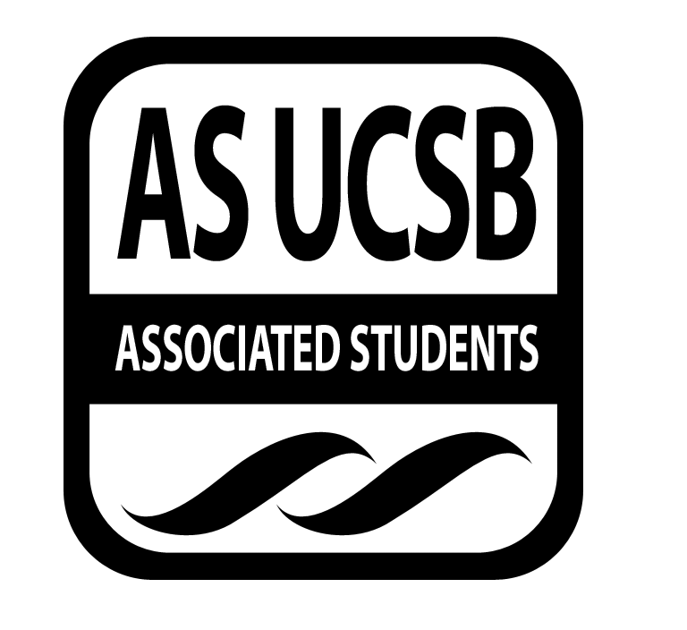
AS Food Bank Committee

Associated Students
November 18, 2016;
Food Bank Lounge
CALL TO ORDER by Breanna Jones, Chair at 2:10pm
Minutes Taken by: Gary Van Huynh

A. MEETING BUSINESS
- Roll Call (Pre-entered Names)

Name | Note:  absent (excused/not excused)  arrived late (time)  departed early (time)  proxy (full name) | Name | Note:  absent (excused/not excused)  arrived late (time)  departed early (time)  proxy (full name)
Breanna Jones | Present | Priyanka Bist | Absent
Gary Van Huynh | Present | Nicolas Pascal | Excused
Yanira “Jenny” Flores | Present | Bianca Fernandez | Excused
Kathy Lee | Present | Patrick Dohoney | Absent
Nathalie Recendez | Present | Tuyen Nguyen | Present
Wen Ying Liu | Present
Steven Marquardt | Excused
Eileen Lui | Present
Khalil Kochiyama | Absent
Teniola Adedji | Present

- Acceptance of Excused Absences
MOTION/SECOND: Jones/Lee
ACTION: Passed by Consent
B. PUBLIC FORUM
a. Check ins:
1. Ice breaker.
2. Agenda summary / Anything to add.

- REPORTS
  - Chair:
    - UCen Governance Board meeting (11/14/16):
      - Proposal for Associated Student Food Bank (ASFB) expansion approved
      - Received half of the study space adjacent to ASFB pantry.
      - Operational staff (Kathy Lopez & Karen) have updated proposal.
    - Advocacy Meeting (11/16/16):
      - Bre, Kathy Lee, and Nathalie working on plan for grand re-opening of expanded Food Bank by Winter 2017 Quarter.
        - Link to meeting notes
    - Meeting for Food Recovery App (11/16):
      - Thomas Wang, Anna Lee, & Sean Lieberman were present.
      - Discussed how app would work on campus.
        - Leftover food from dining commons will be posted on the App.
      - Office of Controller to develop student needs survey.
        - Teni will be the lead
          - She is apart of the Office of the Controller
        - Survey question: How often do you skip meals per week?
    - Interview with Gwen from The Bottom Line (11/17).
      - The space proposal is now public to UCSB staff and students.
      - Spread the news around campus and social media
    - Edible Campus Garden Gathering: Nov. 18 @ 3-5pm.
  - Vice Chair:
    - ASFB operation team hire updates
    - Tuyen, Bre, and I will be meeting with Swipe out Hunger before this quarter ends
  - Internal Affairs Coordinators:
1. Wen Ying Liu:
- Bryn from UC Global Food Initiative (UCGFI) asked about Food Security Rally / Produce First collaboration
  - Wen accepted the collaboration invitation.
- Serve as space for raising awareness on food access and security
- Set date: Saturday, Feb 18th (next quarter)
- Wen will work with Bryn ; Patrick Dohoney also on the project
2. Eileen Lui: none
  - External Affairs Coordinator: Jenny Flores
    - Met with Tuyen and Bre last week to talk about goals for her position
      - Goal: Having a stronger delegation to California Higher Education Conference (CHEFS)
      - Last year (2016) was hosted at University of California, Irvine (UCI)
      - First conference (2015) was hosted to UCSB
  - Publicity Coordinator:
    - Talked to Juli (ASFB 2015-2016 Vice-Chair)
      - Shared her google drive folder for GreekFest
      - Juli’s advice: Start early to have more Greek Houses involved
      - Goal: Greek life folks to develop more philanthropy events
        - Donation walk
        - breakfast/lunch
        - ETC
    - Brandon from UCGHI (Videographer)
      - Food Story Video
    - AS external communication workshop (11/17)
      - Using Associated Student for publicity
        - Start a campaign
      - Vision 2020
  - Treasurer:
    - Received all the funding request needed for the Thanksgiving Luncheon
      - (11/24) from 12-2pm at the Student Resource Building (SRB)
    - Met with Tuyen Nguyen
      - Discussed about/what the ASFB will like look after the space renovation
        - ASFB space layout
        - Furniture
        - ETC
  - Advisor:
    - (12/02) ASFB family gathering before Tuyne’s departure
  - Senate Liaisons: none
  - Others / Voting Members:
    - Teni Adedji
      - Hunger Banquet update/discussion

- ACCEPTANCE of AGENDA/CHANGES to AGENDA
MOTION/SECOND: Jones/Lee
ACTION: Passed by Consent

- ACCEPTANCE of ACTION SUMMARY/MINUTES
- Approval of our Action Summary/Minutes from 11/04/2016
MOTION/SECOND: Jones/Flores
ACTION: Passed by Consent

- ACTION ITEMS
F-2 New Business

- DISCUSSION ITEMS
a. Advocacy Campaign:
- Backward planning for two years out
  - What is our main goal / what is vision:
b. Food recovery:
- Thomas Wang & Brianna Duplessis working on food recovery program.
- Still in early development and currently working through logistics.
  - What can ASFB offer/help with the Food Recovery Program
  - Should ASFB create a new position in AS legal code or have ASFB staff help with the food recovery food distribution?
- Hope to work with AS Food Bank
  - Use of ASFB space as a hub / what is our capacity to help?
- Additional interest in being a lead in this project throughout the year:

ADJOURNMENT
MOTION/SECOND: Jones/Lui
Motion to adjourn at 3:00pm
ACTION: Passed by Consent

