## **A.S. Environmental Justice Alliance MINUTES**ASsquare_logo.tif

## Associated Students

DATE: 1/3/2021 at pm

LOCATION: Zoom Minutes/Actions recorded by: Sofia Carigma

**CALL TO ORDER:**

**A. MEETING BUSINESS**

1. **Roll Call**

| **Name** | **Note:**  absent (excused/not excused)  arrived late (time)  departed early (time)  proxy (full name) | **Name** | **Note:**  absent (excused/not excused)  arrived late (time)  departed early (time)  proxy (full name) |
| --- | --- | --- | --- |
| Landry Guillen (Cochair) | **present** | Pamela Linares-Gutierrez (Community Chair) | **present** |
| Lizzy Mau (Cochair) | **present** | Sofia Carigma (Admin Coordinator) | **present** |
| (publicity chair) | **vacant** | Eliana Stone (Treasurer) | **present** |
| Julia Park (Publicity Chair) | **present** | Phoebe Lawton (HRB Liaison) | **present** |
| Jwan Haddad (Campaign Chair) | **present** | Saul Ventura/Naomi Charlet (EAB Liaisons) | **present** |
| Asia Juarez (Campaign Chair) | **present** | Sarah Siedschlag (Advisor) | **present** |
| Asata Spencer-Gaillard (Campaign Chair) | **present** | Hannah Lee (Senate liaison) | **present** |
| Visala Tallavarjula (Campaign Chair) | **present** | April Zhang (Senate liaison) | **Absent, excused** |
| Gilberto Murillo  (Student Affairs) | **present** |  |  |

1. **Acceptance of Attendance and Excused Absences**

***MOTION/SECOND****:*

***Motion Language:***

***ACTION****:*

1. **Acceptance of Proxies**

**B. PUBLIC FORUM/CHECK-IN**

1. Check in: Public Forum:
2. Announcements
3. **REPORTS**
4. **Advisor’s Report:**

i.

1. **Chair(s)**
   1. **Lizzy Mau (Cochair)**
   2. **Landry Guillen (Cochair)**
2. **Member Report(s)** 
   1. **Jocelyn Ortiz and Julia Park (Publicity)**
   2. **Jwan Haddad (Campaign)**
   3. **Asia Juarez (Campaign)**
   4. **Asata Spencer-Gaillard (Campaign)**
   5. **Visala Tallavarjula (Campaign)**
   6. **Gilberto Murillo (Student Affairs)**
   7. **Pamela Linares Gutierrez (Community Affairs)**
   8. **Sofia Carigma (​​Admin Coordinator)**
   9. **Eliana Stone (Treasurer)**
      1. No updates
   10. **Saul Ventura and Naomi Charlet (EAB Liaisons)**
   11. **Phoebe Lawton (HRB Liaison)**
   12. **Hannah Lee and April Zhang (Senate liaisons)**

i.

1. **Group Project Report (s)**
2. **ACCEPTANCE of ACTION SUMMARY/MINUTES**

1. **Approval of our Action Summary/Minutes from:**

***MOTION/SECOND****:*

***Motion Language:***

***ACTION****:*

1. **ACCEPTANCE of AGENDA/CHANGES to AGENDA**

***MOTION/SECOND****:*

***Motion Language:*** *motion to accept today’s agenda*

***ACTION****:*

1. **ACTION ITEMS**

**F-2 New Business:**

**Retreat Budget:** [**https://docs.google.com/spreadsheets/d/1\_-\_2WC12ez4ootJTSlbZk4j3ZTMvwdwRBi4cC6LH8ls/edit?usp=sharing**](https://docs.google.com/spreadsheets/d/1_-_2WC12ez4ootJTSlbZk4j3ZTMvwdwRBi4cC6LH8ls/edit?usp=sharing)

**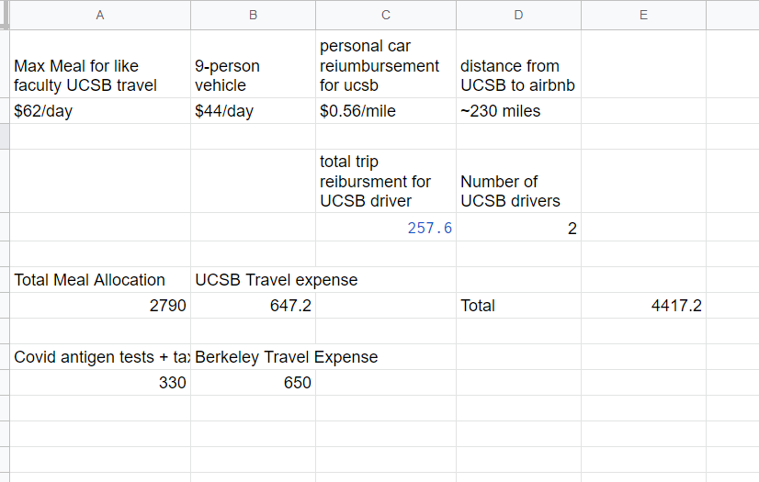**

***A) MOTION/SECOND****: Lizzy/Landry*

***Motion Language:*** *pass $4,500 for supplies and travel expenses for the the EJA x SCEC retreat on 2/19-2/21?*

***ACTION****: 11-0-0*

1. **DISCUSSION ITEMS**
2. **REMARKS**
3. **ADJOURNMENT**

***MOTION/SECOND****:*

***Motion Language:*** *Motion to adjourn meeting at*

***ACTION****: Consent*