
A.S. Environmental Justice Alliance MINUTES

Associated Students
DATE: 1/3/2021 at pm
LOCATION: Zoom Minutes/Actions recorded by: Sofia Carigma

CALL TO ORDER:
A. MEETING BUSINESS

- Roll Call

Name | Note:  absent (excused/not excused)  arrived late (time)  departed early (time)  proxy (full name) | Name | Note:  absent (excused/not excused)  arrived late (time)  departed early (time)  proxy (full name)
Landry Guillen (Cochair) | present | Pamela Linares-Gutierrez (Community Chair) | present
Lizzy Mau (Cochair) | present | Sofia Carigma (Admin Coordinator) | present
(publicity chair) | vacant | Eliana Stone (Treasurer) | present
Julia Park (Publicity Chair) | present | Phoebe Lawton (HRB Liaison) | present
Jwan Haddad (Campaign Chair) | present | Saul Ventura/Naomi Charlet (EAB Liaisons) | present
Asia Juarez (Campaign Chair) | present | Sarah Siedschlag (Advisor) | present
Asata Spencer-Gaillard (Campaign Chair) | present | Hannah Lee (Senate liaison) | present
Visala Tallavarjula (Campaign Chair) | present | April Zhang (Senate liaison) | Absent, excused
Gilberto Murillo  (Student Affairs) | present

- Acceptance of Attendance and Excused Absences

MOTION/SECOND:
Motion Language:
ACTION:

- Acceptance of Proxies

B. PUBLIC FORUM/CHECK-IN
- Check in: Public Forum:

- Announcements

- REPORTS
- Advisor’s Report:
i.
- Chair(s)
  - Lizzy Mau (Cochair)
  - Landry Guillen (Cochair)

- Member Report(s)
  - Jocelyn Ortiz and Julia Park (Publicity)

  - Jwan Haddad (Campaign)

  - Asia Juarez (Campaign)

  - Asata Spencer-Gaillard (Campaign)
  - Visala Tallavarjula (Campaign)
  - Gilberto Murillo (Student Affairs)
  - Pamela Linares Gutierrez (Community Affairs)

  - Sofia Carigma (​​Admin Coordinator)

  - Eliana Stone (Treasurer)
    - No updates
  - Saul Ventura and Naomi Charlet (EAB Liaisons)

  - Phoebe Lawton (HRB Liaison)

  - Hannah Lee and April Zhang (Senate liaisons)
i.
- Group Project Report (s)

- ACCEPTANCE of ACTION SUMMARY/MINUTES

- Approval of our Action Summary/Minutes from:

MOTION/SECOND:
Motion Language:
ACTION:

- ACCEPTANCE of AGENDA/CHANGES to AGENDA

MOTION/SECOND:
Motion Language: motion to accept today’s agenda
ACTION:

- ACTION ITEMS

F-2 New Business:

Retreat Budget: https://docs.google.com/spreadsheets/d/1_-_2WC12ez4ootJTSlbZk4j3ZTMvwdwRBi4cC6LH8ls/edit?usp=sharing
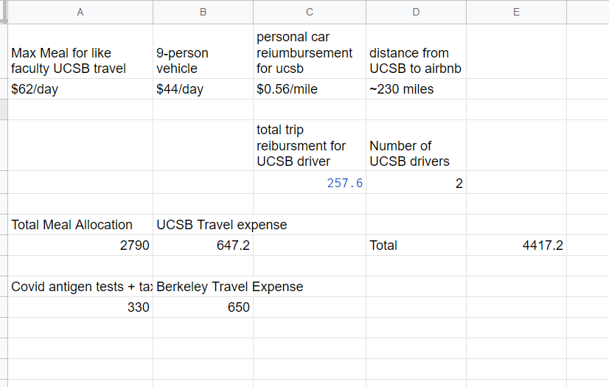
A) MOTION/SECOND: Lizzy/Landry
Motion Language: pass $4,500 for supplies and travel expenses for the the EJA x SCEC retreat on 2/19-2/21?
ACTION: 11-0-0

- DISCUSSION ITEMS

- REMARKS

- ADJOURNMENT

MOTION/SECOND:
Motion Language: Motion to adjourn meeting at
ACTION: Consent

