Elections Board Agenda

Associated Students
5/15/20, 11:00 AM
Virtual Meeting - Zoom

CALL TO ORDER by Davis Quan at 11:00 AM

A. ATTENDANCE

Name | Note: | Name | Note:
Davis Quan  (Chair) | Present | Ruth Garcia Guevara  (Advisor) | Present
Andrew Yan | Present | Diana Collins Puente  (Advisor) | Present
Emma Xing | Present
Wessal Esber | Present
Shannon Hollingsworth | Absent

Also in attendance:
Tyler Barth, AS Attorney General

B. DISCUSSION ITEMS

B.1. Recall Petition

Ruth: As you all know, there is a petition currently circulating to recall the President-elect, Daevionne. This is going to be the second time I have seen a recall petition in my tenure. We saw a lot about the process, last time we worked with the petitioner. We modeled the petition around new fees. Because that was the only template that we had, we used that template for the recall petition. We wanted to make sure students knew what they were signing onto, which is names, perms, and signatures while working with the sponsor.
Ruth: Earlier we compiled a doc about this, which I just sent to everyone again.

Wessal: We need a solution where there are parameters with guidelines on how to approach this recall.

Diana: I would suggest that maybe before thinking about the petitioners right now, think about the process. You have these three questions you should answer today: What is the petition start date, are you accepting online signatures and using what process to validate them, and does the petitioner need to include the legal language?
Emma: Can we do the docusign which has legal language and sent to their school emails?
Wessal: Technically, it says the petition has to be signed by its constituents. the student body aren’t his constituents yet. I would say you can’t recall him because you can’t recall him with these signatures until they started this petition.
Tyler: In my mind, if they were to start with square one with the petition. There was no communication with you initially, and they started the process on their own. They already have the emails, and I feel like they could do it a lot easier than they think. I think the process as a whole can’t begin until they hold the petition. You can’t recall a president-elect, you can recall a president but Alison is the president right now.
Emma: On the document it says petition template needs to be drafted/approved by Elections Board.
Wessal: My opinion is we can’t recall someone who isn’t on the petition. I would agree/recommend that we can’t recall him because he isn’t president right now.
Emma: Could we send the petitioner a docusign for them to forward to everyone else?
Wessal: Yes because the emails were collected too.
Emma: I don’t think we should tell them they should redo everything, but we should provide them with another step.

Davis: Would we be limiting the petitioner’s availability if we do that?
Davis: If we tell them this isn’t valid, we’re almost limiting the recall election to those with AS resources. If we do this, it seems like telling them they did it wrong without providing any sort of a solution.
Ruth: It’s for transparency, to make sure we’re following code.
Davis: I don’t think we’re the ones to say what’s right and what’s wrong at this point.
Diana: We went back and forth about being careful about the language.
Andrew: Yes, even though we had to contact the petitioners first, I don’t fault them at all for not knowing about the Elections Board.

Wessal: So I think that Emma raised a really good point about the emails, and we should come to a compromise. Within the docusign ourselves we should put the Elections code there. We can work the petition sponsor to come up with a fair and equal compromise.

Andrew: Ok, taking the discussion back to Diana’s three questions. The first one is – are we going to allow signatures to be collected before the elected person is sworn in?
Davis: Yes.
Davis: I’m thinking to fee initiatives. Ruth says that the petition for recalls was modeled after new fees. For those we allow collection of signatures before.
Tyler: Good point.

Motion to allow the collection of recall election signatures prior to the elected official being sworn in to office
First/Second: Esber/Yan
Vote: 3-0 to APPROVE, no abstentions

Wessal: So it would be allowed to be started on Elections results day, correct?
Davis: Yes.

Andrew: Earlier the petitioners sent us a question asking if signatures would remain anonymous.
Ruth: The signatures aren’t presented to Senate. The results of the signatures are presented to Senate. They don’t get a list of people or anything. The signatures come to me, or other staff. I may be one of 2 or 3 people on the staff that have access to enrollment records. If Senate asks for it, will you allow that?
Andrew: I see no reason to change that process when it’s been happening every time we collect signatures.
Wessal: I think you should be the only one to see it.
Ruth: It has perm numbers.
Wessal: Exactly.

Motion to make the signatures not public and only allow the signatures for the petition to be seen by AS staff who have access to enrollment records so they can verify the signatures
First/Second: Esber/Xing
Vote: 3-0 to APPROVE, no abstentions

Andrew: The next question we have to answer: Are we going to require online signatures, and if so, does it have to be docusign or a similar verification portal? Just to make it clear, when we say docusign, that means signature validation.
Andrew: From the perspective of the petitioners, if we do this then we would basically tell them they would have to reach out to everyone again. It can take forever to reach out to 5 people at a time and I can’t imagine having to email ~450-500 people to get them to re-sign the petition.
Emma: They have everyone’s emails, right?
Tyler: Yes.
Diana: Andrew, I really hear your point. I think your overriding priority is the integrity of the process. That’s a bigger thing than the inconvenience of the procedures.
Andrew: I wasn’t opposing verification, just bringing up that point. It’s a difficult decision to make because the petition already started, but like everyone else, I do see the need for verified signatures.

Motion to accept online signatures only through Docusign for the recall process of the president elect in the spring of 2020
First/Second: Esber/Xing
Vote: 3-0 to APPROVE, no abstentions

Andrew: So this last question about legal language shouldn’t be too hard right, because we are already requiring verified signatures.
Tyler: You said the last petition that circulated had elections code in the wording. Can you elaborate on that?
Ruth: Of course, I have been searching for this thing and as luck as would have it, I have the template but the actual pdf is not there. I’m trying to pull anything I can find from back then.
Davis: Should we draft the language ourselves or tell them to do it?
Andrew: We should do it.
Wessal: Yea, we should.
Tyler: I will send the Legal Code that will still apply.

Motion to include the following language in the petition:

“To the Associated Students Senate,
Pursuant to Article XI, Section 4 of the Associated Students Constitution, the undersigned constituent members of the Associated Students at the University of California, Santa Barbara, hereby give notice that we are the proponents of a recall petition and that we intend to seek the recall and removal of Daevionne Beasley from the office of President of UCSB and to demand an election of a successor for that office.
Each of the undersigned states for themselves that they are a registered and qualified elector of the University of California, Santa Barbara’s Associated Student government.
The printed names, signatures, and appropriate identification of the proponents are as follows:"
First/Second: Esber/Xing
Vote: 3-0 to APPROVE, no abstentions

Diana: We should discuss subsequent steps.
Wessal: We’re going to send the docusign link. How do we get that set up?
Davis: We would ask Sean, so it would be Monday at the earliest.

Tyler: I was just going to say that I think it would be a good start to put our timeline in the email to the petitioner. In my emails I made it clear that the Elections Board manages this process.
Diana: Again, I think it’s important to think of this process independently without thinking about the emails with the petitioner. The process you’re describing will apply to anyone else who wants to understand this process and everyone else who might want to start a petition in the future. I think it’s important to prepare a document about the recall process to anyone else who might want to understand that.

Andrew: Alright now let’s talk about the actual recall election now. What do we want on the ballot? Basically we have two choices, we can ask one or two questions. If we do one question it would be just the recall question. If we do two questions, it would be 1) do you want to recall, and 2) if recalled by a 2/3 vote, who should be president?
Wessal: What would happen if the recall election reaches a 2/3 majority vote but it doesn’t reach the 20% voter threshold?
Tyler: He remains in office.
Andrew: The second option might give the election a better chance to hit the 20% threshold.
Wessal: I think it would be confusing if we make it two questions, because then we would have people campaigning from both parties while we have the recall going. It could also introduce a new bias into the recall.
Andrew: It would be independents but yea, I agree with that reasoning.
Ruth: Yea, we would have to answer if Daevionne could run again?
Tyler: Strictly from a Legal Code standpoint I think you need two separate elections.
Andrew: Do we want to vote on the question first then?

Motion to hold the recall election and special election separately
First/Second: Esber/Xing
Vote: 3-0 to APPROVE, no abstentions

Andrew: The next question – Senate has to vote by 2/3 majority for the recall election. Does this vote come before the actual recall election, or does it come when they verify the results?
Tyler: Legal Code says upon 2/3 of the voting membership of the Senate, a special election may be called. I don’t know if they would be approving the results or calling the election.
Davis: Yes, the question is does the Senate have to vote?
Wessal: I interpreted it as we verify the petition, make it solid.
Diana: Under the Elections Code, that is the purview of Elections Board.

Tyler: My role is to clear up any ambiguity or confusion about Legal Code. We should discuss if a recall of a 2/3 vote by Senate would constitute a recall election.
Diana: I think your first piece of that is considering whether the Senate would need to ratify, and whether the Senate would need to initially vote for the recall election.
Andrew: I’m not sure. To be honest I think that’s Senate. I don’t think that decision should be made by the Elections Board.
Diana: Maybe it makes more sense to think of this as an elections procedure? The Senate ratifying it is the Senate saying that the agree that you did something according to the process and Legal Code. It’s the same way that you sent Senate the election results. They might not agree with the election results but the sign off says yes, the election was conducted correctly. Similarly, when they vote now, it’s them saying that you did our part.
Emma: I think ratifying is them just approving that we did everything right and the signatures were collected and that the signatures are collected through the right process.

Motion to present the results of the petition after the results have been verified by AS staff, to the Senate for ratification as a procedural vote
First/Second: Esber/Xing
Vote: 3-0 to APPROVE, no abstentions

Motion to specify that a recall election is considered a special election therefore it would need a 2/3 majority vote
First/Second: Esber/Xing
Vote: 2-0 to APPROVE, 1 abstention
Tyler: Just to clarify, what the first motion is, it discusses the initial presentation of the petition results to Senate. Senate would then vote separately by 2/3 majority to call the special election.
Diana: It might be helpful to specify that.
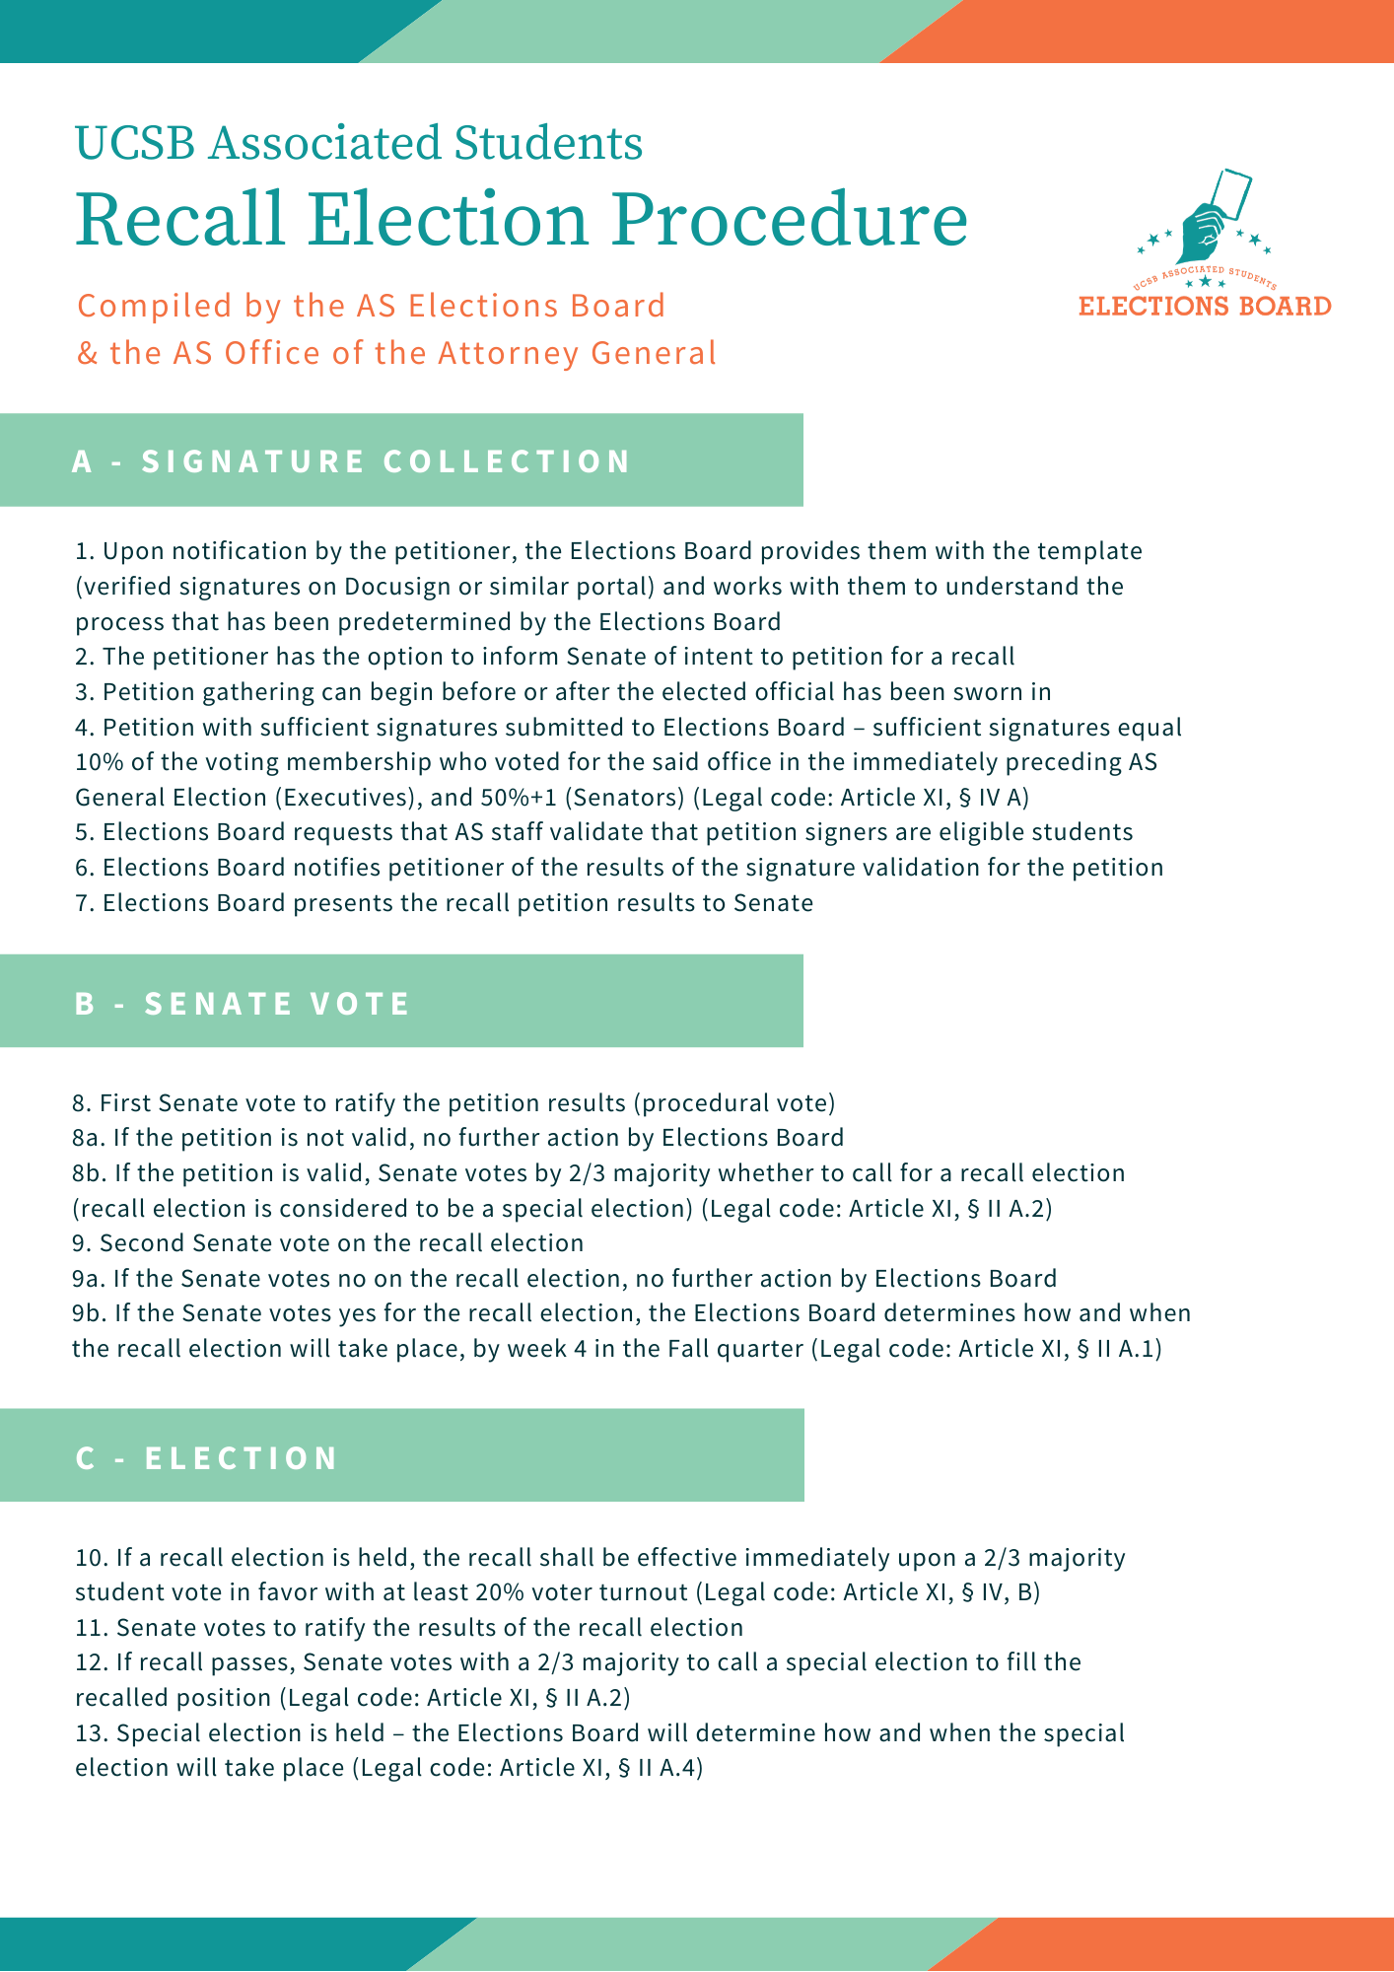
Andrew: Yea, let’s work together to create a timeline for this recall election that we can also use if this situation comes up again in the future.

Motion to approve the recall timeline
First/Second: Esber/Xing
Vote: 3-0 to APPROVE

MEETING ADJOURNED by Davis Quan at 1:55 PM

