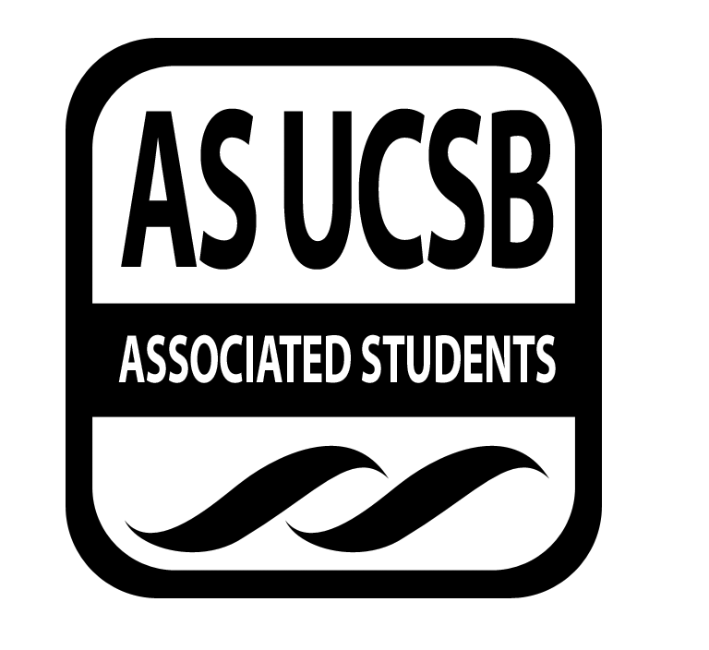
Environmental Affairs Board Minutes/Action Summary

Associated Students
10.22.13, 7pm
Environmental Affairs Board Office (3rd Floor, Ucen)
Minutes/Actions recorded by: Risa Jensen

CALL TO ORDER 7:13 PM by Rebecca Bracken, Co-chair

A. Roll Call

Name | Note:  absent (excused/not excused)  arrived late (time)  departed early (time)  proxy (full name) | Name | Note:  absent (excused/not excused)  arrived late (time)  departed early (time)  proxy (full name)
Kai Wilmsen, Co-chair |  | Chellsee Lee, Sustainable Business Chair | Absent
Rebecca Bracken, Co-chair |  | Mantha Carr, Earth Day Chair | Absent
Risa Jensen, Administrative Assistant |  | Heather Vest, Earth Day Chair
Alexandra Ballinger, Treasurer | Absent | Emily Lytle, Sustainable Foods Chair | Absent
Mackie Forgey, Publicity Chair | Absent | Sukayna Ibrahim, Environmental Justice Chair | Absent
Tayler Reinman, Publicity Chair |  | Benjamin Liddie, Historian | Absent
Shelby Skougard, Student Affairs | Absent | Isabelle Geczy, Clean Energy Chair
Kristi Fleshner, Social Chair | Absent | Adrian Gabriel, Garden Manager | Arrived Late, 7:21pm
Kori Lay, Statewide Affairs Representative |  | Lauren Dykman, Green Bill Consultant
Karina Paonessa, Volunteer Chair

- ACCEPTANCE of ACTION SUMMARY/MINUTES

Approval of our Action Summary/Minutes from 10/14/13

MOTION/SECOND: Jensen/ Wilmsen
ACTION: Vote: 8-0 to APPROVE, 1 abstain
APPROVED.

- ACTION ITEMS
a. Motion to pass $50 for meeting food for 10/23.
MOTION/SECOND: Bracken/Reinman
CALL TO QUESTION: Bracken
ACTION PASSES BY CONSENT

b. Motion to pass $25 for meeting food for BCC Recruitment 10/24.
MOTION/SECOND: Tayler/ Gecszy
CALL TO QUESTION: Bracken
ACTION PASSES BY CONSENT

b. Motion to pass $21 for Farmers’ Market 10/27.
MOTION/SECOND: Kori/Reinman
CALL TO QUESTION: Bracken
ACTION PASSES BY CONSENT

b. Motion to pass $375 for gas for two cars for round trip from UCSB to CSSC Convergence in Humboldt (11/8 - 11/11) if we find two certified drivers. 15 cents per mile for 1208 miles = $375.
MOTION/SECOND: Lai/Gabriel
CALL TO QUESTION: Bracken
Discussion:
-We will send two cars even if one of them is not full because convergences are valuable enough to justify non-carpool car travel.
Vote: 10 in favor, 0 abstain, 0 not in favor. Action Passes.

- UPDATES FROM CORE OFFICERS
Co-Chairs: Kai Wilmsen and Rebecca Bracken
- “In Other People’s Sleevies!”
- Office Hours
  - Google Docs Spreadsheet for Office Hours-Fill it out ASAP!
  - Not using it as a sign-in sheet
- Swap (information) Festival
  - downtown Ventura
  - workshops—wants to know if EAB wants to host one
  - November 3 1pm-6pm
  - Purpose: show the success of the gift economy
  - Workshop for sustainability, alternative economy, etc.
  - Rebecca, Heather, Kori
- Will have new Campus Affairs and Social Chairs by then end of the week!
- Food
  - Kori will be in charge of getting food from the Co-Op tomorrow for the meeting
  - Wednesdays 11-3 Gaucho Farmers Market! We can buy produce there for future meetings, although we do have money a gift card to the co-op
- Bracken and Mentzer want to get a roof-top garden on campus, perhaps on top of the library or UCen
- Trigo Garden
  - Katelyn from CAB thinks maybe in the past it was EAB’s responsibility
  - CAB has tons of volunteers who would love to garden with us
  - Neglected—needs EAB’s love!
- Bracken wants to find a new space for us, perhaps in an environmental resource center
- YERT has cool sustainable-building ideas
- Make-your-own-shampoo workshop
  - Shelby knows a little about this
  - Lauren has a family friend who could supply recipes
  - Risa sent out link to Environmental Working Group website—could be a good resource
- Education for Sustainable Living Program
  - Students can design their own seminars
  - have it at Davis and Santa Cruz
  - teacher and students get credit
- Academic Affairs Board
  - Any course that any student wants to teach can be submitted and be taught
  - We can use this to educate other students about sustainability
- Gaucho Farmers Market wants workshops
- Kori suggests Monthly DIY for EAB members
- Human Rights Week—Week 7. Nov. 11th-15th.
  - Environmental Justice Mixer will be this week.
  - Sukayna will have working group tomorrow to plan events for human Rights Week
- Fossil Free
  - working group this week for Halloween Action
  - with Shelby
- Core Social—fill out a doodle & get together to make pizza!
Earth Day Chair, Heather Vest:
- Trying to pick a date
  - in April
  - by getting in touch with Jonathan Abboud; will stop by his office
- Ideas for a theme—let her know if you have any
Clean Energy Chair, Isabelle Geczy:
- Powershift
  - was great
  - Brief up-date at beginning of general meeting re: powershift this week
  - in-depth presentation at beginning of general meeting following week
- Info Session or Working Group on methods of fossil fuel extraction
  - Fracking; Discussion:
    - this pertains to our area
    - CSSC is starting a Fracking Campaign
    - Calpirg has a fracking working group & Lauren will collaborate with them
  - Mountain-top removal
  - Keystone XL
  - Tarsands
  - Discussion
    - This could become a Fuel Extraction Seminar!
    - This could become a Ventura Swap Festival topic—they fracking going on in Ventura
- Anti-Oppression
  - Would like to lead an in-depth anti-oppression training
  - 2-3 hours in length
  - When
    - Could have it during a retreat or sooner, whenever there is more attendance possible
    - Will make a doodle to choose a date
- Future Working Group on Keystone XL
  - Keystone XL is a pipeline that would go from tar sands in Alberta, CAN to gulf coast of US. Tar sands must go through an immense refinement process (extremely energy-intensive), and the pipeline could leak anywhere along its lengthy extent across the US
  - Phase 3 of Keystone (largest portion) is in discussion (other two portions have been approved) and Obama said he would only approve it if it met climate action plan standards
  - Project: Time Capsules of our work anti-fossil-fuel-extraction work; plant them along the route so that our energy future will have to be dug up, symbolically
Statewide Affairs Representative: Kori Lay
- CSSC
  - Convergence in Humboldt: 3-Day Weekend in November
  - Will make sign-up for meeting
  - Will have powerpoint slide & a newsletter up-date
  - Logistics
    - 1200 miles round-trip
    - Do not have a confirmed driver yet, but drivers need to be certified
    - Would like to pass money for two cars $375
    - Two cars would be money well spent
- POC Conference coming up—ask Lai for application
- Farmers Market 11am Sunday- will lead ride
- Fossil Free Action
  - Day of Action 10/31
  - Fossil Fuel Haunting: something big in the arbor and asking Chancellor for fossil freedom
Green Consultant: Lauren Dykman
- Up-dated Greenbill Poster by Next Week
- Goal: Get 10 AS Groups Certified
  - will email all AS group leaders tonight
  - hopes that AS groups will come to a meeting or talk over lunch re: greenbill
  - Lai suggests getting on other AS groups’ leader-meeting agendas
  - Every club should have a Greenbill Liaison
- Working Group for Green Bill at General Meeting
  - Intensive greenbill training
  - Hopefully working groupees can be sent as liaisons to other meetings
- Like Greenbill Facebook Page, which she will create shortly
- Greenbill Certification
  - Wants to have a meeting with other AS leaders & applaud those who are greenbill certified (adhere well to greenbill)
  - Discussion: greenbill certification could become a big deal & point of pride
- Party Planner
  - Will create a google drive document to compile our knowledge & resources for the Sustainable Party Planner
  - In the end will be a spiffy PDF we can add to
  - Could include green chef recipes
Garden Manager, Adrien Gabriel:
- EAB Children’s Garden Project
  - 16 pre-schoolers, 2 volunteers
  - The first field trip went well 10/ 18
  - Lots of parents came
  - Planted celery & broccoli
- Not sure of next day of EAB Children’s Garden Project
- 10/17 Thursday 12pm Garden Party—meet at food co-op (last week three people came)
- Costumed General Meeting 10/30- with EAB shirts as prizes!
- General Member Recognition
  - could be presented at meetings
  - officers can nominate people based on arbitrary impressiveness, for “standing out to me,” a spotlight on a general member
Volunteer Manager, Karina:
- Adopt-A-Block
  - Lots of participants on Thursday; Collected 33.5 buckets so far!
  - Thursdays at 4pm
  - Also will advertise CAB clean-up hours to EAB members
- Tree Planting
  - This Saturday 10/26 Tree Planting for Veterans at 1pm
  - leave around 12:15pm to bike over from food co-op
  - Goleta Valley Beautiful
- Halloclean 11/2 and 11/3
  - EAB will go one day
  - One day will be a costume day
- 11/2 SB Open Streets
  - Closing two miles of street along Cabrillo for our use of the streets for people-powered activities, including Dancing, Zumba, Yoga
  - Representative from SB Open Streets has been in touch with CAB and EAB seeking volunteers
  - Volunteer trainings coming up

F. ADJOURNMENT

ADJOURNED 8:53 PM

