Environmental Affairs Board Agenda

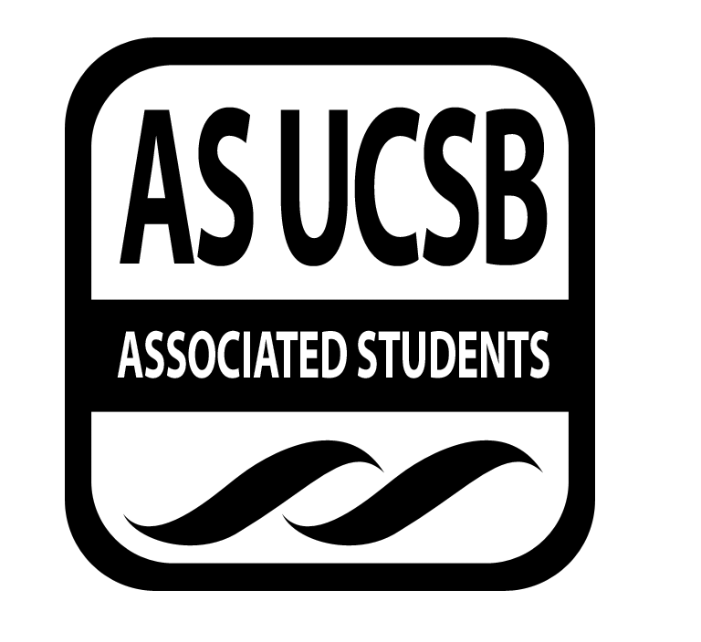
Associated Students
November 24, 2014, 7:00pm
Environmental Affairs Board Office (3rd Floor, Ucen) Minutes/Actions recorded by Victoria Mansfield

CALL TO ORDER 7:01 pm by Suh

A. MEETING BUSINESS
- Roll Call

Name | Note:  absent (excused/not excused)  arrived late (time)  departed early (time) | Name | Note:  absent (excused/not excused)  arrived late (time)  departed early (time)
Heather Vest, Co-Chair | Present | Mackie Forgey, Sustainable Business Chair | Absent
Jenn Suh, Co-Chair | Present | Angelica Villalobos, Earth Day Chair | Present
Victoria Mansfield, Administrative Chair | Present | Emma Moffitt, Earth Day Chair | Present
Marina Quintanilla, Treasurer | Present | Kristen Herrera, Sustainable Foods Chair | Absent
Greg Ryan, Publicity Chair | Present | Unique, Vance, Environmental Justice Chair | Present
Chris Berry, Publicity Chair | Present | David Kim, Historian | Absent
Michael Fanelli, Student Affairs Chair | Present  Left early (7:42) | Nicholas Frey, Clean Energy Chair | Present
Kedrina Garcia, Volunteer Chair | Present | Bailee Lawrence, Garden Manager | Present
Biby Landaverde, Social Chair | Present | Jeremy Peschard, Statewide Affairs Representative | Present
Jessica Russo, Social chair | Present | Emma Carrico, Campus Affairs Coordinator | Absent
Yanira Flores, Green Bill Consultant | Present

B. ACCEPTANCE of ACTION SUMMARY/MINUTES

B-1. Approval of our Action Summary/Minutes

Approval of our Minutes from 11/17/14
MOTION/SECOND: Mansfield/Vest
Motion language: Motions to move into immediate consideration
ACTION: Vote: 15 in favor-6 abstain-0 oppose to APPROVE.

C. MOTION TO ALLOCATE FUNDS
a. $90 for booking the EAB fall quarter campsite
MOTION/SECOND: Russo/Ryan
Motion language: Motions to move to immediate consideration
ACTION: MOTION PASSES BY CONSENT

D. Old Business
a. Recap of events and working groups
i. Earth at Risk Conference remarks
1. Vance-Described speakers and events
2. Lawrence- Mentioned of attendance by older crowd
3. Villalobos- social justice issues tied with environmentalism
4. Peschard- Genuine and in-depth intersectionality discussions
5. Suh-Great learning experience with connection of sustainability and social justice. Interesting being in a crowd that was not just made up of students.
ii. Green Chef remarks
1. Vest-Educational with description of foods, ted talk videos, food quiz.
2. Ryan-Waste of food by supermarkets
3. London–Sandwich shops wasting ends of bread
iii. Movie Night remarks
1. Russo-Some issues with the event. Could be hosted at Manley in future
iv. Hike
1. Russo-pleasant hike
v. “Oceans” and “Cowspiracy” Screening
1. Mansfield- Announced drought campaign at “Oceans”
2. Mansfield- Good turnout at “Cowspiracy” Screening

E. UPDATES FROM CORE OFFICERS:
- Heather Vest and Jenn Suh, Co-Chairs
  - Icebreaker – One word that describes weekend
  - GSA lounge
    - Felt good to be back
    - Clean up after meetings
  - AS Calendar
    - Mansfield should get in contact with person in charge of AS calendar to add EAB events
d. Amazon
i. Amazon free giveaways
ii. Could be useful for future events
e. List-serve
i. All core members should be on AS List serve
f. Gaucho Farmer’s market
i. Asked if we would like to table with them
ii. Tabling for drought
g. AS “Create and design for organization”
i. Flyers in AS main
ii. Graphic design services
h. Winter retreat
i. First weekend of winter quarter
ii. Leave on Jan 10th and come back on Jan 12th
iii. More info to come
iv. Will be at Lake Cachuma
i. Portfolium
i. Student-based linked-In but you can add more
ii. Member from Portfolium reached out and asked if we can do it
iii. $1 per person who signs up
iv. Money can go to our group that we can use for a cause
v. Discussion of whether we should use it
j. Phone votes
i. Allowed but should only be used for emergencies
ii. Members should plan to pass money during core meetings
k. Core meeting times doodle
i. Will be sent out tonight for winter core meeting times
l. Drought campaign logo
i. Deadline will be on Wednesday
ii. One submission so far
m. Reflections on quarter
i. Great learning experience for us all
ii. Should finish fall quarter strong and continue hard work throughout the year
n. Publicity
i. Use of Digi-knows in future
ii. Poster above Pardall Tunnel
o. Farmer of the week
i. Can work on announcing it at weekly meetings
Chris Berry and Greg Ryan, Publicity Chairs
- David Cleveland talk
i. Ryan attended and shared importance of diet change
ii. Will host working group next week
- Ocean Acidification talk
i. Ryan attended and shared information about damage to corals and biodiversity from Ocean acidification as a cause of global warming.
- Bailee Lawrence, Garden Manager
  - Garden
i. Meeting for garden party will be postponed until next week
ii. Wants to host workshop about Food and Nutrition
  - Summit
    - Jan 16-18th
    - EAB can attend or host a workshop
    - Summit about food sustainability and food justice
    - At UCSB
- Jeremy Peschard, Statewide Affairs Coordinator
  - CSSC
    - Each campus has two CSSC reps
    - EAB needs to approve UCSB student involved with Fossil Free to be second rep
  - Current Work
    - Currently focusing on Fossil Free and Gauchos Against Fracking
- Yanira Flores, Green Bill Consultant
  - SIRCC, IVP, EVPSA
    - Set up meetings with all of them
    - Currently working with these and several other groups
  - PACES
    - Waiting for them to finish walk-through
    - Working on Board
  - Take Back the Night
    - No response yet
- Emma Moffit & Angelica Villalobos, Earth Day Coordinators
  - Working group
    - Got suggestions for activities that people wanted to see at event
    - Still need to decide on park
Kedrina Garcia, Volunteer Chair
a. Green books
i. Project is going well
ii. Needs professor names that use Green Books
- Unique Vance, Environmental Justice Chair
  - Earth at Risk Conference
    - Went well this weekend
  - CSSC
i. Working on letter for Ferguson
  - Chumash Environmental office
i. Planning on working with them
- Kristen Herrera, Green Chef Chair
a. No updates
- Biby Landaverde and Jessica Russo, Social Chair
a. Camping trip
i. Will be at campsite in Carpenteria
ii. Discussion of how much money to use for retreat food
b. Breakfast for dinner for core officers
i. Perhaps on Dec 5
ii. Potluck
iii. No time and location decided
xi. David Kim, Historian
a. No updates
xii. Michael Fanelli, Student Affairs chair
- E-Coalition meeting
i. Janet Napolitano 2025 neutrality plan
ii. Global Climate Leadership Council comprised of faculty and students
iii. UC Davis rep expressed desire for a student rep from each campus
b. Attended Discussion
i. Discussed issues of capitalism
c. TGIF
i. Deadline pushed back
ii. Students should continue to be encouraged
xii. Nicholas Frey, Clean Energy Chair
a. Fossil Free UCSB
i. Has been getting more involved
ii. Attended event on Friday at Arbor
iii. Chancellor contacted Fossil Free with meeting scheduled for January
b. Drought campaign video
i. Folder and google doc is made for drought campaign
ii. Trip to Lake Cachuma
c. Lighting
i. Light sensor arrived
ii. Planning on using it in AS offices
iii. Talked to California Electric Supply
xiii. Marina Quintanilla, Treasurer
- Budget
i. Updating budget sheet
b. Requisition form
i. Members should send Quintanilla picture of receipt for a requisition form
ii. Deadline is late Jan
xiv. Victoria Mansfield, Administrative Chair
- Drought campaign
i. Co-hosted working group last week.
- David Cleveland Talk
i. Attended talk and discussed how “Cowspiracy” movie related to it
ii. Interested in helping with working group
xv. Sarah Siedschlag, EAB Advisor
  - Green Bill
i. Discussion of what Green Bill entails
ii. Review of legal code on AS website
iii. Most student groups need to become more aware of what Green Bill entails

F. Additional Comments
a. No additional Comments

ADJOURNMENT
MOTION/SECOND to ADJOURN: Mansfield/Suh
ACTION: Vote: 16 in favor- 5 abstain- 0 opposed to APPROVE.
Vote Taken: 8:43pm

