Environmental Affairs Board Minutes/Action Summary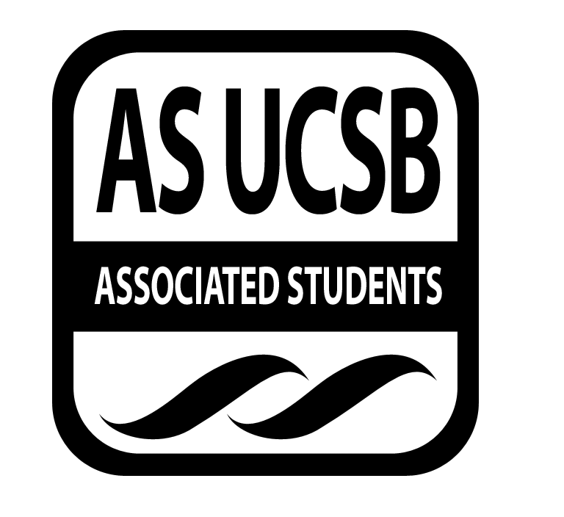
Associated Students
12.3.14
EAB Phone Vote Minutes/Actions recorded by: Heather Vest

CALL TO ORDER 3:03pm on 11.20.14 by Unique Vance

A. MEETING BUSINESS
- Roll Call

Name | Note:  absent (excused/not excused)  arrived late (time)  departed early (time) | Name | Note:  absent (excused/not excused)  arrived late (time)  departed early (time)
Heather Vest, Co-Chair | Present | Mackie Forgey, Sustainable Business Chair | Absent
Jenn Suh, Co-Chair | Absent | Angelica Villalobos, Earth Day Chair | Present
Victoria Mansfield, Administrative Chair | Present | Emma Moffitt, Earth Day Chair | Present
Marina Quintanilla, Treasurer | Absent | Kristen Herrera, Sustainable Foods Chair | Absent
Greg Ryan, Publicity Chair | Present | Unique, Vance, Environmental Justice Chair | Present
Chris Berry, Publicity Chair | Present | David Kim, Historian | Absent
Michael Fanelli, Student Affairs Chair | Present | Nicholas Frey, Clean Energy Chair | Present
Kedrina Garcia, Volunteer Chair | Present | Bailee Lawrence, Garden Manager | Present
Biby Landaverde, Social Chair | Absent | Jeremy Peschard, Statewide Affairs Representative | Present
Jessica Russo, Social chair | Present | Emma Carrico, Campus Affairs Coordinator | Absent
Yanira Flores, Green Bill Consultant | Absent

A-1. Acceptance of Excused Absences

No approved excused absences.

A-2. Acceptance of Proxies

No approved proxies.

B. PUBLIC FORUM

No public forum announcements.

B-1. REPORTS

- Advisor’s Report
No advisor report.

- Executive Officer’s Report(s)
No executive report.

- Group Project/Member Report(s)
No member reports.

C. ACCEPTANCE of AGENDA/CHANGES to AGENDA
Meeting called for motion and discussion to approve passing money for meals for a delegation of EAB students attending the Earth at Risk conference in San Francisco.

D. ACCEPTANCE of ACTION SUMMARY/MINUTES

D-1. Approval of our Action Summary/Minutes from CORE

MOTION/SECOND:
ACTION:
N/A.

E. ACTION ITEMS

E-1. Old Business:

No old business.

E-2 New Business

- Acceptance of funds
Motion/Second: Vance/Ryan
Motion to pass $40 for breakfast and lunch for UCSB EAB delegation to San Francisco for Earth at Risk conference.
This motion is to pass money for food for the UCSB EAB delegation of 8 students to San Francisco for the Earth at Risk conference on the weekend of 11/22.

Email Vote: 13 in favor, 8 abstain, 0 oppose
APPROVED.

F. Discussion Items

No items discussed.

G. Remarks

No remarks.

ADJOURNMENT

MOTION/SECOND to ADJOURN: Vance/Vest
ACTION: Vote: 13 in favor, 8 abstain, 0 oppose
APPROVED.
Vote Taken: 10:49pm on 11.20.14

