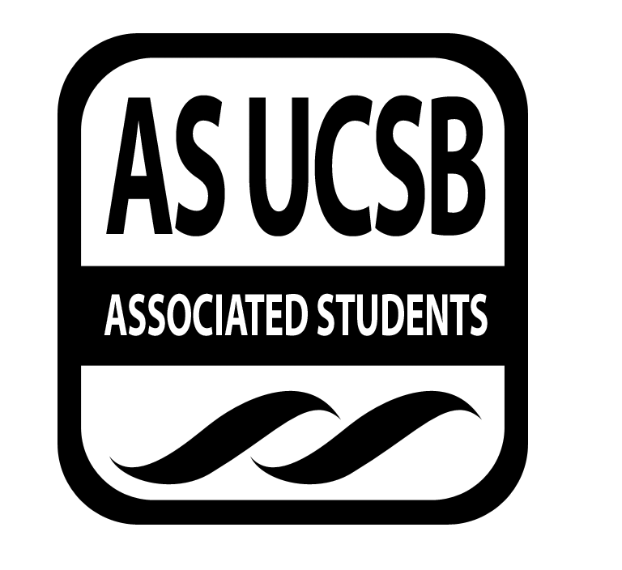
Environmental Affairs Board Minutes/Action Summary

Associated Students

11.18.13, 5pm

Environmental Affairs Board Office (3rd Floor, Ucen)

Minutes/Actions recorded by: Risa Jensen

CALL TO ORDER 5:02 PM by Rebecca Bracken, Co-chair

A. Roll Call

Name | Note:  absent (excused/not excused)  arrived late (time)  departed early (time)  proxy (full name) | Name | Note:  absent (excused/not excused)  arrived late (time)  departed early (time)  proxy (full name)
Kai Wilmsen, Co-chair |  | Chellsee Lee, Sustainable Business Chair | Absent
Rebecca Bracken, Co-chair |  | Mantha Carr, Earth Day Chair | Absent
Risa Jensen, Administrator |  | Heather Vest, Earth Day Chair
Alexandra Ballinger, Treasurer |  | Emily Lytle, Sustainable Foods Chair
Mackie Forgey, Publicity Chair |  | Sukayna Ibrahim, Environmental Justice Chair
Katy Blackburn, Social Chair |  | Sukayna Ibrahim, Environmental Justice Chair
Tayler Reinman, Publicity Chair |  | Benjamin Liddie, Historian | Absent
Shelby Skougard, Student Affairs Chair |  | Isabelle Geczy, Clean Energy Chair
Gabby Schneid, Social Chair |  | Adrian Gabriel, Garden Manager
Kori Lay, Statewide Affairs Representative |  | Lauren Dykman, Green Bill Consultant
Karina Paonessa, Volunteer Chair |  | Jen, Campus Affairs Coordinator

- ACCEPTANCE of ACTION SUMMARY/MINUTES

Approval of our Minutes from 11/11/13

MOTION/SECOND: Jensen/ Vest
ACTION: Vote: 16 in favor, 1 Abstain
ACTION PASSES

- ACTION ITEMS
a) Motion to pass a $300 purchase order for AS Publications for EAB for the remainder of the 2013-2014 school year.
MOTION/SECOND: Bracken/Ballinger
CALL TO QUESTION: Jensen
ACTION PASSES BY CONSENT

b) Motion to pass $400 for 250 Wind-turbine Recycled Pens.
MOTION/SECOND: Forgey/ Gabriel
CALL TO QUESTION: Bracken
ACTION PASSES BY CONSENT
c) Motion to reallocate $25 of Adopt-A-Block Food Funds to Beach Clean-Up Food Funds.
MOTION/SECOND: Paonessa/ Forgey
CALL TO QUESTION: Jensen
ACTION PASSES BY CONSENT

d) Motion to pass $20 for Green Bill bulletin board materials for other groups.
MOTION/SECOND: Dykman/ Lay
CALL TO QUESTION: Jensen
ACTION PASSES BY CONSENT

d) Motion to pass $6 for AS Publications for Green Chef.
MOTION/SECOND: Lytle/ Ballinger
CALL TO QUESTION: Jensen
ACTION PASSES BY CONSENT

- UPDATES FROM CORE OFFICERS
Co-Chairs: Kai Wilmsen and Rebecca Bracken
- Key Card Access – it’s tricky to get into the office with access cards; may need to resubmit forms
- BC4 Meeting 11/22
  - Collaboration forum with other BCCs
    - Lauren may present re: Greenbill
    - Volunteers & collaboration needed for Fossil Free & CSSC & UCCE
  - Core officers encouraged to attend
- Recs & Park District has open position
  - Planning & zoning questions
  - Only elected governing body in IV
  - Application closes 11/22
  - See website for more info
- Educational Session at EAB Meetings
  - Info sessions during EAB meetings, ex: What is or is not recyclable in SB County?
  - EAB Officers could lead our own information sessions, too
  - 5 minutes at beginning of meeting or as a working group; perhaps general members could report back
  - How to spread the knowledge? This could be an educational-campaign working group
- Sprout Up
  - Winter Interviews 12/3 5pm-7pm & 12/6 10am-12pm
  - @ IV Food Co-Op
- AS Sustainability Mixer
  - 11/23 Sunday
  - For environmental leaders
  - Wait ‘til next quarter?
  - The more opportunities for networking the better?
- AS Publications
  - Last year we passed $300 for this
- Greenvolve wants publicity
  - Background: Greenvolve is an online forum for fledgling environmental project
- Meet at SRB before Farmers Market to walk through it together with Heather & Shelby
Earth Day Chair, Heather Vest:
- Finding bands for Earth Day
  - Contacting Storke Plaza Performers
  - Settling contract with Parks & Rec
Clean Energy Chair, Isabelle Geczy:
- Working Group on UCCE Petitioning
- Will file Open Records Request on Agreement with SoCal Edison
- UC Students Association – good discussion
- Met with people from USSA
  - good resources for student campaign organizing
- Farmers Market Bike Ride
  - needs more attendees, perhaps more enticing announcements
  - 11am Sunday
Sustainable Food, Emily Lytle:
- Green Chef – 11/16 1pm @ SRB
  - Went well!
  - 50 attendees, 12 chefs
  - Look out for coverage in the Nexus
Statewide Affairs Representative: Kori Lay
- Up-coming meeting
  - with attendees of CSSC Humboldt
  - they may assist with Spring convergence
- First meeting for planning CSSC in May
- At Environmental Justice Mixer made connection with CalPirg person who wants to assist with convergence
Green Bill Consultant: Lauren Dykman
- FB Page is getting lots of “likes”
- Wants Green Chef recipes for Ultimate Party Planner
- Working Group “Snails, Appreciating (& Controlling?) the Little Things in Life.” (Snails & garden pests)
Volunteer Manager, Karina:
- Beach Clean Up & hangout 11/23 11am-1pm
  - 10:45am set up- needs volunteers: Kai, Lauren
  - For future clean-ups: Coastal Fund will give $ to beach clean-up orgs
  - Will break for food at 12:30pm – needs volunteers: Mackie
- Channel Islands Restoration Trip 11/17
  - 15 volunteers planted 250 native plants
  - Sea lions & dolphins
- Adopt-A-Block
  - Thursday 4pm
  - Monday 3pm with CAB
Environmental Justice, Sukayna:
- Environmental Justice Mixer
  - Got diverse student leaders & some older community members
  - May have workshop at Swap Meet
  - ReCap & Reflection Working Group
Social Chairs, Katy Blackburn & Gabby Schneid:
- Cooking Party 11/12 7:30pm – Location TBA
- Hike Sunday at 3:00pm to Lizard’s Mouth—take flashlights
Student Affairs, Shelby Skougard:
- Swap Meet will be Winter Quarter
  - Take-aways from Working Group
    - Incorporate tabling for other organizations, incl. Free-trade groups
    - Incorporate food drive? Collaborate AS Food Bank
    - Discussion: could be at beginning or end of quarter for textbook swapping, could be at potluck, could be near finals, keep brainstorming!
- Fossil Free up-date & working group this week
Campus Affairs, Jenn Suh:
- GM Proposal
  - Credits will be taken off the market by GM
  - GM has environmental initiatives
  - Buying UCSB’s credits is good for GM PR and Publicity
  - EAB could give qualified support; only supports if UCSB uses profit for further emissions reductions
Publicity Chairs, Tayler Reinman & Mackie Forgey:
- Planning publicity for start of Winter quarter
  - DigiKnows—get submissions in early next quarter!
- T-Shirt Design in Progress
- New Promotional Materials
  - Perhaps use logo sunglasses to promote EAB
  - Decide on pens made in the USA with windmills on top
- Discussion: Publicity Stuff
  - expense, carbon footprint, necessity, quantity
- Food for Thought
  - There are no recycled water bottles made in the USA that are not less than $10 consider our priorities!
Garden Manager, Adrian Gabriel
- 11:30am Garden Workday
- Requests empty jugs (water, milk) to use for pest prevention & greenhouse covering
- Environmental Hall residents will work in EAB garden next quarter
Treasurer, Alexandra Ballinger
- Contact info from all attendees of Environmental Justice Mixer—get these contacts from Alexandra if we ever want activists interested in justice
- Interviews with fishing communities – sustainable food
- Attendees want to have more activism & mixers
Administrator, Risa Jensen:
- Requests that Core Officers Fill Out: Doodle for meeting time next quarter, questionnaire re: Fall Retreat, form for slide show & newsletter

F. ADJOURNMENT

ADJOURNED 6:36 PM

