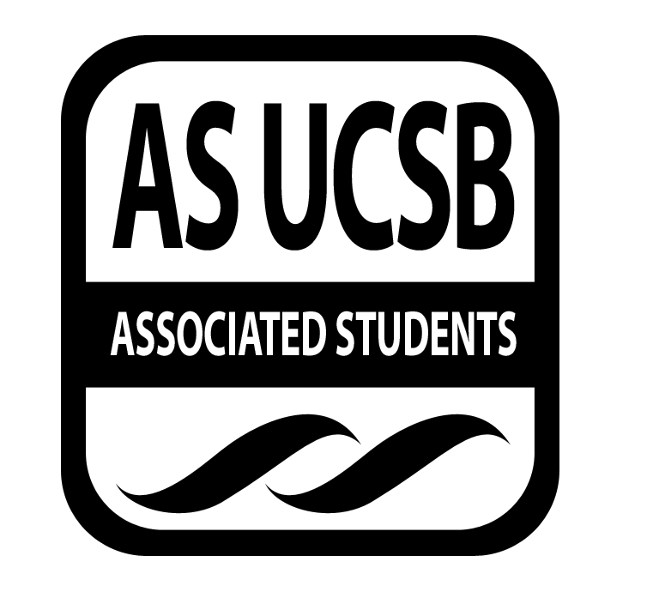

**Committee on Committees Minutes/Action Summary**

Associated Students  
San Rafael Mountain Clusters  Minutes Recorded by:  Priscilla Lee

January 7, 2015 9:30 PM

**CALL TO ORDER at 9:51 by Sydney Bennet, Chair**

**A. MEETING BUSINESS**

1. **Roll Call**

|  |  |  |  |
| --- | --- | --- | --- |
| **Name** | **Note:**  absent (excused/not excused)  arrived late (time)  departed early (time)  proxy (full name) | **Name** | **Note:**  absent (excused/not excused)  arrived late (time)  departed early (time)  proxy (full name) |
| **Sydney Bennet** | Present | **Oscar Zarate** | Present |
| **Andrew Neiman** | Present | **Pedro Villalobos** | Present |
| **Eve Kopecky** | Present | **Priscilla Lee** | Present |
| **Izeah Garcia** | Excused | **Stacey Heo** | Present |
| **Kelly Pearman** | Present |  |  |

**B. DISCUSSION ITEMS**

**B-1: Scheduling (Meetings/Office Hours)**

* If you have anything that’s NOT on the schedule, tell Priscilla (work hours, adding/dropping classes)
* Office hours whenever this week
* Post office hours
* Next week meeting suggestions time

**B-2: AS Olympics**

* Feb 8 - Sunday, 12pm-5pm
* Plan stuff now (games, etc.)
* Ideas for actual activities
* Sign ups first (how many people per team)
* Figure out the maximum capacity for Thunderdome
* Food allowed
* Go over everything with Thunderdome staff by the end of January
* Have people start RVSP end of next week/week after

**B-3: AS Assembly (RSVP/workshops)**

* Email about AS Assembly - register
* Room occupancy ~90 people
* If you think you can lead a workshop, let Sydney know
* Brainstorm outside AS groups to do workshops
  + Health and wellness
  + Career Center
  + CLAS - study skills
  + Writing Center
  + Inclusive language workshop
  + CSO

**B-4: Recruitment Fair**

* Corwin, February 17
* Get date officially booked
* As soon as it’s booked, reach out to AS Graphic Designer to get a flyer for tabling
* Theme (?) ideas:
  + AS Career fair
* Email Career center to help advertise
* Get a book stamped for prizes, give away shirts, ping pong balls, food, etc.

**B-5: Proxy Bank**

* 18 people who signed up
* Start training people for that, make a final push to get the word out for proxy bank
* Share and invite facebook friends to event
* Post in AS related groups
* Thinking about tabling

**B-6: Open Positions & Fellows**

* Interviewed fellows
* If anyone has opinions on them, let Sydney know
* 22 fellows - between 4 exec offices, lobby corps, coc, senate, etc.
* Fellows of CoC focus on AS Olympics/AS Assembly
* Spring Recruitment for next quarter
* Judicial Council interviews soon - if you have any friends that want to go to law school, tell them about JC
* Oscar check in with everything that’s open on the website and make sure it is open (over the weekend)

**B-7: Legal Code**

* By end of this week, Legal Code revisions in Google Doc drive
* Read the part for your position, at very bottom of position, put your name and any comments
* Can be done this weekend
* If you have any new ideas, add them in

**B-8: Secret Santa**

* Picnic (?)
* Park across 7/11
* Saturday or Sunday brunch (11am-12pm)
* Bagels and cream cheese (Bagel cafe), fruit from co-op

**C. REMARKS**

* Next meeting, Wednesday 9:30pm
* Budget for retreat: $50

***MOTION/SECOND: Kopecky/Zarate***

***Motion to approve 50 dollars for CoC retreat***

***ACTION: Vote: passes by consent***

***Advisor/Staff recommendation/instruction/request: None***

***Responsible for Follow-through: Andrew***

***Additional approval required?  No***

**ADJOURNMENT**

Meeting adjourned by Sydney Bennet at 10:21 pm

***MOTION/SECOND:  Villalobos/Lee***

***Motion to end meeting at 10:21 pm***

***ACTION: passes by consent***