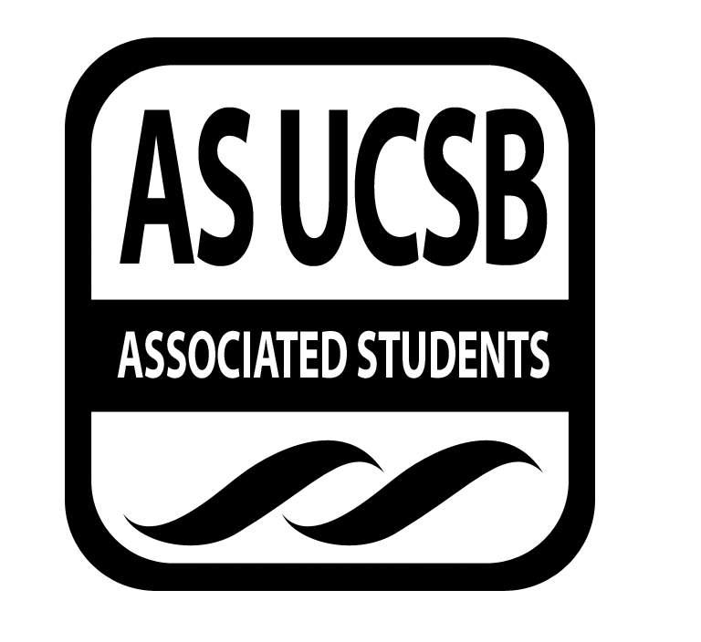
Commission on Disability Equality (CODE) Minutes/Action Summary

Associated Students
Tuesday, April 15, 2014, 5 pm
Annex Minutes/Actions recorded by: Irene Sarmiento

CALL TO ORDER Irene Sarmiento, 5 pm

A. MEETING BUSINESS
- Roll Call

Name | Note:  absent (excused/not excused)  arrived late (time)  departed early (time)  proxy (full name) | Name | Note:  absent (excused/not excused)  arrived late (time)  departed early (time)  proxy (full name)
Guadalupe Ibarra | Absent (excused) | Nikki Calderon | Absent (excused)
Irene Sarmiento
Amanda Brady
Adrian Tabula
Marsha Levinson | Absent (excused)

B. PUBLIC FORUM
  - Announcements/Information/Introductions
- Check ins
- Cinco de Drinko – May 1, 12-3 pm, San Nic/San Miguel lawn

- REPORTS
- Advisor’s Report
- Executive Officer’s Report(s)
- Group Project/Member Report(s)
- Recap on Taco Tuesday: positives and deltas
  - Positives
    - Amanda B.: good turnout
    - Adrian: got rid of all the food
    - Irene: really enjoyed the food
  - Deltas
    - Adrian: talk about the commission, show a video
    - Irene: checking food location beforehand
    - Amanda N.: do one with Lily’s tacos and in a different location
    - Zoe: formal lounge in Chi-5
- Outreach: CODE gear
  - Irene: pens, shirts, bracelets
  - Amanda B.: all new gear with logo
  - Adrian: colors could be white and red, black and white, teal and orange
  - Irene: drawstring backpacks, cups
  - Amanda B.: put logo and acronym on the front and what it stands for in the back
  - Amanda N.: both tanks and t-shirts
- Program planning
  - Amanda B.: e-mailed Tim about wheelchair basketball and will get back to me, will contact event staff, just need to figure out if we can have both able-bodied and differently-abled playing simultaneously, get liability waivers
  - Irene: could show movies that have disabilities in it
  - Amanda B.: could have it with tacos
  - Mallela: could show the movie Jack
  - Adrian: Radio
  - Zoe: Rain Man
  - Adrian: focus on one big one event for the quarter since we only have a few weeks left, too ambitious to have several same events, focus on basketball wheelchair
  - Amanda B.: will e-mail him again
- Election for positions – week 7
  - http://coc.as.ucsb.edu/boardsandcommissions.php
- AS Budget requested for 2014-2015
- AS Awards
  - Irene: nominations are due this Thursday, email about information will be forwarded

- REMARKS
- Irene: stay cold since it’s hot outside

ADJOURNMENT
5:37 pm

