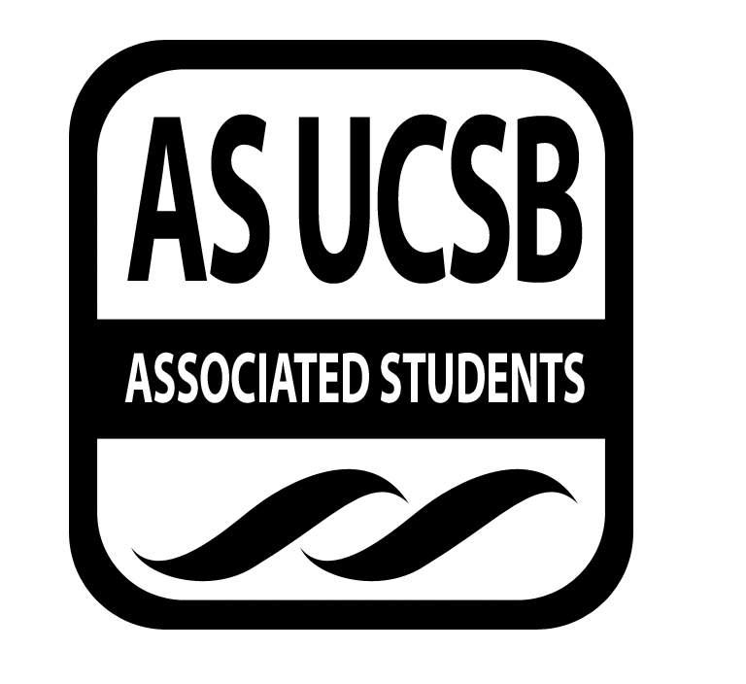
Commission on Disability Equality (CODE) Minutes/Action Summary

Associated Students
Thursday, January 23, 2014, 4 pm
CAB Office Minutes/Actions recorded by: Irene Sarmiento

CALL TO ORDER Guadalupe Ibarra, 4:01 pm

A. MEETING BUSINESS
- Roll Call

Name | Note:  absent (excused/not excused)  arrived late (time)  departed early (time)  proxy (full name) | Name | Note:  absent (excused/not excused)  arrived late (time)  departed early (time)  proxy (full name)
Guadalupe Ibarra |  | Nikki Calderon | Absent (excused)
Irene Sarmiento
Amanda Brady
Adrian Tabula | Absent (excused)
Marsha Levinson

B. PUBLIC FORUM
  - Announcements/Information/Introductions
- Check-ins
- Team building activity
  - Communication ask for help, strengths and areas of improvement

- REPORTS
- Advisor’s Report
- Executive Officer’s Report(s)
- Group Project/Member Report(s)
- Richie Parker video and discussion
- Houseless with mental issues – mentioned by a resident Steven
  - Lupe: working with them, any information?
  - Ashkon: Doctors without Walls Companion Care in Santa Barbara, getting them medical and social resources
  - Erica: Breakfast Club, Dinner Club
  - Allina: Coalition for Housing Justice, 8 pm on Tuesdays in CAB office, working on houseless issues/students
- Hall Council and organization presentations
  - Lupe: present to our organizations about CODE, write down organizations you’re in
- Tabling – MW 11 am – 1 pm, TR 10 am – 12 pm, outside of Annex
  - Lupe: thanks to everyone who helped out, continue it next week, have jeopardy board with lots of great facts, great way to outreach and lots of shirts, pass out shirts to hall councils, ask people if they have a minute
  - Marsha: get rid of old shirts first before making new shirt?
  - Lupe: yes, t-shirt design contest or have logo on it
  - Allina: stick with your logo, can have different design for shirt
- Awareness week brainstorm – week 8
  - Lupe: theme/name for awareness week, emphasize invisible disabilities, any slogan/title for flyers, design for AS for that week
  - Marsha: “Recognizing disabilities and emphasizing possibilities”
  - Lupe: “Invis(ability) – Beyond what you can see” is our theme, will create logo design

- REMARKS

ADJOURNMENT
5:00 pm

