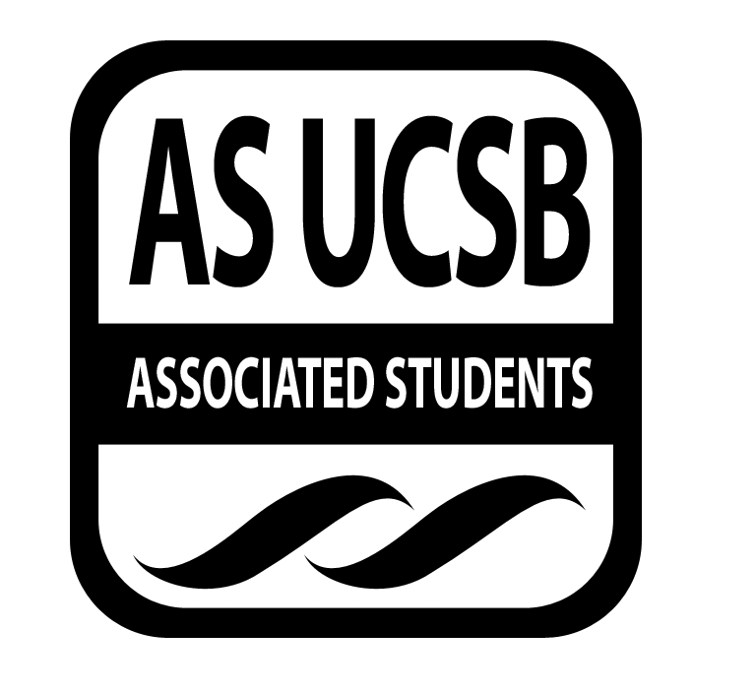
Committee on Committees Minutes/Action Summary

Associated Students
Pardall Center Minutes Recorded by: Priscilla Lee
April 12, 2016 8:00 PM

CALL TO ORDER at 8:09 by Oscar Zarate, Internal Chair

A. MEETING BUSINESS
- Roll Call

Name | Note:  absent (excused/not excused)  arrived late (time)  departed early (time)  proxy (full name) | Name | Note:  absent (excused/not excused)  arrived late (time)  departed early (time)  proxy (full name)
Oscar Zarate | Present | Sunny Chao | Present
Pedro Villalobos | Excused | David Zhong | Excused
Priscilla Lee | Present | Tony Aceves | Present
Megan Wong | Present | Theresa Tran | Unexcused
Kelly Pearman | Excused | Tiffanie Vo | Present
Christina Pallone | Excused | Maren Roberts | Unexcused

A-2. Acceptance of Excused Absences
MOTION/SECOND: Lee/Vo
Motion to approve the attendance and excused absences on 4-12-15
ACTION: Vote: passes by consent

C. DISCUSSION ITEMS

C-4: Individual Reports
- Sunny - make an email to chairs about AS banquet/assembly
- Priscilla - schedule interviews tomorrow during office hours
  - Make an email for chairs about new interviewing schedule (send to Oscar)
- Tony - book Corwin asap for banquet/assembly
  - Theresa ordered the amazon giftcard
  - Ordered the plaque engraving
- Everyone - invite 50 people to the recruitment fair FB event page
- Megan - meeting with new representatives that we appointed for UCEN Gov Board and Financial Aid Advisory Committee
  - Double check with the financial aid committee to be sure that they still want a representative
  - Banquet - more intimate so spaces like MPR
  - Shoot LaDonte an email that you need Senators to respond to
  - Some kind of survey about relationship between senator and shared governance committees

D. REMARKS
- Post on facebook and read minutes!!!

ADJOURNMENT

Meeting adjourned by Oscar at 8:54 PM

